Dartboard GUI Component
Released by: | Signature:
Institute: | Date:

Keywords:
Approved by: | Signature:
Institute: | Date:

Author Signature: | Date:

Software Manual

Igor Verstovsek
KGB, Jozef Stefan Institute, Slovenia

Change Record
REVISION | DATE | AUTHOR | SECTIONS/PAGES AFFECTED
REVISION | REMARKS
1.0 | 2001-09-07 | Igor Verstovsek | All
1.0 | Created

Table Of Contents

Change Record 2
1 Introduction 4
1.1 Coordinate system 4
1.2 The Sun, the Moon and the Telescope 4
1.3 The wind 4
2 Design-time usage 5

Introduction

Dartboard is a GUI component that is used for displaying positions of the Sun, the Moon, and a selected Telescope in the sky. It is also displaying wind direction and speed. When fully functional, the Dartboard should look something like this:

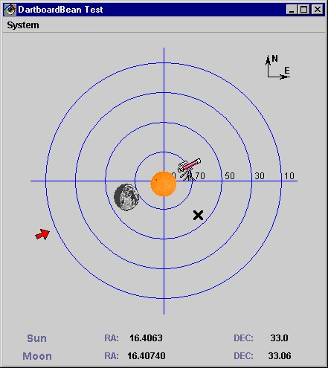

Coordinate system
The radial direction represents the elevation coordinate, ranging from 0 to 90 degrees – the largets circle corresponds to 10 degrees and the centre to 90 degress. The azimuth coordinate is represented by the polar angle on the Dartboard, azimuth zero is located on the vertical line going upwards form the centre. Azimuth is increasing in the clockwise direction.

The Sun, the Moon and the Telescope
The Sun, the Moon and the Telescope are all represented as icons on the Datrboard. The Moon's icon also shows current lunar phase. The black cross is representing the desired direction of the telescope.

In the panel on the bottom of the Dartboard the Sun's and Moon's rightascension and declination are displayed.

The wind
The wind is represented by a coloured arrow around the circumference of the Dartboard. Wind direction is displayed by the position of the arrow. Wind speed is represented by the color of the arrow, where:
- v < 12 m/s green colour
- 12 m/s < v < 18 m/s yellow colour
- v > 18 m/s red colour

Design-time usage
For configuring the Dartboard to visualize the required properties, use the visual composition's property-to-property connection to connect the appropriate properties from the DeviceBeans that represent the Moon, the Sun and the telescope to the correspodnding properties of the DartboardBean. DartboardBean properties are:
- RODoubleProperty telescopeElevation
- RODoubleProperty telescopeAzimuth
- RODoubleProperty telescopeDestinationElevation
- RODoubleProperty telescopeDestinationAzimuth
- RODoubleProperty sunElevation
- RODoubleProperty sunAzimuth
- RODoubleProperty sunRightAscension
- RODoubleProperty sunDeclination
- RODoubleProperty moonElevation
- RODoubleProperty moonAzimuth
- RODoubleProperty moonRightAscension
- RODoubleProperty moonDeclination
- ROIntProperty moonPhase
- RODoubleProperty windDirection
- RODoubleProperty windSpeed

At the end, when all the connections are made, the Dartboard should look something like this:

