A CS Component Simulator - Design and Usage
Released by: | Signature:
Institute: | Date:

Keywords: DynamicImplementation, ACS, Component, Container
Approved by: | Signature:
Institute: | Date:

Author Signature: | Date:

Design and Usage Document

David Fugate
University of Calgary

Change Record
REVISION | DATE | AUTHOR | SECTIONS/PAGES AFFECTED
REVISION | REMARKS
3.1 | 2003-12-11 | D. Fugate | All
3.1 | Created
3.1 | 2003-12-13 | D. Fugate | All
3.1 | Missing design aspects but complete for the most part.
3.1.1 | 2004-02-06 | G. Chiozzi | All
3.1.1 | Added comments.
3.1.1 | 2004-03-18 | D. Fugate | All
3.1.1 | Updated to reflect Gianluca's comments. Still needs UML diagram fixed.
4.0 | 2004-09-02 | D. Fugate | All
4.0 | Added some preliminary instructions on using the simulator.
4.0 | 2004-11-09 | D. Fugate | All
4.0 | Updated for ACS release
4.0.1 | 2005-02-10 | D. Fugate | CDB
4.0.1 | Added note about CDB usage.
4.0.1 | 2005-03-11 | D. Fugate | CDB
4.0.1 | Added small section about accessing in/inout parameters.
5.0.4 | 2006-07-25 | D. Fugate | All
5.0.4 | Partially updated for ACS 5.0. Needs work still.

Table of Contents
1 Scope 4
2 Overview 4
2.1 Abbreviations and Glossary 4
2.2 References 5
3 Design 5
3.1 Requirements 5
3.2 Implementation Language 6
3.3 UML Diagram 6
3.4 Configuration Database Entries Defining IDL Interfaces 6
3.5 Graphical User Interface 10
4 Usage 10
5 Known Problems and Issues 18
None at the moment. 18
6 Appendix 18

Scope
This document describes in detail the design and usage of a CORBA object simulator written in Python.

Overview
Shortly before the release of ACS 3.0, it was decided there was a need for a dynamic component (derived from ACSComponent) capable of implementing its IDL interface at run-time. For those unfamiliar with ACS terminology, ACSComponent is an IDL interface defined in the acscomponent module and it is the base interface for all components within ALMA software. Editor’s note: as of ACS 4.0, the simulator framework also supports components derived from the BACI CharacteristicComponent IDL interface.
A dynamic, “simulated” component becomes especially useful when a developer wants to test Components against an IDL interface that has no concrete implementation yet. This simulator will either generate return values, exceptions, etc. on the fly or accept these parameters from the user in some form or another (i.e., command-line, GUI, configuration database, etc.). Also, the simulator takes advantage of ACS helper classes where applicable (i.e., ComponentLifecycle, ACSComponentImpl, etc.).
For those who only want to learn how to use the ACS simulator framework, you can safely skip ahead to the section on usage.

Abbreviations and Glossary
ACS | ALMA Common Software
acspy | ALMA Common Software Python software module
BACI | Basic Access and Control Interfaces
CDB | ACS Configuration Database
characteristics | The run-time properties of an IDL interface’s implementation. This includes but is not limited to return values, timeouts, and the native code methods should execute.
component | A CORBA object derived from the ACS::ACSComponent IDL interface
container | A CORBA object responsible for the lifecycle of components.
CORBA | Common Object Request Broker Architecture
DynamicImplementation | A dynamic implementation class for IDL interfaces.
IDL | Interface Definition Language
MACI | Management and Control Interface

References
[R01] | ACS Architecture (http://www.eso.org/~gchiozzi/AlmaAcs/OnlineDocs/ACSArchitecture-4.0.pdf)
[R02] | ACS Software Module: “acspy” (ACS/LGPL/CommonSoftware/acspy in the ALMA CVS repository)
[R03] | Python Essential Reference (Beazley)
[R04] | CORBA (http://www.omg.org/technology/documents/formal/corba_iiop.htm)
[R05] | OMG IDL-Python Mapping (http://www.omg.org/technology/documents/formal/python.htm)
[R06] | ALMA Python Coding Standards  (http://www.eso.org/projects/alma/develop/alma-se/reference/CodingStandards.html)
[R07] | A GENERIC SIMULATOR OF CONTROL SYSTEMS FOR APPLICATION  DEVELOPMENT AND TESTING  (http://kgb.ijs.si/KGB/articles/PCaPAC2002-A_Generic_Simulator_of_Control_Systems_for_Application_Development_and_Testing.pdf)
[R08] | BACI Specifications Document  (http://www.eso.org/~gchiozzi/AlmaAcs/OnlineDocs/ACS_Basic_Control_Interface_Specification.pdf)

Design

Requirements
- Must be able to generate complete implementations of all IDL methods and attributes of an interface on the fly.
- Enumerations will be fully supported.
- If an interface defines a CORBA object attribute or a method that returns a reference to another CORBA object, the simulator should create the CORBA object.
- A simulated component should behave in the same manner as a real component. That is, simulated components shall be derived from the ComponentLifecyle class and other utility classes where applicable.
- Users will have the option to specify a timeout value for methods. When the method is invoked it will sleep for a period of time defined by the timeout and then return.
- Read/write attributes should have some form of “memory” to store the value if it is being set. If the attribute is being read and it is not in the ‘RANDOM’ state, the “memory” value will be returned.
- This design recognizes the fact that it may be necessary to simulate the “crashing” of a component.
- A GUI shall be implemented allowing developers to set return values, timeouts, etc. for each attribute and method an IDL interface defines. Furthermore, the GUI will accept as a parameter a Python package and a function name which can substitute for a simulated attribute or method. If the developer does not set these parameters via the GUI, the infrastructure should then search the ACS configuration database and if the values cannot be found there either, they will be generated on the fly.
- The GUI will be a dumb client for all intensive purposes. In other words, the intelligence of the simulation will reside in an API available to developers and the GUI will just make requests of the API. This will be used to facilitate the simulator’s use in modular tests in particular.

Implementation Language
Because the simulator should be able to emulate components where the IDL interfaces are not known ahead of time, a dynamic programming language seems like the logical choice for an implementation. Python is both dynamically scoped and typed, supports dynamic inheritance, and most importantly allows developers to dynamically redefine methods at run-time. ACS already provides a Python container which makes Python the ideal language for the simulator’s implementation.
Class and Data Descriptions
To be redone for ACS 6.0!
Description goes here.

UML Diagram
To be redone for ACS 6.0!
Description goes here.

Configuration Database Entries Defining IDL Interfaces
The usefulness of predefining simulated component behavior is acknowledged by this document. For example, perhaps the end-user wants to find out what happens when the return value of some method is fixed, but non-default. Productivity may be hampered because of the time spent changing return value(s) each time the simulated component is activated. For reasons like this, the characteristics of a simulated component should be retrieved from the ACS configuration database if the user does not explicitly set them by some other means. The CDB entries will be placed in $ACS_CDB/alma/simulated/* in a similar fashion to BACI CharacteristicComponents. By doing this, simulated BACI properties will be able to use the real CDB configuration files for the component (if available). The only real difference between the two is that simulated components must validate against the SimulatedComponent.xsd schema defined as follows:
<xs:schema xmlns="urn:schemas-cosylab-com:SimulatedComponent:1.0" xmlns:xs="http://www.w3.org/2001/XMLSchema" targetNamespace="urn:schemas-cosylab-com:SimulatedComponent:1.0" elementFormDefault="qualified" attributeFormDefault="unqualified">
<xs:complexType name="imports" mixed="true">
<xs:annotation>
<xs:documentation>
This end-user nicety allows developers to declare Python import statements
which will then automatically be imported into the simulator framework.
For example, this element could contain:

from time import sleep
import sys
import FRIDGE

It must be noted that these lines must not be preceded by white space and are limited
to simple import/from statements.
</xs:documentation>
</xs:annotation>
</xs:complexType>
<!--#####################################################################-->
<xs:complexType name="event" mixed="true">
<xs:annotation>
<xs:documentation>
The event type is an XML element describing ALMA events and channels.
What this element does is tell the simulator framework that a given event type on a
given channel should be sent out using:
1. A block of Python code existing within this element where the last line
corresponds to an event. An example could be something similar to:

joe = FRIDGE.temperatureDataEvent(7L)
joe

2. A random instance of the event type generated by the simulator framework.

Event also allows end-users to send events on a given frequency. Finally,
an attribute exists which allows setting the probability that the event will not be
sent at all.
</xs:documentation>
</xs:annotation>
<xs:attribute name="Channel" type="xs:string" use="required">
<xs:annotation>
<xs:documentation>
Name of the channel we will send events to.
For example, "SCHEDULING_CHANNEL".
</xs:documentation>
</xs:annotation>
</xs:attribute>
<xs:attribute name="ID" type="xs:string" use="required">
<xs:annotation>
<xs:documentation>
The IDL id of the ALMA event we will send an event to.
For example, "IDL:alma/FRIDGE/temperatureDataEvent:1.0".

If the event element contains some text, the simulator framework
will not create a random instance of this event but will instead evaluate
the element's text to produce the event.
</xs:documentation>
</xs:annotation>
</xs:attribute>
<xs:attribute name="Frequency" use="optional" default="0">
<xs:annotation>
<xs:documentation>
The floating point number of seconds the simulator framework should wait
before sending an event after the previous event. The default value of 0 implies
the framework should only send one event and then stop.
</xs:documentation>
</xs:annotation>
<xs:simpleType>
<xs:restriction base="xs:float">
<xs:minInclusive value="0"/>
</xs:restriction>
</xs:simpleType>
</xs:attribute>
</xs:complexType>
<!--#########################################################################-->
<xs:complexType name="eventResponse" mixed="true">
<xs:annotation>
<xs:documentation>
The eventResponse type is an XML element describing ALMA events and channels.
What this element does is tell the simulator framework that a given event type on a
given channel name should be subscribed to and when an event of the correct type
is received:
1. A block of Python code existing within this element should be executed and/or
2. Another event should be sent out as a response.
</xs:documentation>
</xs:annotation>
<xs:attribute name="IncomingChannel" type="xs:string" use="required">
<xs:annotation>
<xs:documentation>
Name of the channel we will subscribe to.
For example, "CONTROL_CHANNEL".
</xs:documentation>
</xs:annotation>
</xs:attribute>
<xs:attribute name="IncomingID" type="xs:string" use="required">
<xs:annotation>
<xs:documentation>
The IDL id of the ALMA event we are subscribing to.
For example, "IDL:alma/FRIDGE/temperatureDataEvent:1.0".
</xs:documentation>
</xs:annotation>
</xs:attribute>
<xs:attribute name="OutgoingChannel" type="xs:string" use="optional" default="">
<xs:annotation>
<xs:documentation>
Name of the channel we will send an event to as a response to an incoming event.
For example, "SCHEDULING_CHANNEL".
This attribute is not used unless the OutgoingEventId attribute is modified from the
default value.
</xs:documentation>
</xs:annotation>
</xs:attribute>
<xs:attribute name="OutgoingID" type="xs:string" use="optional" default="">
<xs:annotation>
<xs:documentation>
The IDL id of the ALMA event we will send out as a response to an incoming event.
For example, "IDL:alma/FRIDGE/temperatureDataEvent:1.0".

If the OutgoingChannel attribute is not modified from the default value, the event will
be sent to the IncomingChannel.
</xs:documentation>
</xs:annotation>
</xs:attribute>
<xs:attribute name="Delay" type="xs:double" use="optional" default="1">
<xs:annotation>
<xs:documentation>
The floating point number of seconds the simulator framework should wait
before sending an event in response to receiving an event of IncomingEventId
type. This attribute is ignored if OutgoingEventId has not been changed from its default
value.
</xs:documentation>
</xs:annotation>
</xs:attribute>
<xs:attribute name="MissedEventChance" use="optional" default="0">
<xs:simpleType>
<xs:restriction base="xs:double">
<xs:minInclusive value="0"/>
<xs:maxExclusive value="1"/>
</xs:restriction>
</xs:simpleType>
</xs:attribute>
</xs:complexType>
<!--#########################################################################-->
<xs:complexType name="corbaAttribute" mixed="true">
<xs:annotation>
<xs:documentation>
Type which defines CORBA attributes such as BACI properties.
This XML element should contain a block of Python code with the last line being the return value.
It could be something similar to:
return "this string value for the following IDL - readonly attribute string stuff;"
</xs:documentation>
</xs:annotation>
<xs:attribute name="Name" type="xs:string" use="required">
<xs:annotation>
<xs:documentation>
Name of the CORBA attribute.
</xs:documentation>
</xs:annotation>
</xs:attribute>
<xs:attribute name="Timeout" type="xs:float" use="optional" default="1">
<xs:annotation>
<xs:documentation>
Amount of time in floating point seconds that must pass before the simulator framework returns
control to the caller.
</xs:documentation>
</xs:annotation>
</xs:attribute>
</xs:complexType>
<!--#########################################################################-->
<xs:complexType name="lifeCycleMethod" mixed="true"/>
<!--#########################################################################-->
<xs:complexType name="corbaMethod" mixed="true">
<xs:annotation>
<xs:documentation>
Type which defines a CORBA component method.
This XML element should contain a block of Python code with the last line being the return value.
If the CORBA method is void, the final line should return None:
print "beginning"
while 1:
#do some stuff

None
</xs:documentation>
</xs:annotation>
<xs:attribute name="Name" type="xs:string" use="required">
<xs:annotation>
<xs:documentation>
Name of the CORBA method. For example, "on".
</xs:documentation>
</xs:annotation>
</xs:attribute>
<xs:attribute name="Timeout" type="xs:double" use="optional" default="5">
<xs:annotation>
<xs:documentation>
Amount of time in floating point seconds that must pass before the simulator framework returns
control to the caller.
</xs:documentation>
</xs:annotation>
</xs:attribute>
</xs:complexType>
<!--#########################################################################-->
<xs:element name="SimulatedComponent">
<xs:annotation>
<xs:documentation>
CDB XMLs located in the $ACS_CDB/alma/simulated/* section of the CDB must validate against this schema.
SimulatedComponent defines the behavior of components using the generic IDL simulator framework.
</xs:documentation>
</xs:annotation>
<xs:complexType>
<xs:sequence>
<xs:element name="pythonImports" type="imports" minOccurs="0"/>
<xs:element name="initialize" type="lifeCycleMethod" minOccurs="0"/>
<xs:element name="cleanUp" type="lifeCycleMethod" minOccurs="0"/>
<xs:element name="_corbaMethod" type="corbaMethod" minOccurs="0" maxOccurs="unbounded"/>
<xs:element name="_corbaAttribute" type="corbaAttribute" minOccurs="0" maxOccurs="unbounded"/>
<xs:element name="_almaEvent" type="event" minOccurs="0" maxOccurs="unbounded"/>
<xs:element name="_almaEventResponse" minOccurs="0" maxOccurs="unbounded">
<xs:complexType mixed="true">
<xs:complexContent mixed="true">
<xs:extension base="eventResponse"/>
</xs:complexContent>
</xs:complexType>
</xs:element>
</xs:sequence>
<xs:attribute name="AllowInheritance" type="xs:boolean" use="optional" default="true">
<xs:annotation>
<xs:documentation>
This attribute is used by the simulator framework to determine if it's OK to look at superclasses
of the component also residing within the $ACS_CDB/alma/simulated/* section of the CDB.
Change it to 'false' and the simulator will only use the current XML.
</xs:documentation>
</xs:annotation>
</xs:attribute>
</xs:complexType>
</xs:element>
<!--#########################################################################-->
</xs:schema>

Graphical User Interface
To be redone for ACS 6.0!

Usage
Getting Started
Regardless of how you intend on using the simulator, there are a few steps that must be performed. Obviously an IDL file must be created which defines an IDL interface derived from ACS::ACSComponent or ACS::CharacteristicComponent. There are other ACS documents and examples which describe this process in detail so we will assume you have already created an IDL file, compiled it, and installed it into an INTROOT area.
Editing the CDB to Specify Simulated Components
Just like all other components in ALMA software, your simulated component will need at least one entry in the ACS Configuration Database. Specifically, $ACS_CDB/CDB/MACI/Components/Components.xml must be modified to tell the Python container to activate the component using a special Python package developed by ACS. For example, the entry for the “HELLODEMO1” component found in the default ACS CDB installed with ACS would be changed from:
<_ Name="TEST_RPS_1"
Code="acsexmplRampedPowerSupplyImpl"
Type="IDL:alma/RampedPS/RampedPowerSupply:1.0"
Container="cppContainer"/>

to:
<_ Name="TEST_RPS_1"
Code="Acssim.Servants.Simulator"
Type="IDL:alma/RampedPS/RampedPowerSupply:1.0"
Container="pyContainer"/>

The Code attribute of the component must appear verbatim as depicted above, but you are completely free to choose a different reasonable name for the Container attribute so long as it is started as a Python container.
Editing the CDB to Specify Default Behavior for a Simulated Component
After completing the previous step, you’ve actually done everything that is required to instantiate and simulate the methods and attributes of your component. That is, the Python package described by the Code attribute for your component in $ACS_CDB/CDB/MACI/Components/Components.xml will use the CORBA Interface Repository to automatically generate random return values on the fly!
In some cases completely random values are desired, but in other cases a developer might want to specify that “abc” method always returns the value “x”. To deal with this, the ACS component simulator framework allows the developer to optionally place an XML file (which conforms to the SimulatedComponent.xsd schema found in $ACSROOT/config/CDB/schemas) with a name identical to that of the component in $ACS_CDB/CDB/alma/simulated/. In this XML the developer can specify the return values or exceptions to be thrown on any given method invocation or attribute access. It’s important to note that the developer can omit method and attribute definitions entirely from this XML without worrying about whether or not they will fail (e.g., the framework will automatically implement them if they’re not found in the XML). The rest of this section is dedicated to an example which depicts how to implement a simple simulated component XML configuration file.
Let’s take a look at an example simulated component XML configuration file based on the RampedPowerSupply IDL interface found in the acsexmpl CVS module:
- <SimulatedComponent xmlns="urn:schemas-cosylab-com:SimulatedComponent:1.0"
- xmlns:xsi="http://www.w3.org/2001/XMLSchema-instance"
- AllowInheritance="true">

- <pythonImports>
- import acstime
- </pythonImports>

- <initialize>
- #the lifecycle and component methods defined within IDL
- #are not actual instance methods of the simulated component.
- #instead, they are actually proxy functions which get indirectly
- #called by the simulated component. because of this, the
- #simulator framework provides a reference to the raw component
- #as the final param within the parameters list. using this
- #gives us access to the container services!!!
- logger = parameters[0].getLogger()
- logger.logInfo("logging directly from XML using a nice trick!!!")

- #create both of the objects
- compl = ACSErr.Completion(0L, 0L, 0L, ())
- cbdo = ACS.CBDescOut(0L, 0L)

- #now use some special API functions defined within Acssim.Goodies
- #to store these local objects globally
- setGlobalData("compl", compl)
- setGlobalData("cbdo", cbdo)

- #get a reference to the power supply component
- ps = parameters[0].getComponent("TEST_PS_1")

- #get a reference to the readback property
- readback_prop = ps._get_readback()

- #attach a new member to the simulated component to
- #provide easy access to the readback property
- parameters[0].readback_prop = readback_prop
- </initialize>

- <cleanUp>
- #be sure to cleanUp everything!
- parameters[0].releaseComponent("TEST_PS_1")
- </cleanUp>

- <_corbaMethod Name="stopRamping" Timeout="0">
- print "Simulated stopRamping (alma/simulated/TEST_RPS_1 CDB section):"
- print " messing with another component and invoking the callback's done method."
- print

- #get the readback property's value
- readback_prop = parameters[len(parameters)-1].readback_prop
- readback_value = readback_prop.get_sync()[0]

- print "Value of TEST_PS_1's readback property is:", readback_value
- parameters[0].done(getGlobalData("compl"),
- getGlobalData("cbdo"))
- print
- return
- </_corbaMethod>

- <_almaEventResponse IncomingChannel="fridge"
- IncomingID="IDL:alma/FRIDGE/temperatureDataBlockEvent:1.0"
- OutgoingChannel="TIME_CHANNEL"
- OutgoingID="IDL:alma/acstime/Duration:1.0"
- Delay="0.123"
- MissedEventChance="0.43">
- print "Simulated almaEventResponse(temperatureDataBlockEvent):", parameters

- #create a duration to be sent as an event. it doesn't matter
- #that this isn't technically an event - all that matters is
- #that Duration is an IDL struct
- my_event = acstime.Duration(345L)
- return my_event
- </_almaEventResponse>

- </SimulatedComponent>

This file would be placed in $ACS_CDB/CDB/alma/simulated/TEST_RPS_1/ and named ‘TEST_RPS_1.xml’ for a component named ‘TEST_RPS_1’.
1 | This XML file provides the partial implementation of the TEST_RPS_1 component. Because of this XML's location within the ACS CDB (i.e., $ACS_CDB/CDB/alma/simulated/.), this simulated behavior description is tied into the TEST_RPS_1 component and in no way affects the behavior of other simulated components implementing the IDL:alma/RampedPS/RampedPowerSupply:1.0 interface.  There are several things to take note of here:  1. Everything defined within XML elements consists of Python code. You must obey the whitespace rules of Python within these.  2. Not all methods and BACI properties defined in IDL for this component are defined here. This is unnecessary as the simulator framework will dynamically generate methods and properties that have not been defined by some means available to the end-user.  3. Implementations of inherited methods defined in other parts of the CDB will be used where applicable. In this specific case, see $ACS_CDB/CDB/alma/simulated/interfaces/alma/PS/PowerSupply/1.0 and also $ACS_CDB/CDB/alma/simulated/interfaces/alma/RampedPS/RampedPowerSupply/1.0. These locations found within $ACS_CDB/CDB/alma/simulated/interfaces can be determined by the CORBA interface repository ID of your component (i.e., “IDL:alma/PS/PowerSupply:1.0”).  4. With respect to 3, one should also note that it's perfectly acceptable to override methods defined within $ACS_CDB/CDB/alma/simulated/alma/*. All simulated components should be derived from the SimulatedComponent XML element. Pay close attention to the fact we set the AllowInheritance attribute to true. This means we want the simulator to search through other sections of the $ACS_CDB for (inclusive) supers of the RampedPowerSupply IDL interface which also specify simulated behavior.
5 | Section where normal Python imports are performed. By importing modules/packages here, they will be accessible throughout the rest of the XML.
9 | Here we override a lifecycle method. This is being done so that we only have to create a Completion and Callback descriptor a single time rather than with each invocation of the startRamping method to invoke the "done" method of the Callback param.
40 | Another lifecycle method.
45 | A CORBA method is implemented. This particular method, stopRamping, accepts as its first parameter a CallbackVoid object. We in turn play around with the callback before returning.

Important Notes:
- CORBA attributes that are specified in the CDB and not BACI properties should have _get_ prepended to the Name attribute of the _attribute XML element.
- The example presented above is a subset of a complete example found in the acspyexmpl module. The rest of the example can be found in acspyexmpl/test/CDB/alma/simulated/interfaces/alma/PS/PowerSupply/1.0/ and a acspyexmpl/test/CDB/alma/simulated/interfaces/alma/RampedPS/RampedPowerSupply/1.0/
Using Interactive Container Sessions
At times it can be quite useful to change the behavior of a simulated method or attribute at run-time. With recent additions to the ACS Python framework this is now possible! Upon starting the first simulated component, a widget now pops up which allows you to enter in Python commands as if they were being inputted into an interactive Python sessions. This in itself is quite powerful, but without an API to configure the run-time behavior of simulated components it is somewhat lacking. An API has been created in the form of the Acssim.Goodies Python module. Developers interested in using the API should look at the pydoc for the appropriate methods which are generally in the format setXXX where XXX is some configurable data. Some of the configurable items are:
- A standard timeout for all methods and attributes that are dynamically implemented by the framework
- The maximum sequence size for CORBA sequences
- Associating a new timeout, function to be executed, etc for a particular component’s method or attribute

The following is a sample interactive session in which the behavior of TEST_RPS_1’s stopRamping method is implemented in a similar fashion to the previous CDB example:

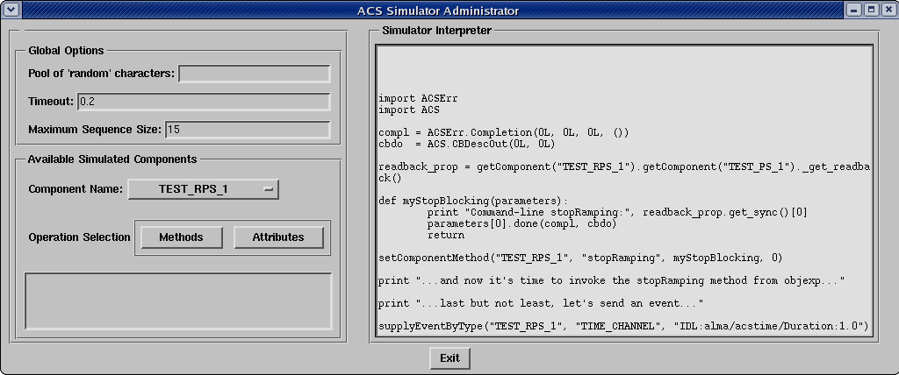

Special Notes:
- After defining functions, make sure you add one extra newline after the last line of your function.
- When defining functions to simulate component methods using the “setComponentMethod” API function; your function should only accept one parameter regardless of how many in/inout/out parameters the IDL method defines. This parameter corresponds to a list of the real parameters passed to the IDL component. To further illustrate this, see the stopRamping implementation above.
- After striking the “Enter” key, all characters on the current line are sent to the real Python interpreter to be evaluated.
- While you may be able to “Backspace” your way up to the previous line, this has no real effect.
- Messages from the real Python interpreter sent to stderr will end up in red text within the widget. Non-erroneous messages are sent to the real Python console as would occur normally.

The text entered into the Simulator Interpreter results in the following output from the real console:
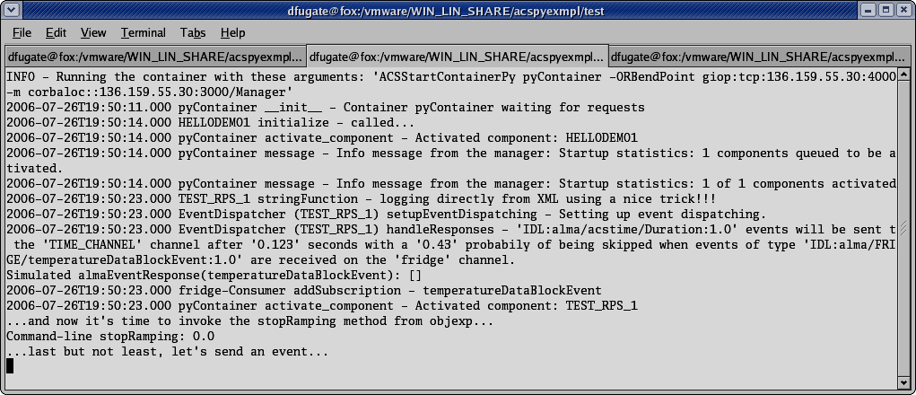

Using the GUI
The first time a simulated component is activated, a graphical user interface is automatically started which allows configuring the run-time behavior of simulated components in the same fashion as the API described previously. Once this GUI has been closed it cannot be restarted without restarting the Python container so be very careful about this.

Figure 1 – the main panel
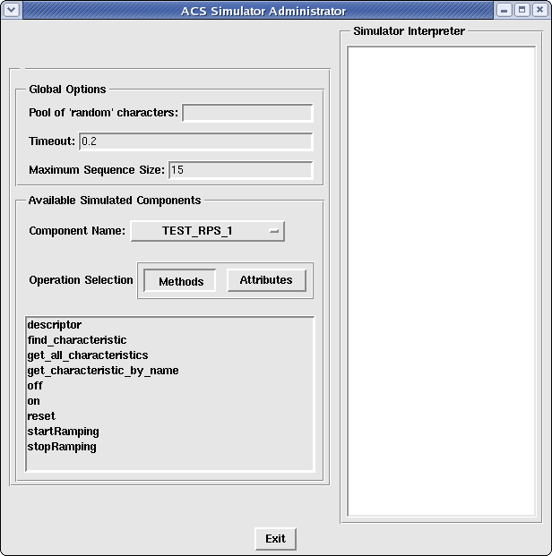

Figure 2 – panel created by clicking on the “stopRamping” text in the main GUI
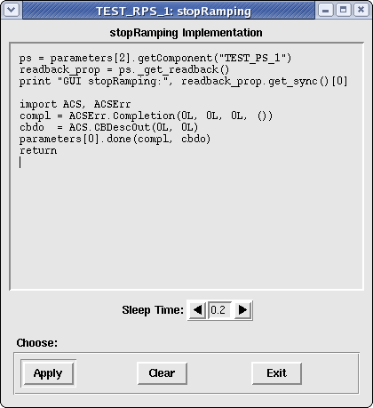
Then once you’ve finished implementing the method, simply click the “Apply” button!

Special Notes
Accessing Method Parameters
The in and inout parameters passed to simulated methods are accessible from the CDB, API, and GUI. They can be accessed via the parameters variable (a Python list) which is automatically placed in the proper namespace for the developers to use in the case of the CDB and GUI. As for the API, faux method implementations should always accept only a single parameter – parameters.
The ordering of parameters within this list is identical to that of the IDL->Python mapping. For example, say we are given an IDL method defined like this:
string methodA(in boolean x, inout long y, out double z)
In this case, parameters could be equal to [0, 34L, comp_ref] where 0 maps to the x boolean parameter and 34L maps to the y parameter, and comp_ref is a literal reference to the raw Python component being simulated (meaning you have direct access to it’s ContainerService methods). Under the IDL->Python mapping, z is omitted from the list of parameters.

Known Problems and Issues

None at the moment.
...

Appendix
RampedPowerSupply IDL Interface

PowerSupply IDL Interface

