Released by: | Signature:
Institute: | Date:

Keywords: ACS, Installation, Overview
Approved by: | Signature:
Institute: | Date:

Author Signature: | Date:

ALMA Common Software
Overview

6

Gianluca CHIOZZI
European Southern Observatory
Matej Šekoranja
Jozef Stefan Institute

Change Record
REVISION | DATE | AUTHOR | SECTIONS/PAGES AFFECTED
 | REMARKS
1.0 | 2001-09-24 | G.Chiozzi | All.
 | Document created from notes prepared by M. Šekoranja
1.0-Rev.1 | 2001-10-08 | G.Chiozzi | Added
Added section on Environment Variables.
Added minor details and fixed typos.
1.0-Rev.2 | 2001-10-23 | G.Chiozzi | First page
 | Replaced Advanced Common Software with ALMA Common Software
 | 2001-11-13 | G.Chiozzi | Sec. 2 and 3
 | Fixed a few typos.
1.0-Rev.3 | 2001-11-22 | B. Jeram | Sec. 2.3.8 and 2.3.9
 | Added information about ORB ports for maciActivator and maciManager
1.1 | 2002-04-05 | G.Chiozzi | All
 | Modified for ACS 1.1
1.1-Rev.1 | 2002-06-28 | G.Chiozzi | All
 | Updated with suggestions/feedback after first set of installations
2.0 | 2002-12-06 | G.Chiozzi | All
 | Updated for ACS 2.0
2.1 | 2003-06-09 | G.Chiozzi | All
 | Updated for ACS 2.1
2.1.1 | 2003-07-07 | G.Chiozzi | All
 | Updated environment variables section
3.0.0 | 2003-11-15 | G.Chiozzi | All
 | Updated for ACS 3.0
3.0.0.1 | 2003-12-29 | G.Chiozzi | All
 | Updated for ACS 3.0. Fixed errors.
3.0.1.0 | 2004-02-18 | G.Chiozzi | All
Updated for ACS 3.0.1 and according to comments from J.Schwarz.
Added captions.
Removed Alarm Display.
Added instructions to start LCU Containers.
3.1.0 | 2004-05-11 | M.Schilling | Sec. 2.2, 2.3, 3.2
 | Now mentions acsList, and general “–help” option. Adminc now outdated.
5.0.4 | 2006-07-24 | G.Chiozzi | Sec. 6
 | Updated ports usage information.
6 | 2012-05-22 | J. Schwarz
 | Revised for ACS 10.2
7 | 2014-05-15 | A. Caproni
 | Revised for ACS 2014.2

Table of Contents

1 Summary 4
References 4
2 Overview of ALMA Common Software 5
2.1 ACS Command Center 6
2.2 ACS Instance 7
2.3 ACS Startup 7
2.3.1 Start CORBA Services and Manager 7
2.3.2 Start any needed Container: 8
2.3.3 Start any client 8
2.4 ACS Shutdown 9
2.5 ACS Processes 9
2.5.1 acsStartContainer 9
2.5.2 acsStopContainer 10
2.5.3 acsStartManager 10
2.5.3.1 Resolving Manager reference algorithm 11
2.5.4 acsStopManager 11
2.5.5 acsStartJava 12
2.5.6 acsLogSvc 12
2.5.7 cdbjDAL 12
2.5.7.1 cdbjDAL command 12
2.5.7.2 cdbjDALClearCache command 13
2.5.7.3 cdbjDALShutdown command 13
2.5.7.4 cdbRead command 14
2.5.8 ACS daemons 15
2.5.9 CORBA Services 16
2.5.9.1 Naming Service (TAO) 16
2.5.9.2 Notify Service (TAO) 17
2.5.9.3 Interface Repository (TAO) 17
2.5.9.3.1 Feeding the Interface Repository 17
2.5.10 loggingClient 17
2.5.11 loggingService 18
2.5.11.1 Controlling logging behavior 19
2.5.12 Alarm system 20
3 ACS User Interface utilities 21
3.1 ACS Command Center 21
3.2 CDB Browser 21
3.3 cdbChecker 22
3.4 Logging User Interface (jlog) 22
3.5 logLevelPane 23
3.6 Object Explorer 24
3.7 Event Browser 26
4 Structure of the Configuration Database 27
4.1 Resolving the Configuration Database Reference 28
4.2 Database configuration files 28
4.2.1 Manager Configuration Database 28
4.2.1.1 Manager's own CDB branch 28
4.2.1.2 Component definitions for Manager 29
4.2.2 Container Configuration Database 30
4.2.2.1 Container's own CDB branch 30
4.2.2.2 Component’s definitions for Manager 30
4.2.3 Characteristic Component Configuration Database 30
4.2.4 Alarm system configuration 30
4.2.5 Configuration Database 31
5 ACS Environment Variables 32
5.1 Most Important environment variables 32
5.2 Other environment variables set in .bash_profile.acs and used by ACS: 33
5.3 Environment variables deprecated or not used any more: 35
6 TCP Port Allocation for ACS 35

Summary
This is a simple Overview of the ALMA Common Software (ACS) version 2014.2. Read it to get an idea of what is provided and how to get the system up and running. It is also useful to read this manual if you have been using any earlier version and are upgrading to 2014.2 or later.
This document is not intended to be an introduction to ACS features and concepts.
For details on ACS concepts, architecture and APIs look at the main ACS Web Page[1] or directly at the index page of the ACS Online Documentation[2] and pick the documents that most interest you. The ACS Web Page also contains some introductory papers presented at conferences; these provide an overview of ACS concepts.
References
All documents referenced here are available in the online ACS 8.2 documentation
- ACS Web Page: (http://www.eso.org/projects/alma/develop/acs)
- ACS Online Documentation: http://www.eso.org/projects/alma/develop/acs/OnlineDocs/index.html
- ACS Installation Manual
- ACS Configuration Database, CDB
- VLT Common Software - Installation Manual - VLT-MAN-ESO-17200-0642 v.1.14
- VLT Software - Tools for Automated Testing User Manual - VLT-MAN-ESO-17200-0908 v.1.5

Overview of ALMA Common Software
The following component diagram shows the processes running in a typical ACS session and the main relationships between them.
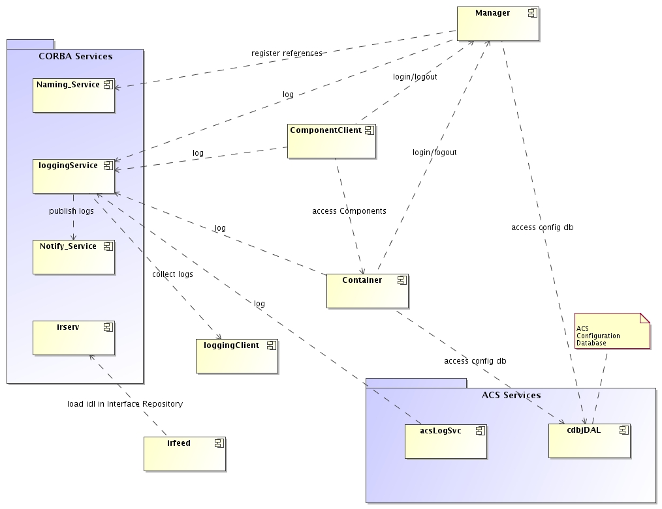
Figure 1- ACS Tasks Diagram. After the most basic start-up scenario for ACS has completed, the following processes will be operational: the Manager as we;; as all CORBA and ACS services (contained within the two blue rectangles). The container, component client and logging client shown in the figure will be started at the user's discretion. Note that most of the tasks shown here can run on one or more hosts, and that the real “meat” of an ACS-based system, the components, run within containers.
The following sections provide some introductory details on the functionality covered by these processes and ACS start-up/shutdown procedures.
In what follows, we assume that there will be one ACS Manager and all CORBA services running on the main Linux workstation. As of ACS 8.0, it became possible to use the ACS daemons to start CORBA services on arbitrary hosts, and since ACS 4.0, to federate different instances of ACS via ACS Manager federation (this latter facility has been tested, but not used regularly, while use of the daemons is routine in tests and early science operation at the ALMA OSF in Chile). There will be one C++ Container per LCU and possibly other Container processes on multiple workstations. ACS container daemons allow to start containers in any host.

ACS Command Center
ACS can be started, shutdown and administered from the ACS Command Center GUI.

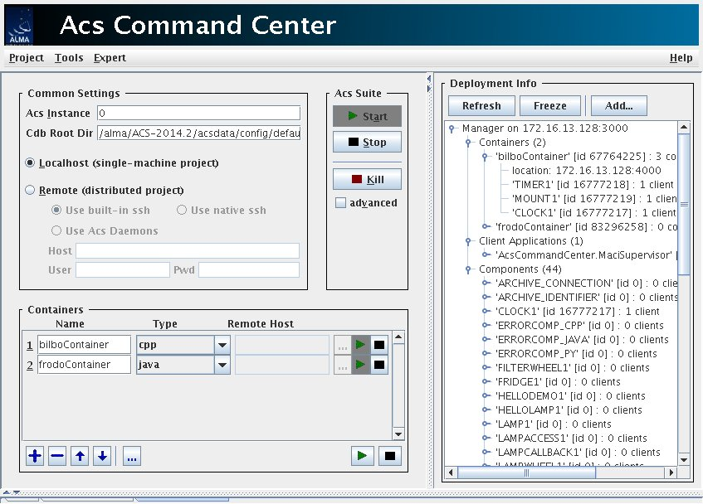
Figure 2- ACS Command Center
Through the Command Center you can start/stop ACS services, Manager and Containers as well as ACS tools like the Object Explorer. It also supports deploying ACS, components and containers on remote hosts.
To start the application type the following command:
> acscommandcenter [ARGUMENTS] [OPTIONS]
While the simplest way to use the command is without any arguments, once you have a configuration (customized Configuration Database, configured containers), it will be more convenient to save this configuration in a project file using the “Project” menu. By specifying the project file name on the command line, you will not have to enter the details of the configuration by hand every time you start the command center.
Starting the tool with –h switch shows the supported aurguments and options. A more detailed description of the command center's many features can be found at
http://www.eso.org/projects/alma/develop/acs/OnlineDocs/ACSCommandCenter/Acs_Command_Center_-_User_Guide.html

ACS Instance
In order to allow multiple users to work in completely separate sandboxes on the same machine, we have introduced the concept of “ACS Instance”
The environment variable ACS_INSTANCE can assume the values from 0 (default) to 9.
Based on this environment variable (and/or the –b <ACS_instance #> option for most ACS commands), ports used by ACS services and processes are automatically calculated according to the rules described in section 6.
Users selecting two different values for ACS_INSTANCE will work without interfering with one another. Which instances are currently used on a machine can be determined with the acsList command. When no ACS instance is running, acsList will simply return without any message. (For a list of options, issue the 'acsList -h' command.)

ACS Startup
As an alternative to the use of the command center, shell commands are available to start and stop ACS processes. Invoking most of these commands with -h or --help will provide usage information.
Before Containers can be started, ACS services and Manager must be active.

Start CORBA Services and Manager
> acsStart [-nowaitifr] [Other options]

Note that acsStart -h will display a complete list of this command's optional arguments.
The services started include the Interface Repository (IFR), logging (acsLogSvc), alarm and the Configuration Database server (cdbjDAL).
This command returns control when the services and Manager are up and running and the IFR has been fully loaded. Note that this last action may be quite time-consuming, e.g., in an ALMA configuration that includes all subsystems. To shorten the waiting time, the starting up of the IFR is done immediately so that it starts loading the IDLs in parallel to the starting up of the other services.

Besides that, the IFR uses a binary IDL cache ($ACS_TMP/<hostname>/ifr_cache) that will speed up IDL loading times during start-up, and is very useful when no IDL files have been changed since the preceding start-up of ACS. The existence of the cache file will cause the cache to be used at start-up (but see list of conditions that invalidate the cache below). When the cache has been used, you will find the log message
INFO [acsInterfaceRepository] Loading of IDL interfaces in Interface Repository is being skipped due to up-to-date persistence file.
This means that the loading from ASCII IDL files is being skipped, while the IFR loads all IDL data from the binary cached representation instead. In the following cases, the cache is not used
- The cache is automatically invalidated when any IDL file is newer than the cached data.
- Command ifrCacheInvalidate deletes the cache, needed when adding INTROOT directories, or removing IDL files, or adding IDL files with a file date older than the cache, or interrupting acsStart which leaves an incomplete IFR cache file behind, etc.
- acsdataClean also removes the cache.
The IFR isn’t usually needed until, immediately at startup, you are going to run the Object Explorer (objexp), so if you don't need objexp, you can often use the optional –nowaitfr flag to acsStart to speed start-up of ACS considerably (the IFR will be loaded as a background task).

Start any needed Container:

> acsStartContainer <-cpp|-java|-py> <Container name>This command starts a container with the given name. The first parameter is a switch to select the programming language of the container to start between C++, java and python.

Start any client
We suggest running each command in an independent window/xterm to be able to look at the output produced.
The command acsStart will try to start everything according to the value of the ACS_INSTANCE variable (0 by default). Since there can be only one ACS instance running for a given value of ACS_INSTANCE, if acsStart finds out that ACS processes are already running with the selected value, it will terminate with an error message asking the user to select a new instance.
Both acsStart and acsStartContainer, like most other ACS commands, accept the command line option:
-b <acs instance #>
This overrides the value of the ACS_INSTANCE environment variable.
acsStart waits for each service to start for a given amount of time. If the service did not started during that time, acsStart assumes that there has been an error and shuts down all the service. It should be noted that the time allowed for most of the ACS start-up commands to complete can be increased by increasing the value of the ACS_STARTUP_TIMEOUT_MULTIPLIER environment variable (an integer greater than 0). The same behavior can be duplicated by using the following command-line option available in most start-up and shutdown scripts:
-t <integer timeout multiplier value>
This overrides the value of ACS_STARTUP_TIMEOUT_MULTIPLIER.

ACS Shutdown
ACS processes can be stopped with the following commands:
- acsStop [-b <acs instance #>]
- killACS [-Q]
acsStop, gracefully terminates all the services and the containers. killACS will instead try to KILL all ACS processes in the host for all ACS_INSTANCE values and clean things up. The optional –Q parameter will kill ACS processes much more quickly but it will not kill all ACS clients. It is an (almost) last resort option to cleanup a host from dangling ACS processes. In very rare cases killACS might not be sufficient. The real last resort is to kill -9 the dangling processes/threads.

ACS Processes

acsStartContainer
The acsStartContainer command is used to start ACS containers for C++, Java or Python. To successfully resolve object interfaces (IDL IDs), C++ containers use the Interface Repository Service. In order to use BACI recovery, Container must use a dedicated ORB port (by default 3050 for C++, 3052 for Java, 3054 for Python and ACS_INSTANCE=0).
The ORB port can be changed using the command line option ––port or (for C++ Containers) the same option in the configuration database entry named Flags:
acsStartContainer [ ––port < 0-25 | precise port number > ]
< –cpp | -java | -py > <Container name>
If the Container is running on the same host as the ACS Manager and there are no other Containers running on the host, it is not necessary to pass any configuration parameters:
acsStartContainer < –cpp | -java | -py > <Container name>
If the Container runs on another host, the corbaloc for the reference to the manager shall be given on the command line or in the configuration database:
acsStartContainer
–m corbaloc::<manager_host>:<manager_port>/Manager
< –cpp | -java | -py > <Container name>

Manager reference is resolved using algorithm described in 2.5.3.1.
For information on the Container’s CDB data see section 4.2.2.
Other command-line options can be examined using the –h option.
Instructions on starting a Container under a VxWorks LCU are available in the following ACS FAQ:
http://almasw.hq.eso.org/almasw/bin/view/ACS/FAQVxWorksContainerStart

acsStopContainer
acsStopContainer is used to shut down one or more Containers whose reference is retrieved by name from the Manager. Wildcards can be used to specify the name of the Container(s) to be shutdown. To resolve the Manager’s reference, the algorithm described in section 2.5.3.1 is used:
acsStopContainer <Container name(s)>
[–m corbaloc::<computer address>:<manager_port>/Manager]
Other command-line options can be examined using the –h option.

acsStartManager
ACS provides a Manager implemented in Java that is automatically started by acsStart.
To start the Manager, run the command:
- acsStartManager
By default the Manager ties up TCP port 3000 (for ACS_INSTANCE=0). This can be changed by using the command-line option –:
–ORBEndpoint iiop://<host>:port
If –ORBEndpoint option is not specified from the command-line or in the configuration database and the environment variable MANAGER_REFERENCE is defined, then the port number is extracted from it. The environment variable is normally of the form:
corbaloc::<manager_host>:<port>/Manager
Manager uses the Naming Service to map activated Components and some special references (NameService, InterfaceRepository, Log, LogFactory, NotifyEventChannelFactory, ArchivingChannel, LoggingChannel). Since Manager is the central communication point, it is necessary that all applications retrieve the needed references through the Manager and not directly through the NameService.
acsStartManager [–ORBInitRef NameService=corbaloc::<ns_host>:
4000/NameService]
To minimize system configuration, Manager uses the following algorithm to resolve NameService references:
- Command-line corbaloc
- CDB option -ORBInitRef
- Environment variable NAMESERVICE_REFERENCE
- Using generated reference: corbaloc::<hostname>:<ns_port>/NameService
For information on the Manager’s CDB data see section 4.2. To see other command-line options for Manager, use the –h option.

Resolving Manager reference algorithm
ACS services and clients use the following algorithm to resolve Manager reference via the API function maci::MACIHelper::resolveManager():
- Command line option: -m or –managerReference
- Environment variable MANAGER_REFERENCE
- Using generated reference: corbaloc::<hostname>:<manager_port>/Manager

acsStopManager
acsStopManager is used to remotely shut down the Manager. To resolve Manager’s reference, the algorithm described in section 2.5.3.1 is used:
acsStopManager
[–m corbaloc::<computer address>:<manager_port>/Manager]
Other command-line options can be examined using the –h option.

acsStartJava
This script is used on Linux to execute any ACS Java application.
It automatically builds the $CLASSPATH environment variable locating all needed jar files and setting all Java properties used by ACS Java applications:
acsStartJava <java_class_name>
For example:
acsStartJava alma.acsabeans.examples.PSPanel.PSPanel
The option -vmtools provides a little visual toolbox to configure logging levels and system properties for the application
Other command-line options can be examined using the –h option.

acsLogSvc
This ACS process activates a logging IDL interface implementation that any CORBA-aware client can use to generate Log messages of the types specified in the ACS Logging and Archiving specifications without having to manually format the corresponding XML string. The acsStartORBSRVC script automatically executes this command.

cdbjDAL
This process provides the IDL DAL (Data Access Layer) interface to the ACS xml-based configuration database (CDB).

For more details, see section 4 and the Configuration Database manual [4].

cdbjDAL command
This command starts the Configuration Database service. The acsStartORBSRVC script automatically executes it.
The Configuration Database service uses the following algorithm to resolve the path of the directory where the CDB XML files are located:
- Command line option –root <path>
- Environment variable ACS_CDB
Once the path has been resolved, it expects to find CDB XML files in the CDB sub-directory.
When cdbjDAL is executed from within acsStartORBSRVC it is not possible to pass the –root option. Therefore the only real usable way of defining the path for the CDB files is using the environment variable ACS_CDB. The default value for this variable provided by the login scripts is $ACSDATA/defaultCDB, where the ACS installation procedure puts the standard sample CDB.
At run-time, the cdbjDAL service searches for schema definitions, in the given order, in the following directories:
CDBPATH= $ACS_CDB/CDB/schemas
$PWD/../config/CDB/schemas:
$INTROOT/config/CDB/schemas:
$ACSROOT/config/CDB/schemas
Other command line options:
-o <file> writes in the given file the IOR
-OAport specify a TCP port different from the default

cdbjDALClearCache command
This command requests the Configuration Database (jDAL implementation) to clear its internal cache and to notify applications (in particular the Manager) that updated data may be available.
Using this command, it becomes easy to modify the CDB and make the new values “active” without having to restart ACS processes:
- Edit the CDB XML files with a text editor
- Issue the cdbjDALClearCache command to notify the CDB
- The Manager gets automatically notified and updated and reloads its data from the CDB at the next request.

cdbjDALShutdown command
This command shuts down the Configuration Database service. The acsStopORBSRVC scripts executes this command.
Useful command line options:
-k corbaloc::<HOST>:<CDB_PORT>/CDB
Host and port where the cdbjDAL is running

cdbRead command
This command is a utility to directly dump DAOs from the Configuration database.
The calling syntax is:
cdbRead <DAO name> [-raw]
where <DAO name> is the hierarchical name of the DAO in the CDB, for example the command:
cdbRead MACI/Containers
on the default CDB would yield something similar to the following:
________________________________________________________
Node frodoContainer
xmlns:xsi="http://www.w3.org/2001/XMLSchema-instance"
xmlns="urn:schemas-cosylab-com:Container:1.0"
xmlns:log="urn:schemas-cosylab-com:LoggingConfig:1.0"
ImplLang="java"
Timeout="3.0E1"
UseIFR="true"
ManagerRetry="10"
DALtype="DAL"
ServerThreads="5"
Recovery="true"
Node LoggingConfig
minLogLevel="2"
minLogLevelLocal="2"
centralizedLogger="Log"
dispatchPacketSize="100"
immediateDispatchLevel="10"
flushPeriodSeconds="10"
maxLogQueueSize="1000"
maxLogsPerSecond="-1"
Node jacorb@frodoContainer
Name="jacorb@frodoContainer"
minLogLevel="5"
minLogLevelLocal="5"
flushPeriodSeconds="10"
maxLogQueueSize="1000"
maxLogsPerSecond="-1"
minLogLevelLocal="2"
________________________________________________________

cdbRead /alma/LAMP1
produces the output:
________________________________________________________
ode LAMP
xmlns="urn:schemas-cosylab-com:LAMP:1.0"
xmlns:baci="urn:schemas-cosylab-com:BACI:1.0"
xmlns:cdb="urn:schemas-cosylab-com:CDB:1.0"
xmlns:xsi="http://www.w3.org/2001/XMLSchema-instance"
recentCommand=""
recentTimeStamp=""
actionThreadStackSize="1024"
monitoringThreadStackSize="2048"
Node brightness
description="brightness"
units="%"
min_step="1.0"
min_value="0.0"
max_value="100"
min_delta_trig="0.0E1"
default_value="0.0E1"
graph_min="-1.7976931348623157E308"
graph_max="1.7976931348623157E308"
archive_delta="0.0E1"
archive_delta_percent="0.0E1"
format="%9.4f"
initialize_devio="false"
resolution="65535"
archive_suppress="false"
archive_mechanism="monitor_collector"
archive_priority="3"
archive_min_int="0.0E1"
archive_max_int="0.0E1"
default_timer_trig="1.0E0"
min_timer_trig="1.0E-3"
________________________________________________________

Other command line options:
-raw as last parameter after the DAO name, dumps the DAO as a raw XML file.
-k corbaloc::<HOST>:<CDB_PORT>/CDB
Host and port where the cdbjDAL is running

ACS daemons
ACS daemons helps deploying services and containers in several hosts. When the daemons are running in a given host, then it is possible to start ACS services and containers from the command line by invoking a IDL method on the daemon to ask for the activation or deactivation of a given service or container.
There are 2 daemons:
- acsservicesdaemon: to start/stop CORBA and ACS services
- acscontainersdaemon: to start/stop containers
Once you have started the daemons in the hosts, you can start acs with the following command:
acsdaemonStartAcs –i <instance> -H <host>
This command start ACS in the passed host and with the passed instance. To stop use acsdaemonStopAcs.
To start a container use:
acsdaemonStartContainer –i <instance> -H <host> -t <type> -c <name>
This starts a container with the given instance in the passed host. The type of the container must be passed py, cpp or java for instance; finally the name of the container to be started. Use acsdaemonStopContainer to terminate a remote container.
The linux commands we saw allows to start ACS services in a given, remote host. However, with the services daemons it is possible to deploy ACS services in different hosts given that a instance of the services daemon is running in each of the hosts. For example, to balance the load on the servers, it is possible to deploy the logging notify service in one host and the alarm service in another host. The deployment of services in different hosts can be done only programmatically in two steps: generate a configuration associating the services to the host and finally asking one of the available services daemon to start the service. This daemon will take care of contacting the daemons in the other serves and to start the services in the expected order.
ACS services daemons daemon check if the services they started are still running and restart them if they crashed in attempt to recover the system.
For further information about the daemons, we suggest to read ACS documentation.

CORBA Services
ACS uses a number of standard CORBA Services, which need to be started before any ACS specific process.
The script acsStart (or, more precisely, acsStartORBSRVC) and
acsStop (or, more precisely, acsStopORBSRVC) are used to start and stop one by one the CORBA Services, passing the necessary command-line parameters. All services are started on the local host and it is assumed that also the ACS Manager process will be started on the same host.
In particular, it is necessary to configure each service to run on a specific TCP port (see chapter 3) and to pass the -ORBDottedDecimalAddresses=1 option to allow communication with LCUs.
These scripts also start/stop the Logging Service (see 2.5.11), acsLogSvc, cdbjDAL, alarm service server.

Naming Service (TAO)
Naming_Service –ORBEndpoint iiop://<host>:<ns_port>
-ORBDottedDecimalAddresses=1

Notify Service (TAO)
TAO Notify Service requires Naming Service to run.
Notify_Service –ORBInitRef
NameService=corbaloc::<ns_host>:<ns_port>/NameService
–ORBEndpoint iiop://<host>:<notify_port>
-ORBDottedDecimalAddresses=1
Where <ns_host> is the host where the Names Service is running.

Interface Repository (TAO)
The Interface Repository does not automatically register its reference to the Naming Service. This is done by acsStart (acsInterfaceRepository to be more precise) during the startup by invoking the TAO nsadd tool ($ACS_ROOT/TAO/utils/nslist/nsadd):
$ACE_ROOT/TAO/orbsvcs/IFR_Service/IFR_Service -ORBEndpoint iiop://$HOST:$IR_PORT -p -b $PERSISTENCE_FILE -o $IR_IOR $ORBOPTS &

Feeding the Interface Repository
The interface repository needs to be given all ACS IDL interfaces. The generic command syntax is:
acsstartupLoadIFR
[-IRcorbaloc corbaloc::$HOST:$ACS_IR_PORT/InterfaceRepository] [-c]
When used as above, the acsstartupLoadIFR script will load (or check, if the -c switch is used) all IDL files found in the directories listed in the IDL_PATH environment variable.
The acsstartupLoadIFR command can also be used at any time (and in particular during development and debugging) to (re-)load specific IDL interfaces into the Interface Repository:
acsstartupLoadIFR <filename1>.idl, <filename2>.idl, ...

loggingClient
Logging client is a simple example of an application that attaches to the Notification Service, retrieves ACS Logs or Archive Monitors, and displays them on standard output. It is a structured push event consumer. For its operation the Naming Service is queried to resolve references of notify channels. The current implementation has the capability of monitoring the Logging and Archiving channels.
loggingClient LoggingChannel
–ORBInitRef NameService=corbaloc::<ns_host>:
<ns_port>/NameService
or
loggingClient ArchivingChannel
–ORBInitRef NameService=corbaloc::<ns_host>:
<ns_port>/NameService
It is often convenient to redirect the output to store the logs in a file.

loggingService
The loggingService activates Telecom Logging Service Log and LogFactory interfaces and creates the LoggingChannel (with domain_name=Logging). All these objects are registered with the Naming Service and are accessible via Manager using get_service() method.
loggingService requires Naming Service and Notify Service to run.
Running loggingService:
loggingService
–ORBInitRef NameService=corbaloc::<ns_host>:
<ns_port>/NameService
-ORBDottedDecimalAddresses=1
–ORBInitRef NotifyEventChannelFactory=corbaloc::
<notify_host>:<notify_port>/ NotifyEventChannelFactory

where <notify_host> is the host where the Notification Service Event Channel Factory is running.
Specifying -ORBInitRef NotifyEventChannelFactory option is optional. NotifyEventChannelFactory reference is obtained from the Name Service, but -ORBInitRef has higher priority then NS lookup, algorithm:
1. resolve_initial_references
2. Name Service lookup
For more detailed information about logging and archiving, see the Logging and Archiving specification.
Notice that logs are published on the Notification Channel as XML strings.
If no application (such as loggingClient) listens to the Notification Channel, the logs are lost.

Controlling logging behavior
The logging system uses as much as possible the standard Logging APIs of C++, Java and python.
Each log has one of the 10 possible priorities. The logs generated by ACS components and tools are published into the logging notification channel and in the standard output. To limit the amount of logs sent in the NC or written in the standout it is possible to configure the log level of components and container. This can be done by setting the proper tag in the configuration database. The logLevelGUI allows to change the levels at run time and it is very useful for example when a component is misbehaving to see the debug logs that are normally disabled.
ACS jlog (see section 3.4) connects to the logging notification channel and shows the logs produced at run time in a sortable table. The tool has several features being the filtering one of them. Jlog can also be used to read XML file of logs for offline debugging and investigation.
See the ACS Logging System documents for further details.
C++ Logging System
The C++ Logging system is based on the ACE Logging API.
Several macros are defined in $ACSROOT/include/logging.h to make message logging simpler for user applications. All messages which are logged using the logging macros are sent to the ACS loggingService except when the application is unable to connect to the loggingService (for example, if the loggingService is not running). In this case, log messages are sent to a local text file. Each process/thread writes its own logging text file by appending its process name and PID to a standard root.
By default, the standard root name is:
$ACSDATA/tmp/<host>/ACS_INSTANCE_n/acs_local_log_
For example, ACS Manager would write a file like:
$ACSDATA/tmp/<host>/ACS_INSTANCE_n/acs_local_log_maciManager_12345
It is possible to change the default destination for ALL ACS temporary files by setting the environment variable $ACS_TMP.
It is possible to change the root name for logging files by setting the environment variable $ACS_LOG_FILE. If $ACS_LOG_FILE is set, $ACS_TMP is ignored.
The environment variable ACS_LOG_STDOUT can be used to control the amount of information sent to stdout at a per-process level. By default, only log messages with priority equal or higher than LM_INFO are sent to stdout. If ACS_LOG_STDOUT>0, all log messages with priority >= ACS_LOG_STDOUT are also sent to stdout.
The C++ logging system caches log messages on a per-process basis before transmitting them to the centralized logging service. Several configuration database parameters control whether messages are to be logged at all, which messages should be cached locally, and which messages should be transferred immediately to the logging service (or the local log file):
- Messages with a priority less than MinCachePriority are not logged at all. Manager and Container provide a CDB point with this characteristic (see sections 4.2.1 and 4.2.2). By default, MinCachePriority is set to zero so that all messages are logged.
- Messages with a priority greater than MinCachePriority but less than or equal to MaxCachePriority are cached locally. When the cache fills up, all cached messages are transferred to the logging service.
- Messages with a priority greater than MaxCachePriority are logged immediately, bypassing the cache.
- The cache size for Manager and Container can be controlled in their CDB definition using the CacheSize characteristic (see sections 4.2.1 and 4.2.2). If CacheSize is set to 0 or 1, all messages (except those with priority less than MinCachePriority ) are logged immediately without caching.

For more information, look at the online documentation for the LoggingProxy class.
This is the class used by applications to interact with the loggingService.
Java Logging System
The ACS Java Logging API is based on the official JSDK Java Logging java.util.logging and it has been integrated with the implementation of the CORBA Telecom Logging Service and the rest of the ACS.
Python logging system.
The ACS python logging is based on the official python Logging and it has been integrated with the implementation of the CORBA Telecom Logging Service and the rest of ACS.

Alarm system
There are two implementations of the alarm system available in ACS: the simplest converts each alarm into a log of the proper level that can be seen by the operators with the logging client. The second implementation is based on the Alarm System developed at CERN for the Large Hadron Collider. The type of alarm system to use is defined in the configuration database.
The alarm system is the last service started by acsStartORBSRVC. Sources of alarms send a alarm to the alarm service through a notification channel or, in special caes, directly invoking a IDL method of the service. ACS has a dedicated API for sending alarms in C++, java and python.
The CERN implementation of the alarm service, checks each alarm against a set of reduction rules defined in the configuration database and the set of active alarms. The reduction rules allows the alarm service to define if a alarm is the root cause of a cascade of alarms. The purpose is to show to the operators the alarms that is the cause of a problem, masking out the other alarms. The alarmPanel is used to show alarms to the operators: The alarmPanel is used to browse the alarms.
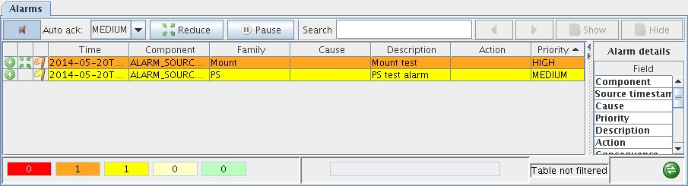
Figure 3 The alarm panel.
There are 4 available priorities for the alarms. The panel sorts the alarms depending on their priorities and time of arrival. A basic filtering is also available.
For further details, read the ACS alarm system documentation.

ACS User Interface utilities
ACS provides some generic GUIs to administer and interact with a running system.
Each of these applications is described in detail in a specific user manual.

ACS Command Center
Used to startup/shutdown and administer ACS. Already described briefly in section 2.1

CDB Browser
This application is used to browse and modify the run-time configuration database. It needs a running ACS instance to connect to and shows the content of the configuration database by means oftable or a XML struct.
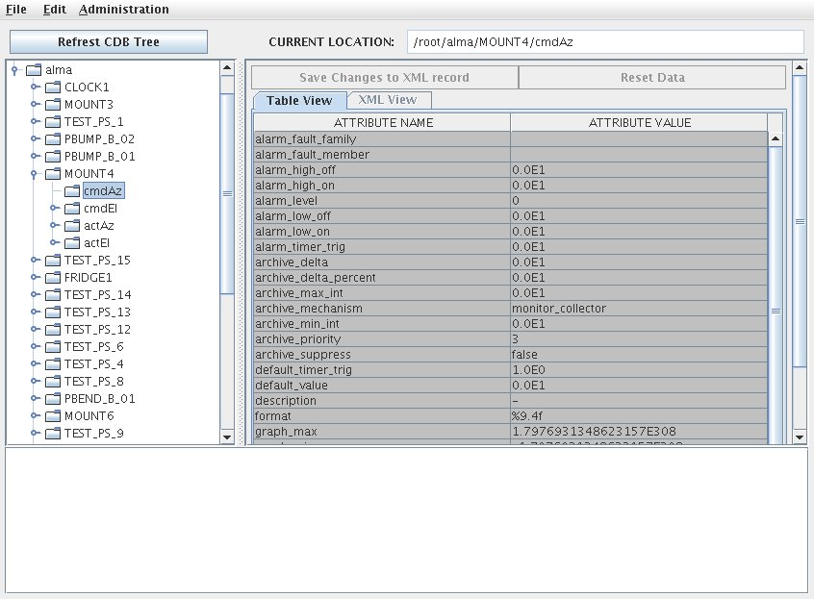
Figure 4- CDB Browser

cdbChecker
This command, which can be run even when ACS has not been started, will check the XML files in the Configuration Database (CDB) for a) correct XML syntax; and b) for conformity to the defining XML Schema for each document (if any). The command-line syntax is:
cdbChecker [-v] [path to CDB XML files] [path to CDB XSD files]
When run without arguments, cdbChcecker will assume that the CDB referred to has its root directory at $ACS_CDB/CDB. The -v (verbose) option provides details about the checking process.

Logging User Interface (jlog)
This application is used to display logging system messages.
You can run it with the command:
> jlog
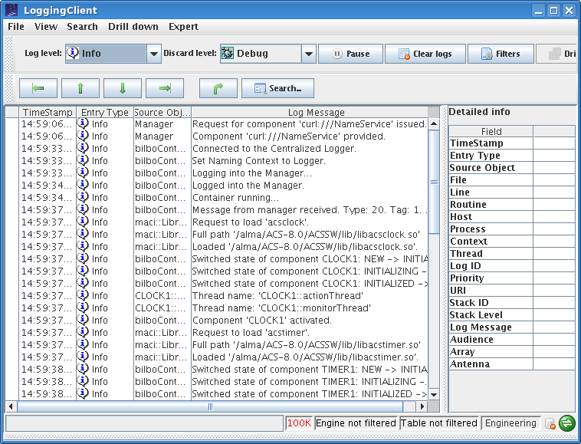
Figure 5- Logging GUI
Jlog shows the logs it reads from the lgging notification manual in the table in the lefts side. The details of a selected log are displaied in the right side of the pnale.
Jlog allows to set filters to show or hide the logs to display in the table. Filters can be defined on each field of a log and can be set to accept or reject logs that matches with the given filter. Filters can be saved to be reused between different instance of jlog,
To deal with the large number of logs possibly produced at run-time, jlog allows to set filters to get rid of the logs at the level of the notification channel i.e. before they are digested by the tool; this is what we called engine filters. To give the user time to read the logs, the content of the table is refreshed approximately every 2 seconds and a pause button freezes the content of the table until it is deselected.
Read the Logging client manual for a detailed description of this tool.

logLevelPane
The log level panel allows to change the levels of the local (stdout) and global (logging notification channel) at run time.

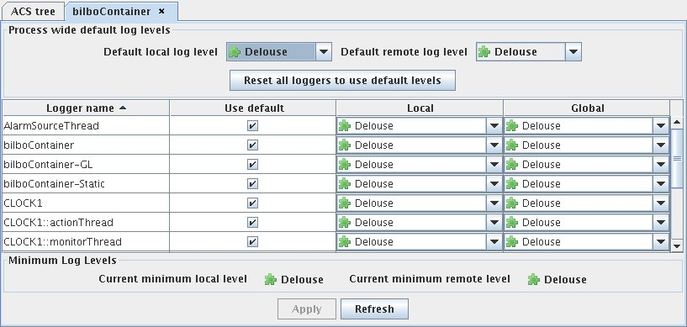
Figure 6 The panel to set the level of local and global log
The panel offers, for each named logger, a dropbox to select the desired level of logs. All the logs having a priority less then the priority selected with this panel will be discarded.
This panel is specially useful when something strange is happening in the system to increase the level of the log of the components, manager, services or containers without restarting the system.

Object Explorer
This application is used to navigate through the hierarchy of Components in the system. It allows you to call each method, get/set Properties and view Characteristics, install monitors, and draw trend plots.
You can run it with the command:
> objexp

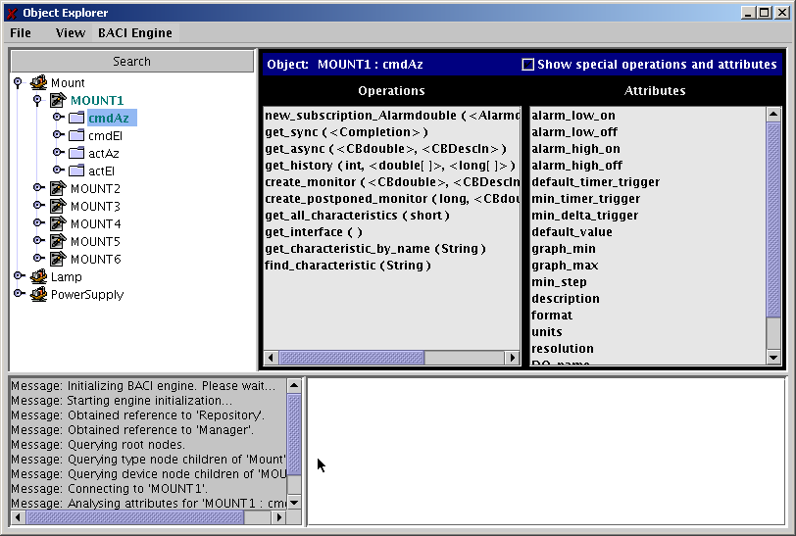
Figure 7- Object Explorer
A trend panel is available for a given property by selecting the create monitor method. Once selected in which axe to display values and times, the trend is plotted in the panel. Destroy monitor must be selected when done with the panel.
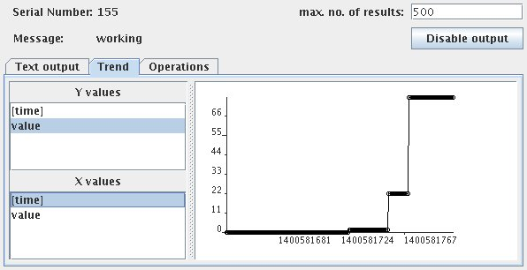
Figure Property Monitor trend plot.
The objexp command-line accepts all options and Java virtual machine parameters that can be passed to the acsStartJava command.
In particular you can pass the JVM option -Dobjexp.pool_timeout=<time in ms> to set DSI pool timeout, that by default is 5000ms.
For example the following command line:
objexp -m corbaloc::te98:3000/Manager -Dobjexp.pool_timeout=60000
will configure the Object Explorer to wait 60 seconds before assuming that a timeout is occurred and to connect to the Manager explicitly specified on the command-line.

Event Browser
eventGUI, is a browser designed to monitor all events on one or more of the ACS event channels. It is a eclipse RCP application that replace the old event broser written in python; it can be run once the Manager is online by:
- typing eventGUI on the command line.
- by clicking the “Event Browser (modern)” option in the Tools menu of acscommandcenter.
This GUI shows the available notify services and their channels. For each channel it is possible to see the number of subscribers and publishers ans follow the flow of items published at run time.
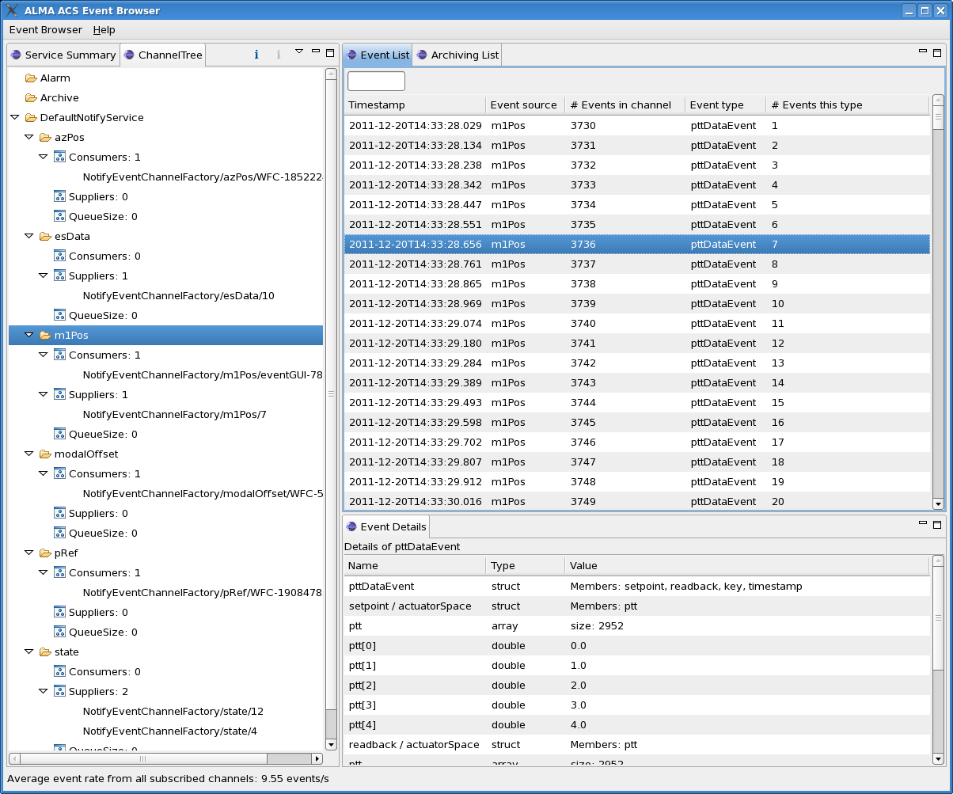
Figure 8 – ACS eventGUI. The left-hand panel displays Notify Service instances, their channels, the number of consumers and suppliers on each channel, and other information concerning the state of the channel. Channels can be subscribed to/unsubscribed from a channel by right-clicking on the channel name and selecting the appropriate option.

Structure of the Configuration Database
This structure describe the structure and syntax of the XML implementation of the configuration database. For more information on the Configuration Database syntax, look at the ACS Configuration Database manual[4]. For the structor of the relational implementation, the TMCDB, look at the tables contained in the cdb_rdb module.

Resolving the Configuration Database Reference
ACS applications (like acsStartContainer) use the following algorithm to resolve the DAL reference:
- Command line option –d or -DALReference
- Environment variable DAL_REFERENCE
- Using generated reference: corbaloc::<hostname>:<dal_port>/CDB

Database configuration files
Each Configuration Database is defined by a set of XML ASCII files in the directory:
$ACS_CDB/CDB

A standard configuration database contains four sub-directories:
alma – This directory contains configuration data for Components in the ALMA system, if they actually have configuration stores in the CDB. CharacteristicComponents ALWAYS have configuration data, but simple Components do not require having any data in the CDB..
MACI – This directory contains configuration data for MACI Manager, Containers and the Components’ main configuration file used by ACS Manager to map Component names into their implementation and the Container responsible for them.
schemas – This directory contains schema files used to resolve default values and inheritance in CDB DAO instances. Each DAO instance in the Configuration Database is represented by an XML file and shall be an instance of an XML Schema file in the schemas directory or in the config/CDB/schemas sub-directory of $INTROOT or $ACSROOT. When the cdbjDAL server gets a request for a DAO, the XML parser uses the corresponding XML Schemas to expand the complete structure of the DAO.
Alarms – This directory contains configuration data for the alarm system: the type of alarm system in use, categories, alarms and reduction rules. This folder can be omitted. In that case the ACS implementation of the alarm service will be used.

Manager Configuration Database

Manager's own CDB branch
The Configuration Database for the Manager is in the database branch:
/MACI/Managers/Manager
The definition of the configuration parameters for the Manager is in the schema file:
$ACSROOT/config/CDB/schemas/Manager.xsd
Important parameters are:
- Startup: List of Components to be automatically activated when the container, where they are supposed to run, starts
- LoggingConfig: allows to configure the logging generated by the Manager.

Component definitions for Manager
For each Component in the system, the Manager must be able to find on request all information needed to return its reference to clients and to start/stop it when commanded.
Therefore, the Configuration Database used by the Manager must also contain the file:
/MACI/Components/Components.xml
The definition of the Components configuration file is in the schema file:
$ACSROOT/config/CDB/schemas/Components.xsd
This consists of a table with one record per each known Component, like in the following example:
<_ Name="PBEND_B_01"
Code="acsexmplPowerSupplyImpl"
Type="IDL:alma/PS/PowerSupply:1.0"
Container="bilboContainer"
ImplLang=”cpp”/>
Five attributes must be defined for each of these instances:
- Name: the name of the component
- Code: the code of the component (for C++ is a dll; for java is the name of the class)
- Type: the IDL interface of the component
- Container: the name of the container where the component has to be activated
- ImplLang: implementation language of the component (it can be one between cpp, java, py)

Changing this information allows relocating Components and replacing versions without having to stop and recompile the system.

Container Configuration Database

Container's own CDB branch
The Configuration Database for a C++ Container is in the database branch:
/MACI/Containers/<Container name>/<Container name>.xml
The CDB entry for a container is optional (defaults are used if not present .
The definition of the configuration parameters for the a container is in schema file:
$ACSROOT/config/CDB/schemas/Container.xsd
Important parameters are:
- Autoload: DLLs to be loaded automatically on Container start-up (only C++ containers)
- LoggingConfig: configuration of the logging
- ImplLang: implementation language of the container
- Flags: optional command line flags for starting the container

Component’s definitions for Manager
Whenever the Manager requests a Container for a Component, it passes to it information about the DLL or class to be loaded and run.

Characteristic Component Configuration Database
Characteristic Components, i.e. Components implemented according to the BACI Design Patterns, keep the configuration for their Properties and Characteristics in the CDB.
Each Characteristic Component looks for its configuration information in the database branch:
/alma/<Component name>/<Component name>.xml
The actual structure of the database depends on the type of Component, but will essentially contain characteristics for each Property as defined in $ACSROOT/config/CDB/schemas/BACI.xsd

Alarm system configuration
Alarm system configuration is located in 2 folders:
- /Alarms/Administrative
- /Alarms/AlarmDefinitions
The former allows to chose which alarm type to use, define the Categories and the Reduction Rules. The latter is where the documentation of each alarms is configured.
If /Alarms does not exist then the ACS implementation of the alarm system is started.
The type of alarm system to use is selcetd by setting the Implementation property in
/Alarms/Administrative/AlarmSystemConfiguration/
AlarmSystemConfiguration.xml

If the property is set to CERN the the CERN implementation of the alarm services is started; in all other cases the default alarm services is the ACS implementation based on logs. With the ACS implementation, the alarm definitions under /Alarms are ignored.
Each alarm published by a source is identified by a triplet composed of fault family, a fault member and a fault caode. The fault family groups all the alarms of the same type; the fault member identify which member of the groups is actually sending the alarms; the fault code specify which type of alarms is the member publishing.
As an example, think of power supplies in ALMA: each antenna has a power supply and each power supply can send different type of alarms (for example, over temperature, fire and so on). In this example the fault family would be “power supply” and groups all the power supply devices in all the ALMA antennas; the fault member would be the name of the antenna where the failing power supply is located; the fault code would be 0 for over temperature, 1 for fire and so.
The configuration of the CDB for the alarms depends on this definition of triplets for defining the Catgories, the fault family, members, codes and reduction rules. A complete and detailed description of the CDB configuration, functioning of the ACS alarm system and the API for C++, python and java is out of the scope of this document but it can be found in the Alarm System documentation.

Configuration Database
After the installation of ACS, the directory
$ACSDATA/config/defaultCDB:
will contain a sample configuration database.
This is the configuration database that is used by default when ACS is started.
This database declares a number of Component instances that are defined in the ACS example module acsexmpl as well as the Java and Python example modules (jcontexmpl and acspyexmpl).
These Components are provided as examples for the users of ACS and for testing ACS.
We suggest that you make a backup copy of defaultCDB and modify your own copy. It is also a good practice to create new Configuration Databases for specific applications, assigning them explicit names, like corrCDB, instead of using defaultCDB all the time.
But do NOT forget to export the environment variable ACS_CDB to point to the configuration database instance you want to use before starting ACS.

ACS Environment Variables
The configuration of ACS is determined by a number of environment variables.
Generally, these variables are set to a proper default value by the default login script whose template is available in $ACSROOT/config/.acs/.bash_profile.acs. Each user has to take care of copying this script into his home directory (typically in the .acs directory), eventually adapting it and executing it to prepare the environment.
Some variables have been already described in the previous sections, but we give below a list of the most interesting ones.

Most Important environment variables
ACS_CDB (default: $ACSDATA/config/defaultCDB)
Location of the configuration database files to be used when cdbjDAL is started.
ACSDATA (default: /alma/ACS-<version>/acsdata)
The root directory where all ACS configuration files (including Configuration Database files) are stored.
ACS_INSTANCE
If unset, 0 is assumed; it can be any integer between 0 and 9 and is used to run different instances of ACS; For a better discussion see 6.
ACS_LOG_FILE ($ACSDATA/tmp/<host>/acs_local_log_, when not set)
Location and root file name for ACS log files. Each process/thread generates a unique file name by appending process name and PID to the root file name. See section 2.5.11.1.
ACS_LOG_STDOUT
Control the amount of information sent to stdout.
By default, only LM_INFO log messages are sent to stdout.
See section 2.5.11.1.
ACS_NAME_SERVICE (default not set):
CORBA Initial Reference for the Naming Service.
Usually the reference of the Manage is sufficient for applications.
ACSROOT
The place where ACS modules are installed. This is typically: /alma/ACS-<version>/ACSSW
ACS_STARTUP_TIMEOUT_MULTIPLIER
An integer value used to increase the amount of time ACS startup scripts are given to execute. For example, setting this value to “3” would effectively triple the amount of time the acsStart script has to finish before exiting abnormally.
ACS_TMP ($ACSDATA/tmp/<host>/)
The path where all ACS temporary files are written.
ALMASW_RELEASE
The current ACS release. This is ACS-<version>.
This is (together with ALMASW_ROOTDIR) the main variable used to derive all other environment variables; for example, ACSROOT is built as: $ALMASW_ROOTDIR/$ALMASW_RELEASE/ACSSW. Users can overwrite the default value to switch between different versions of ACS.
ALMASW_ROOTDIR
The root directory for all ALMA ACS software components and all releases.
This is (together with ALMASW_RELEASE) the main variable used to derive all other environment variables.
By default it points to /alma.
INTROOT
The integration area where user software is installed.
Typically each user has their own integration area.
See the ACS Installation Manual[3] for details. If you want to use a INTROOT remember to define this variable before sourcing the ACS bash profile.
INTLIST
A ordered set of integration areas where to install patches.
MANAGER_REFERENCE
CORBA Reference for the MACI.
NAMESERVICE_REFERENCE
CORBA Reference for the Naming.

Other environment variables set in .bash_profile.acs and used by ACS:
CLASSPATH
form: <JARFILE01>:<JARFILE02>:<JARFILE03>; used by Java runtime and compile time; Tells Java where to look for Java class files
JAVA_HOME
form: <DIRECTORY>; used by Java tools; Tells Java/Java tools where to find the Java installation currently being used.
ACE_ROOT
form: <DIRECTORY:$ACE_ROOT_DIR/linux>; used byACS environment initialization; this tells where ACE is installed (used by ACE)
ACE_ROOT_DIR
form: <DIRECTORY>; used by ACS environment initialization; ACS environment variable which tells where the various architecture specific versions of the ACE wrappers can be found
ALMASW_INSTDIR
form: <DIRECTORY:$ALMASW_ROOTDIR/$ALMASW_RELEASE>; used by ACS environment initialization; tells where ALMA subsystems are installed.
ANT_HOME
form <DIRECTORY>; used by ACS make system; tells where the ANT make system can be found
OMNI_ROOT
form: <DIRECTORY>; used by ACS make system; tells where OmniOrb is installed.
OMNIORB_CONFIG
form: <DIRECTORY:$OMNI_ROOT/config>; used by OmniOrb; tells where the configuration files for OmniOrb are found.
IDL_PATH
form: -I<DIRECTORY> -I<DIRECTORY> -I<DIRECTORY>; used by ACS make system; Where to find IDL files.
JACORB_HOME
form: <DIRECTORY>; used by ACS make system; Where JacOrb is installed.
PYTHON_ROOT
form: <DIRECTORY>; used by ACS make system; Where Python is installed
PYTHONPATH
form: <DIRECTORY01>:<DIRECTORY02>:<DIRECTORY03>; used by Python tools; Where Python source files can be found
DDSHOME
Form <DIRECTORY>; poin to the installation folder of DDS
RTAI_HOME
Form <Directory>; point to the installation of the real time
GNU_ROOT
form: <DIRECTORY>; Where ACS shipped GNU tools are found.
TCLTK_ROOT
form: <DIRECTORY>; used by ACS make system; Where ACS shipped TCL/Tk
LD_LIBRARY_PATH
form: <DIRECTORY01>:<DIRECTORY02>:<DIRECTORY03>; used by dynamic loader, ACS containers; Specifies where share libraries can be found.
PATH
form: <DIRECTORY01>:<DIRECTORY02>:<DIRECTORY03>; used by Unix shells, ACS make system; Specifies where binaries can be found for shell & makefiles

Environment variables deprecated or not used any more:
- CMM_HOST
- VLTDATA
- VLTROOT
- RTAPENV

TCP Port Allocation for ACS
All TAO CORBA Services can locate themselves using the TAO Multicast mechanism. This is a very useful feature, but it is not a CORBA standard and it is not usable with multiple services, e.g., more than one Naming Service.
ACS uses a port allocation scheme and API functions are available in C++, Java, Python and Bash shell to retrieve/calculate the port of each ACS service.
See also: http://almasw.hq.eso.org/almasw/bin/view/ACS/AcsPortsAllocation for more details and for a discussions.
In order to allow multiple users to work in completely separate sandboxes on the same machine, we have introduced the concept of “ACS Instance”
The environment variable ACS_INSTANCE can assume the values from 0 (default) to 9.
Based on this environment variable (and/or the –b <ACS_instance #> option for most ACS commands) ports are calculated according to the following formula:
<service port> = 3000 + 100 * ACS_INSTANCE + <offset>
ACS_INSTANCE=0 is treated in a special way for what concerns ports used by Containers: The whole range from 4000 to 4999 is allocated to this purpose. This is done to allow the ACS_INSTANCE=0, to be used in operations and for larger test setups, to handle many more Containers and services than basic developer’s configurations.
Service | offset
Standard Manager | 0
CORBA Services | Range 1 to 10
Naming Service | 1
Notify Service | 2
Logging Service | 3
Interface repository | 4
(Logging) notification service | 5
(BACI monitor archiving notification service | 6
ACS Extended Services | Range 11 to 20
ACS Log Service | 11
Configuration Database | 12
Alarm service | 13
ACS Containers | Range 4000 to 4999 for ACS_INSTANCE==0, 50-98 inside range for other values of ACS_INSTANCE (even numbers only)

If the Container port passed to a Container startup command is smaller or equal to 24 it is considered an offset in the range of the instance. If it is greater than 24, the TCP port is used as provided.

In the case that more than one Manager is running in the system (i.e., the Managers are federated), the string “Manager” should be replaced by a unique name for the federated instance of the Manager.

