# mDAB_2 plugged to mDOM_mainboard Rev.3

## Programming using ISE Impact

For some reason, at least this is my experience, ISE impact is not recognizing the standard Xilinx programmer ”Platform Cable USB II”, while the Digilent JTAG -SMT-3 worked always. Check the lower left of the ISE Impact window. There should be visible:

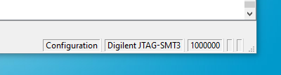

If not use the menu: Output/Cable Auto Connect

### Programming with ICM and mDAB being plugged

See above, the jumpers J6, J5 and J13 must be unset. First, run the following command sequence:

wp_on.py

icm_fpga_reboot.py -w 7 -i 2

lid_enable.py

./enable_calibration_power.py

Run ISE, start the Impact programmer from Menu / Tools. Do a boundary scan first. With right mouse click in the device field do “Initialize Chain”. You might be enforced to do Edit/Add Device. ISE does not know Spartan7 FPGAs ( while Vivado does not know, how to program CPLDs, unfortunately). Using impact to generated a .bsd file for the mainboard FPGA as a workaround. Use right mouse click on the device icon to assign / program /../ files.

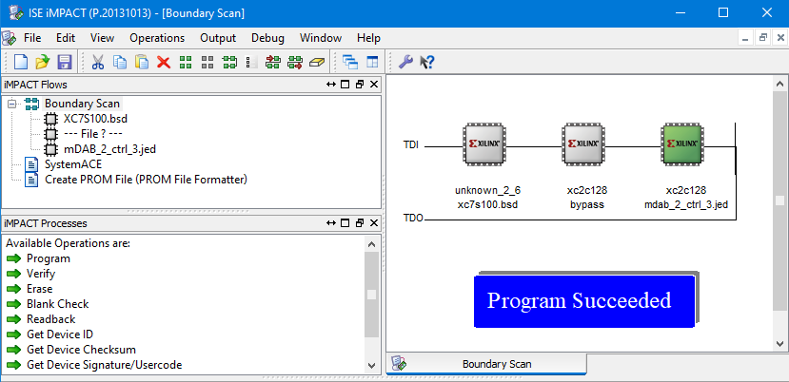

mb_FPGA

mb_CPLD

mDAB_CPLD