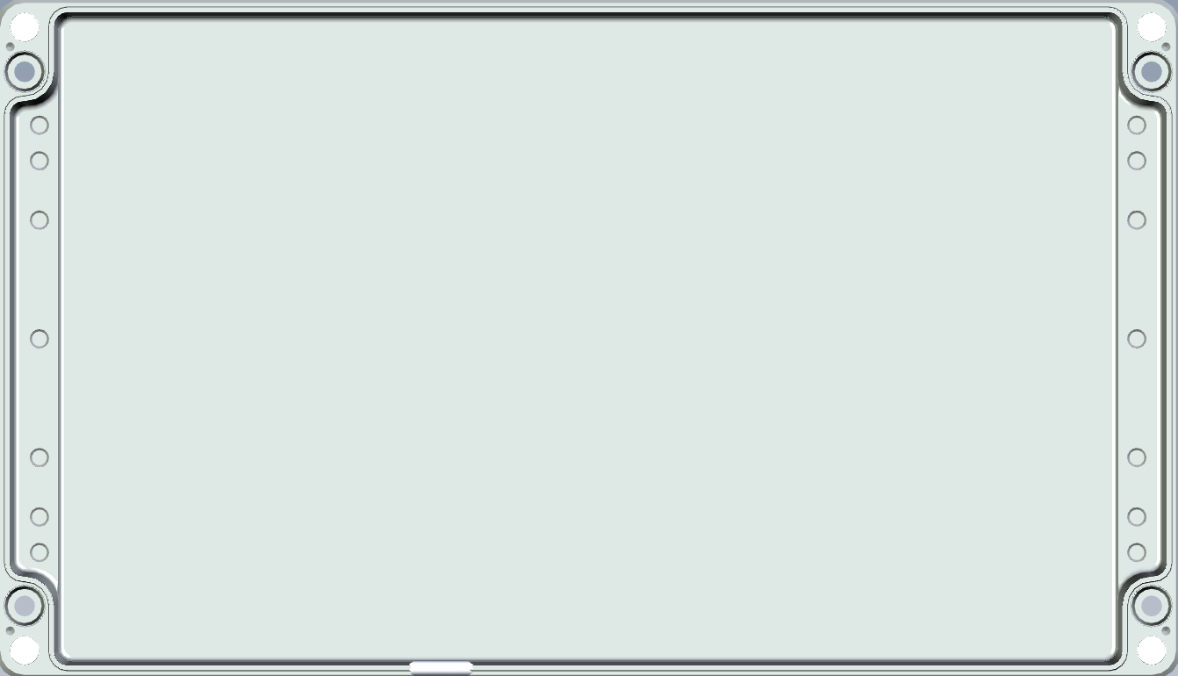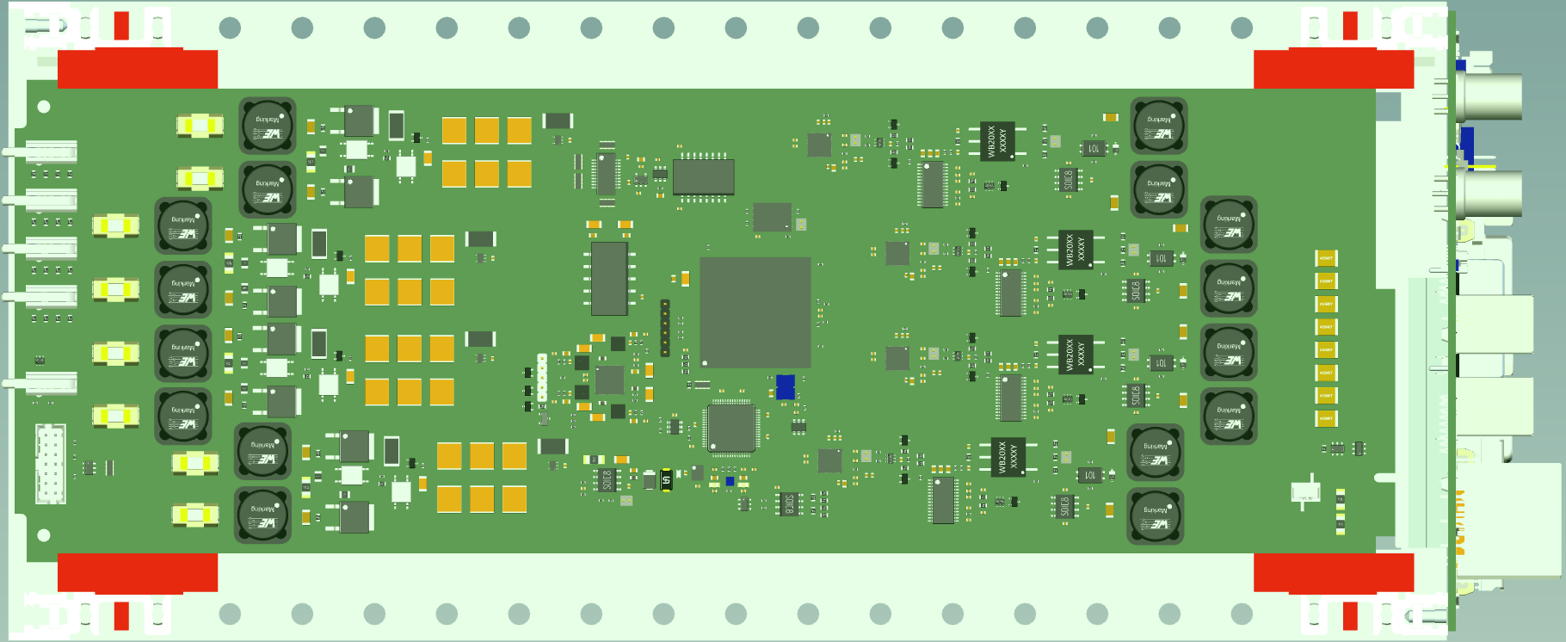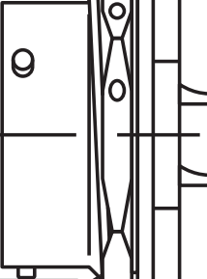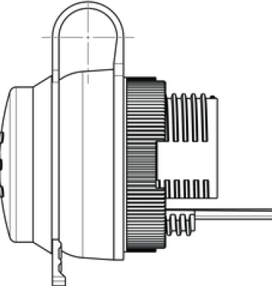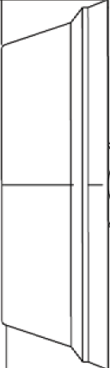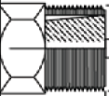

SpoolHub, Top View, scale 1:2, version #2, 2x2 quad conns. vertically aligned

RevPI 4

Quad#1,2

Quad#3,4

PARO

96Vin

PT02E-14-12S
PT02E-14-5S
PT02E-14-5P
Ethernet

Tango 23
WLAN antenna
Weidmuller 1018790000

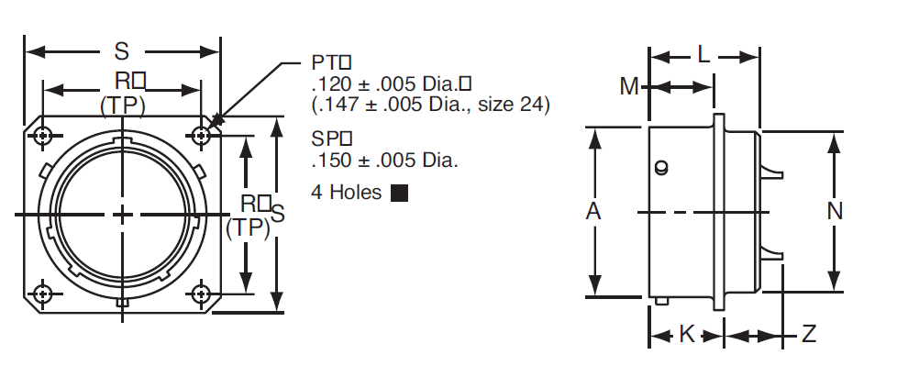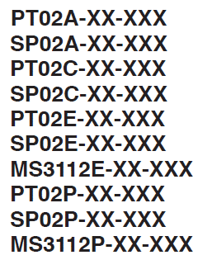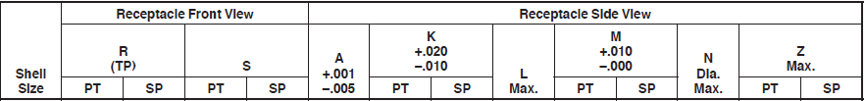

MIL-Spec Connectors, 14”, Box Mounting
mm | 23,01 | 26,19 | 28,58 | 34,14 | 22,26 | 12,52 | 13,31 | 20,96 | 10,95 | 11,74 | 20,91 | 11,82 | 11,13

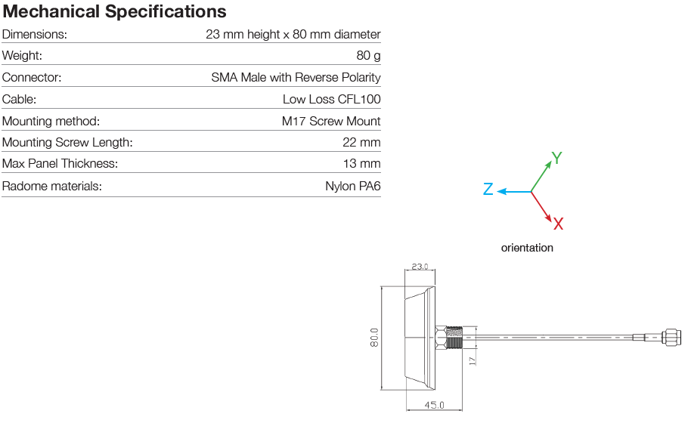

Antenna Tango 23

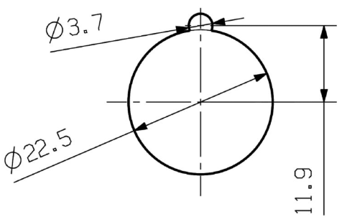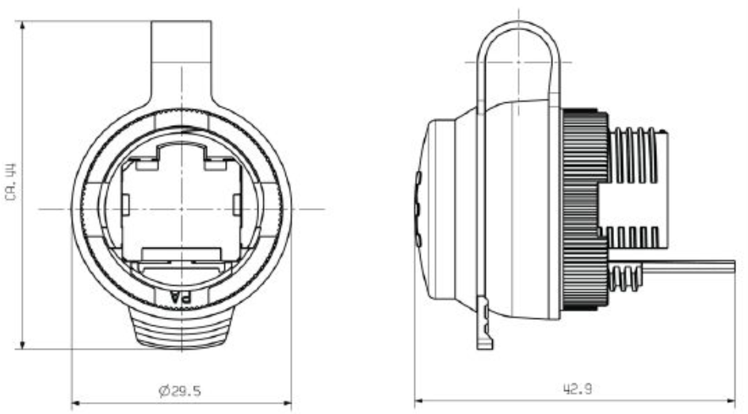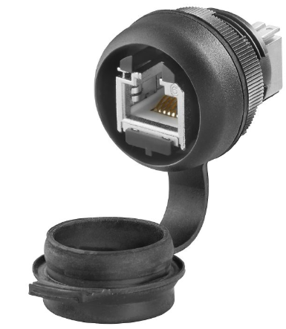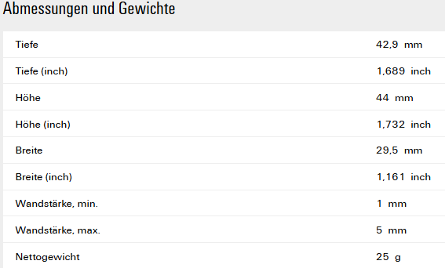

Ethernet Connector, Weidmuller 1018790000

