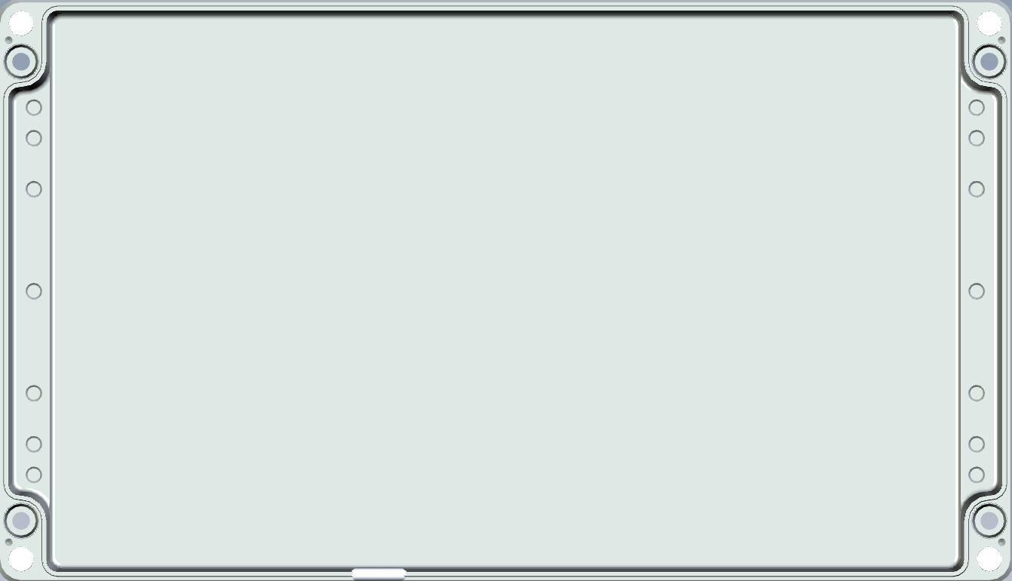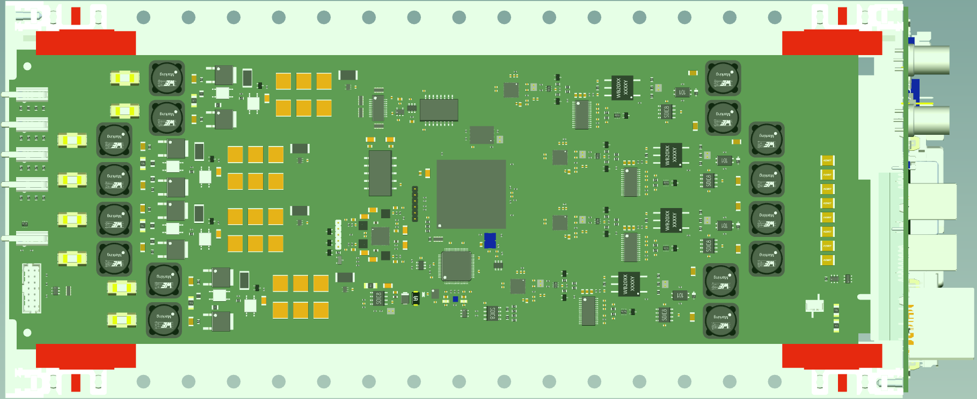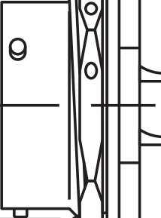

## SpoolHub, Top View, scale 1:2, version #1, all quad conns. in a row

Quad#1

## RevPI 4

Quad#2

Quad#3

Quad#4

PARO

96Vin

PT07A-14-12S

PT07A-14-12S

PT07A-14-5S

PT07A-14-5P

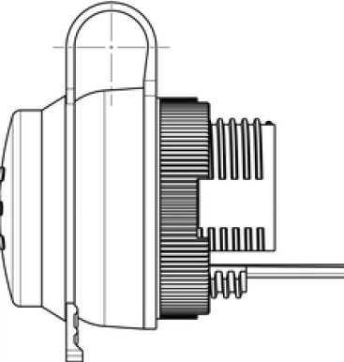

Ethernet

In the connector region the wall thickness must get reduced to 3mm

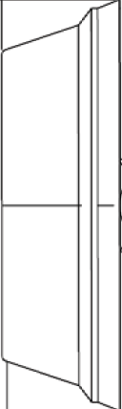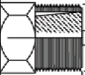

Tango 23

WLAN antenna



## SpoolHub, Top View, scale 1:2, version #2, 2x2 quad conns. vertically aligned

## RevPI 4

Quad#1,2

Quad#3,4

PARO

96Vin

PT07A-14-12S

PT07A-14-5S

PT07A-14-5P



Ethernet

Tango 23



WLAN antenna



## Generating scaled models