SpoolHub, Internal Cabling

PevPi 4 and PARO-Power + Data connection
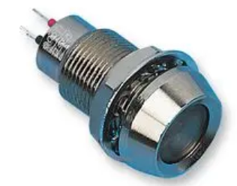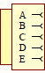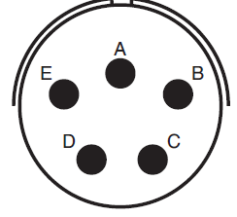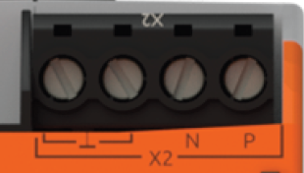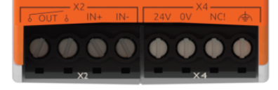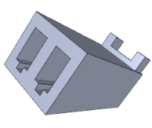
Wire end ferrules
0.25mm2
for
PT02E-14-5S
RevPi 4
PARO Connector
TxRx+
TxRx-
Pwr+
Pwr-
Shield
Lapp 91200, 0.3m
Wire end ferrules 0.25mm2
To FBAP-mini, J19
Molex 22013027
Crimp pins Molex 08550102
RevPi 4
M2.5 ring terminal
Shield at enclosure
brown

gray

yellow / black

brown

blue

Lapp 912023, 0.3m
blue

brown

Lapp 91200, 0.3m
Lapp 91200, 0.3m
blue

brown

MARL 512-532-21
LED green
View on solder caps

SpoolHub to Quad #1…4 Patch Cables
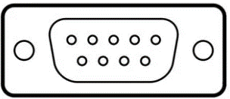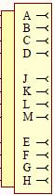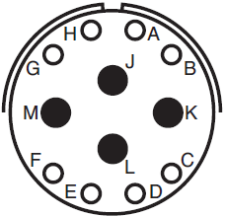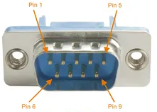
5-747904-2
PT02E-14-12S
To FBAP-mini
Quad Conn.
WP0+
WP0-
WP1-
Shield
WP1+
Cable: Lapp 912023, 0.4m
WP1-
WP1+
WP0+
WP0-
1
5
6
9
Shield at enclosure
M2.5 ring terminal
5
1
9
6
View on solder caps
black

yellow

brown

gray

View on solder caps
black

yellow

brown

gray

black

yellow

brown

gray

96VDC-input to FBAP-mini Cable
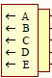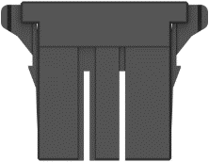
PT06E-14-5P
To FBAP-mini
96VDC-in
GND_48
+48VDC
GND_48
-48VDC
Shield
Shield at enclosure
M2.5 ring terminal
1
2
3
Cable: Lapp 912023, 0.4m
1-178128-3
Crimp pins 175195-3
View on solder caps
black

yellow

brown

gray

