SpoolHub, External Cabling

SpoolHub to PARO-Quad Patch Cable
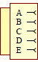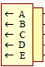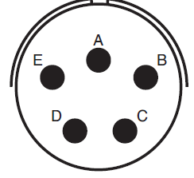
PT06E-14-5P-SR
PT01E-14-5S-SR
To SpoolHub
To PARO Quad
TxRx+
TxRx-
Pwr+
Pwr-
Shield
Cable: Lapp 1032108, 2m
View on solder caps
View on solder caps
green

yellow

brown

white

Shield
green

white

brown

yellow

green

yellow

brown

white

SpoolHub to Quad #1…3 Patch Cable
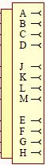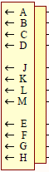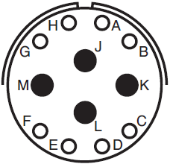
PT06E-14-12P-SR
PT01E-14-12S-SR
To SpoolHub
To Quad
WP0+
WP0-
WP1-
Shield
WP1+
Cable: Lapp 1032108, 2m
green

yellow

brown

white

yellow

yellow

green

brown

white

green

white

brown

View on solder caps
View on solder caps

SpoolHub to LOM, Quad22, Patch Cable
PT06E-14-12P-SR
PT01E-14-5S-SR
To SpoolHub
To Quad22, LOM
WP0+
WP0-
WP1-
Shield
WP1+
Cable: Lapp 1032108, 2m
green

yellow

brown

white

yellow

yellow

green

brown

white

green

white

brown

View on solder caps
View on solder caps

Slipring to SpoolHub, 96VDC Cable
PT06E-14-5P-SR
PT06E-14-5S-SR
To SpoolHub
To Slip Ring
GND_48
+48VDC
GND_48
-48VDC
Shield
Cable: Lapp 1032108, 2m
green

yellow

brown

white

green

yellow

brown

white

View on solder caps

Battery Box to Slip Ring (or to SpoolHub), 96VDC Cable
PT06E-14-5P-SR
PT06E-14-5S-SR
To Slip Ring
To Battery Box
GND_48
+48VDC
GND_48
-48VDC
Shield
Cable: Lapp 1032108, 3m
green

yellow

brown

white

green

yellow

brown

white

View on solder caps

