Battery Box, External Cabling

Battery Box to Slip Ring, 96VDC Cable
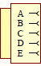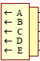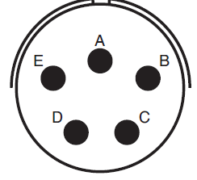
PT06E-14-5P-SR
PT06E-14-5S-SR
To Slip Ring
To Battery Box
GND_48
+48VDC
GND_48
-48VDC
Shield
Cable: Lapp 1032108, 2m

