# FSEB_2, Frontplate – marking

nvent | Schroff 30848-431, 0.1 inch offset, scale 1:1

LED-holes (D=3,3) with chamfering at the back side

Letter size in 1/100 inch

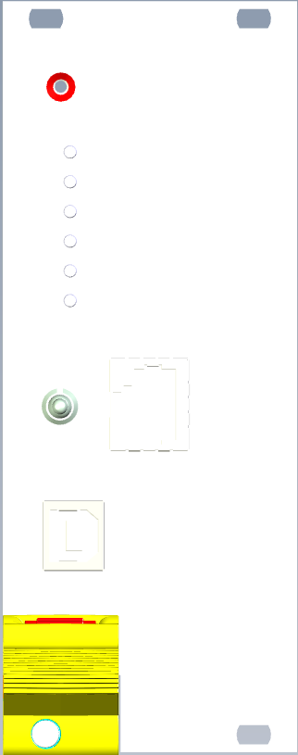

FSEB.2

7

3

ESP_P3V3

12V

12V_over_current

String-voltage_in

String-voltage_out

String_over_current

ESP_Reset

String

OFF

ON

ESP

PoE



ESP

UART

8

15

12

8

8

9

9

12

9