# FSEB_2, initial changes, 2023-10-02

## Changes, table sorted by RefDes

|  |  |  |
| --- | --- | --- |
| RefDes | Old value | New value |
| **C108** | 2u2 2220 | DNL |
| **C109** | 2u2 2220 | DNL |
| **C112** | 2u2 2220 | DNL |
| **C113** | 2u2 2220 | DNL |
| **C37** | 100n 50V 0603 | 10u 25V 0603 |
| **C39** | 100n 1206 250V | DNL |
| **C41** | 150u 200V | DNL |
| **C78** | 100n 1206 250V | DNL |
| **C92** | DNL | 100n 50V 0603 |
| L7 | BLM31KN121SN1L 1206 | Thermistor B57237S0330M000 |
| **L8** | BLM31KN121SN1L 1206 | BLM31SN500SH1L 1206 |
| **R7** | 2R7 0805 | 12R 0805 500mW |
| **R8** | 2R7 0805 | 12R 0805 500mW |
| **R10** | 4R7 0805 | 100k 0805 |
| **R101** | 100R 0603 | 200R 0603 |
| **R109** | 0R 0603 (was DNL) | CD0603-B0340R |
| **R112** | 0R 0603 | CD0603-B0340R |
| **R117** | 1k3 0603 | 2k2 0603 |
| **R25** | 4R7 0805 | 100k 0805 |
| **R54** | 0R 1210 | DNL |
| **R62** | 200R 0603 | 430R 0603 |
| **R66** | 47k 0603 | 56k 0603 |
| **R84** | 100k 0603 | 1M 0603 |
| **R86** | 100k 0603 | 1M 0603 |
| **R95** | 24k 0603 | 18k 0603 |
| **R118** | 10k 0603 | 10n 0603 |
| **U18** | SN74LV1T34DCKR | 74LVC1G04GW.125 |
| **U21** | NTE0303MC | NTE0305MC |
| **V24** | IPD600N25N3GATMA1 | IKD15N60RATMA1 |

## Schottky Diodes CD0603-B0340R as replacement for R109, R112

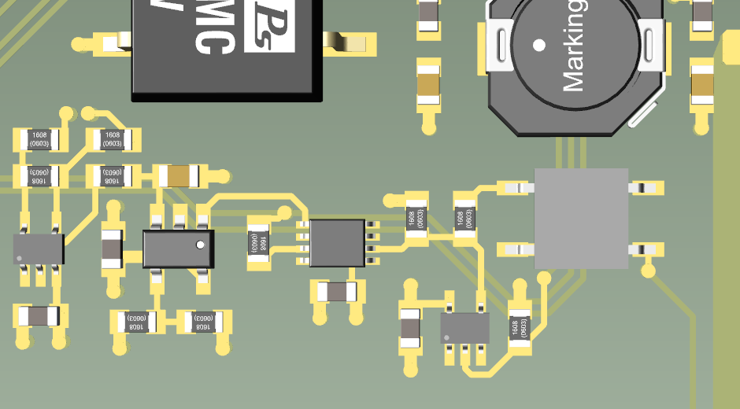

cathode

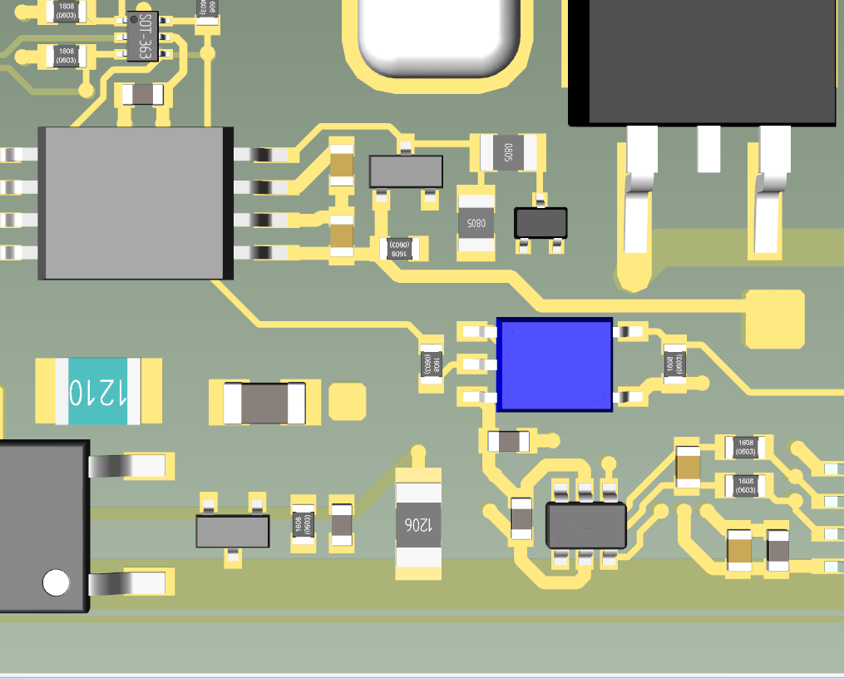

cathode

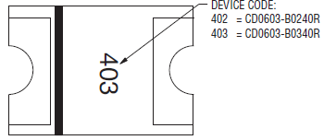

cathode

## Änderungen, Tabelle sortiert nach Wert

100nF 0603 50V, bitte Rolle überprüfen, versehentlich 100pF genommen ?

|  |  |  |
| --- | --- | --- |
| RefDes | Old value | New value |
| **R112** | 0R 0603 | CD0603-B0340R |
| **R118** | 10k 0603 | 10n 0603 |
| **R109** | 0R 0603 (was DNL) | CD0603-B0340R |
| **R54** | 0R 1210 | DNL |
| **R66** | 47k 0603 | 56k 0603 |
| **R84** | 100k 0603 | 1M 0603 |
| **R86** | 100k 0603 | 1M 0603 |
| **C39** | 100n 1206 250V | DNL |
| **C78** | 100n 1206 250V | DNL |
| **C37** | 100n 50V 0603 | 10u 25V 0603 |
| **C92** | DNL | 100n 50V 0603 |
| **R101** | 100R 0603 | 200R 0603 |
| **C41** | 150u 200V | DNL |
| **R117** | 1k3 0603 | 2k2 0603 |
| **R62** | 200R 0603 | 430R 0603 |
| **R95** | 24k 0603 | 18k 0603 |
| **R7** | 2R7 0805 | 12R 0805 500mW |
| **R8** | 2R7 0805 | 12R 0805 500mW |
| **C108** | 2u2 2220 | DNL |
| **C109** | 2u2 2220 | DNL |
| **C112** | 2u2 2220 | DNL |
| **C113** | 2u2 2220 | DNL |
| **R10** | 4R7 0805 | 100k 0805 |
| **R25** | 4R7 0805 | 100k 0805 |
| L7 | BLM31KN121SN1L 1206 | Thermistor B57237S0330M000 |
| **L8** | BLM31KN121SN1L 1206 | BLM31SN500SH1L 1206 |
| **V24** | IPD600N25N3GATMA1 | IKD15N60RATMA1 |
| **U21** | NTE0303MC | NTE0305MC |
| **U18** | SN74LV1T34DCKR | 74LVC1G04GW.125 |