FSEB_2 Check List
item | check | location | remark
Optical check | X
J1 is set? | X | 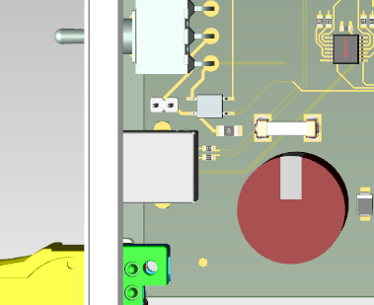 | Front panel switch-enable
Power on by front panel switch | x | 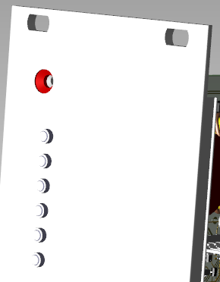 | Start with 50V input, check LEDs
P12V_OUT1 | x | 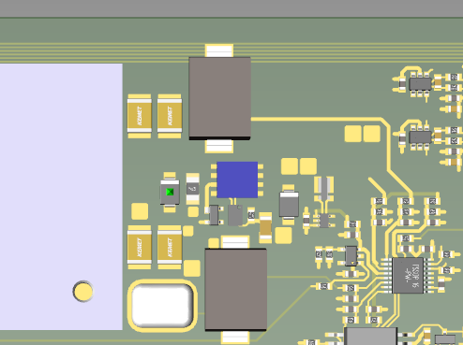 | Probe at V10
P12V_OUT2 | x | 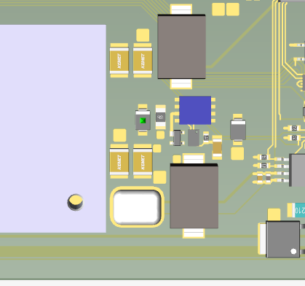 | Probe at V9
P12V | x | 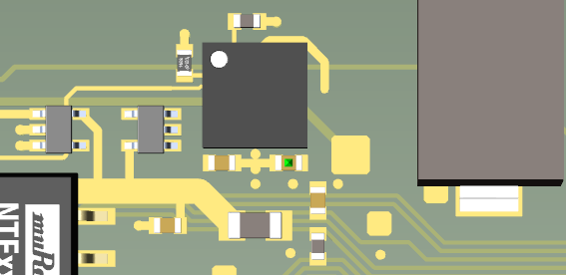 | probe at C94
P3V3 | x | 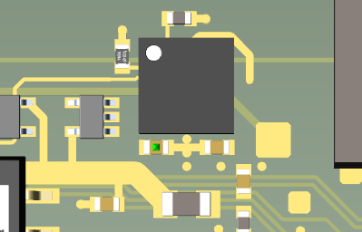 | Probe at C65
P5V_ISO | x | 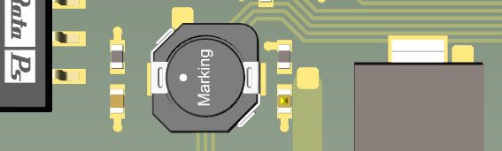 | Probe at C64
P48_OUT, N48_OUT |  | 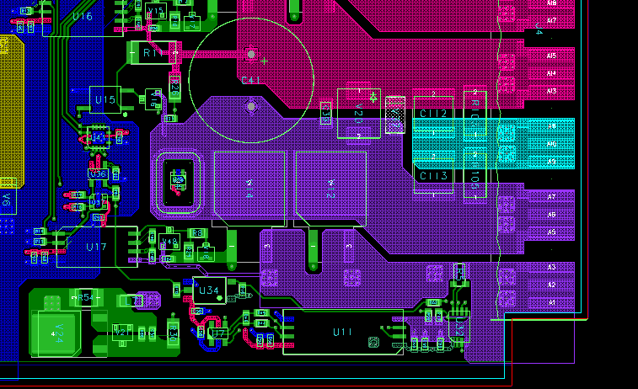 | Probe at C41 or V20
Shortcut test |  |  | Connect P48_OUT to N48_OUT, use current probe, expect single (!) ~50A x 15us spike, red String_over_current LED should be ON
P12_VOUT1 = 2V | X |  | Monitoring, ADC input values, U9 pins 1…8
P12_VOUT1 = 2V | X
P12_VOUT = 2V | X
P12V_CUR | X |  | U(V)=I(A) x 0.2
U1_TEMP ~ 0.76V | X |  | 10 mV/°C, 500 mV at 0°C
U2_TEMP ~ 0.76V | X
V11_TEMP ~ 0.76V | X
V12_TEMP ~ 0.76V | x
STRG_CUR+/- | x | 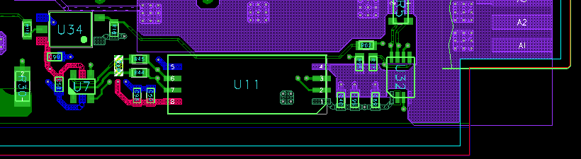 | At C64, U(V)=I(A) x 0.0164  e.g. ~ 0.125V at 7.6A (96Vin, 12.5 ohm load)
STRG_VOUT+/- | x | 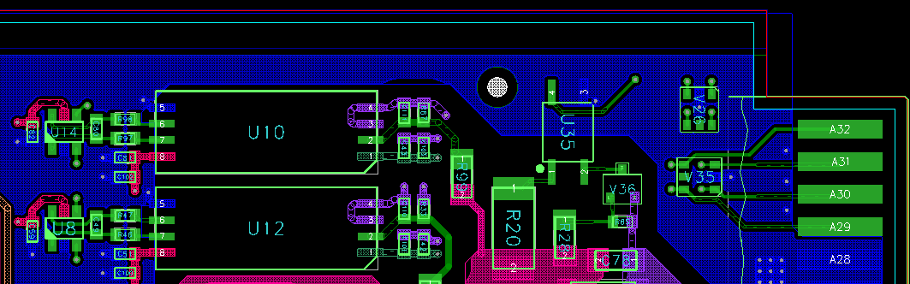 | At C49, U(V) = 0.01072 x STRG_VOUT(V), e.g. ~1.02V @ 96Vin
STRG_VIN+/- | x |  | At C80, U(V) = 0.01072 x STRG_VIN(V) ), e.g. ~1.02V @ 96Vin

