FSEB_1 Corrections, 2023-04-17

- Two TVS Diodes 8.0SMDJ64A additionally between P48_OUT and GND_48, between 48_OUT and GND_48, solder to TH-pins of C41, C42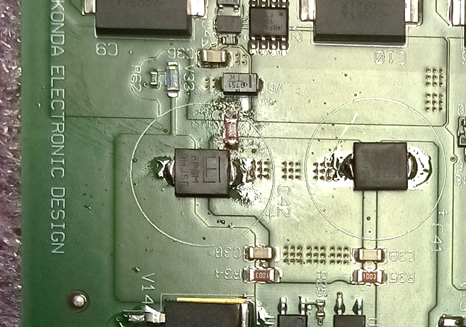
Cathode
Cathode
- 100k 1206 between GND and GND_48, blue wires to be ignored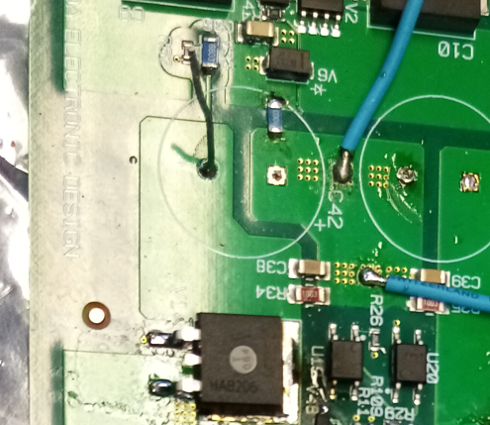
- R71, R72, use pads for cross connections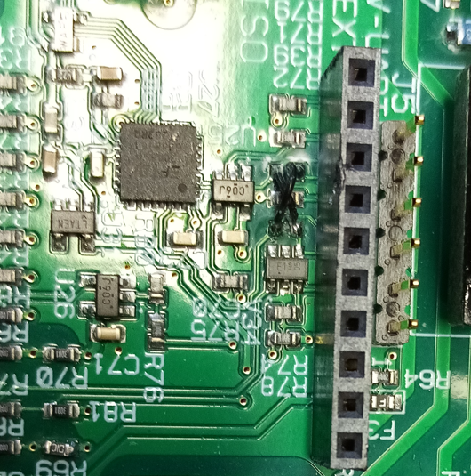
- Latest changes
RefDes | New value | remark
R19 | 6k2 0603
R29 | 270k 1206 | 200V
R11 | Pick & place angle | Was rotated by 90°
R30 | 16k 0603
R24 | 4k7 0603
R1 | DNL | 43k 1206
R2 | DNL | 43k 1206
C45 | DNL | 100n 0603
R8 | DNL | Alle all 4 pins must be connected, see below
R7 | 0R003 0612
V32 | 75k 1206
V39 | 75k 1206
V33 | 680k 1206
V40 | 680k 1206
R16 | 33k 0805
R17 | 33k 0805
R83 | 100R 0603
R65 | 100R 0603
R18 | 2K2 0603

- Remove R8, connect all 4 Pins by a solder drop
