# FDOR_2, Frontplate, Rev. 1

nvent | Schroff 30848-426, 0.1 inch offset, scale 1:1

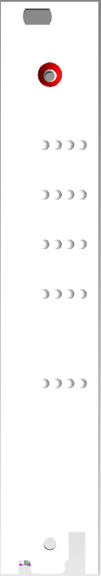

29,2

10

10

10

18

8,95

20x D=2,1mm

2,54



WP0



Power

USB

FhRx

FhTx

+12V_err

+12V

+5V

FPGA_cfg

WP1

WP2

WP3

FDOR.2

7

3