Digital Trigger, L2-Crate power Connectors

usage | manufacturer / type | view | remark
auxiliary power supply, 230VAC input at the back side of the crate | Hirschmann STASAP 2 B | 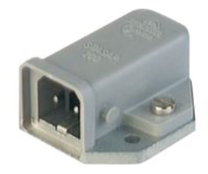 | pin usage  1 : L  2 : N  h : PE
+24V main power connection at the back side of the crate | Amphenol SLPRBTPSR | 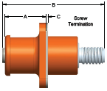 | red, 4 x 8.0mm type, see below  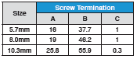
+24V main power return connection at the back side of the crate | Amphenol SLPRBTPSB | 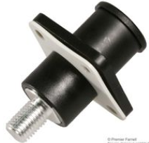 | black, 4 x 8.0mm type, see below
+24V main power, cable connection | Amphenol SLPRB50CPSR | 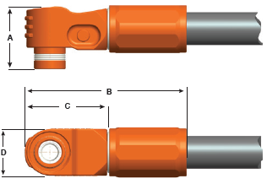 | red, 4 x 8.0mm type, see below  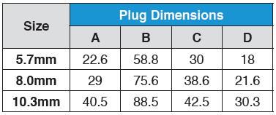
+24V main power return, cable connection | Amphenol SLPRB50CPSB |  | black, 4 x 8.0mm type, see below

