Modification of the Digital trigger Crate-Camera power
Interface Control Document
Ref version: 0.3 from 7/8/2017

Page 1:
Remove Nadia in “accepted by” field.
Document change record:
Edition 1.0 from 2018-08-29.
Modified pages: all

Page 4:
Add PDB (Power Distribution Box)+ DTC (Digital Trigger Crate) in the list of abbreviations. Correct L2TB .... to L2BP (L2 crate Backplane)
note: DTC is the same like L2-crate, shown in Figure 1
Page 5: Replace very last paragraph of chapter 3 by :
Option 2 was preferred. The digital trigger crate hosts a little power supply unit able to deliver 24V and enabled by Embedded Camera Controller (ECC) prior to the main24V power delivered by the PSBs.
Page 6: Modify table 1 legend by : List of Amphenol SurLok Plus connectors used in the PSBs.

Page 7:
Replace paragraph 4.3 by the following text:
On the digital trigger crate (DTC) side, Amphenol SurLok Plus connectors are also used. Connectors on the DTC panel are receptacle, while the cable connector gender is male (Plug). Connector references are the ones given in table 2 and table 3. Note that for safety reasons it would have been better to use panel mount male connectors but they are not available in this gender.
In order to plug the four cables coming from each of the two PSB, the DTC hosts 8 receptacle panel mount connectors (4 reds for 24V input and 4 black for return current).
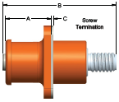 | 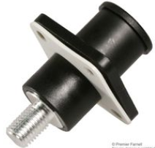
Amphenol SLPRBTPSR | Amphenol SLPRBTPSB
Table 2: +24V main power connection at the back side of the crate. Black connector is for return current.
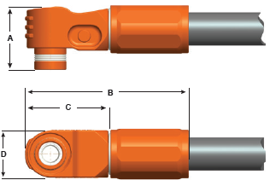
Amphenol SLPRB50CPSR | Amphenol SLPRB50CPSB
Table 3: +24V main power cable connection. Right connector should be black connector and is used for return current.

Please remove fig 3.
Left paragraph 4.4 unchanged

Chapter 5: auxiliary power connectors and cables

5.1 Overview
In this section, we will discuss the auxiliary power applied to the digital trigger crate. This power should be applied according to the sequencing discussed in section 3.
The Digital trigger Crate hosts a PULS CS5.241 at the back side of the crate. This 32*124*117mm3 (W*H*D) power supply is able to deliver an output voltage of 24V and an output current of up to 5A, from a 230V single phase input delivered by the power distribution box (PDB). This 230V output of the PDB should be derived from the 400 V camera input and is controlled through a relay by the ECC. The communication between the ECC and PDB is done through a Modbus Ethernet communication.

5.2 Auxiliary power connectors

PDB side
The 230V delivered by the PDB is provided by one Weidmuller 1498200000 female connector, enclosed in an 1497600000 aluminium base which guarantees a long lifespan with high resistance to corrosion and impact. The housing interlock system provides integrated safety. The patented spring system provides the housing interlock with a secure grip and prevents accidental opening. The connector is a 3 positions + earth screw connector, able to rate 16A. Pin 3 is neutral and pin 1 is phase. Cable has Weidmuller 1498100000 plug connector. Table 4 shows the connectors that equip the PDB side.
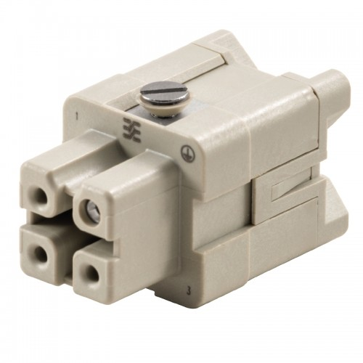 |  | 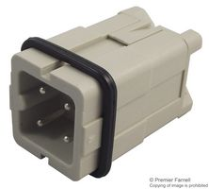
Weidmuller 1498200000 PDB female connector | Weidmuller 1497600000 connector base | Weidmuller 1498100000 cable mount plug connector
Table 4: The 230 V auxiliary power is delivered by the PDB through a Weidmuller 1498200000 connector

DTC side
ON DTC side, the Hirschmann STASAP 200 socket male connector is used. It is a two contact connector + protected earth. It is rated up to 250V and 16A AC. Safety bracket STASI 2 is also used. Pin 1 is phase, pin 2: Neutral. The cable is equipped with Hirschmann STAK 2 female connector.
Table 5 shows the connector that receives the 230V auxiliary power at the DTC level.

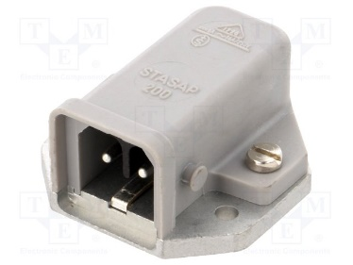 | 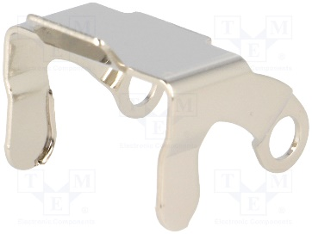
Hirschmann STASAP 200 Male connector | STASI 2 safety bracket
Table 5: the 230V auxiliary power is delivered to the DTC through a Hirschmann STASAP 200 rectangular connector.

Chapter 6 Responsibilities
§6.1: Please modify the corresponding sentence by the following: The auxiliary power supply and connections is the responsibility of DESY.
§6.2: Please modify the corresponding sentence by the following: this includes the auxiliary power supply.

