FrontEnd – Backplane Interface for CTA cameras

Author | Laboratory |  | Approved by | Laboratory
Oscar Blanch
Joan Boix
Carlos Díaz
Hidetoshi Kubo
Gustavo Martínez
Patrick Nayman
Riccardo Paoletti
Michael Punch
Karl-Heinz Sulanke
Luis Angel Tejedor
Francois Toussenel

List of Abbreviations

History
Version | Date | Observation
0 | 18/05/2012 | Original version
1 | 21/06/2012 | Some corrections before Paris meeting
2 | 23/07/2012 | New FE-BP connector names and drawings
3 | 23/10/2012 | L1_DELAY_REF signal added
4 | 26/10/2012 | Mechanical drawings added
5 | 12/11/2012 | One mechanical drawing with mistakes has been removed
6 | 20/11/2012 | Bad drawing corrected and added back to the document
7 | 15/02/2013 | Some modifications of signal names. Backplane V1 pictures added.
8 | 10/02/2014 | BUSY signal has been added to the interface specification
9 | 25/06/2014 | Trigger Type serial link specified. Delay_ref signal removed from specification.

Distribution

Table of Contents
1 Introduction 4
2 FrontEnd-Backplane interface description 4
2.1 Connectors references 4
2.2 Connectors pinout 6
3 Signal descriptions 10
4 Mechanical drawings 14

Introduction

This document contains a description of the interface between the front-end readout board and the backplane board for CTA cameras. This interface aims to be used both for Nectar and Dragon readout systems and both for Digital and Analog Trigger systems. The information contained in this document is based in the technical information interchange performed at Pisa meeting last April 2012 among the persons who sign this document as authors.
The main goal of that meeting was the preliminary definition of the specifications of a backplane board for CTA cameras that can be compatible with all subsystems mentioned above.

FrontEnd-Backplane interface description

Connectors references

The connectors proposed for the physical layer of the interface are the following:

- For the Backplane board: Tyco 6469025-1
- For the FrontEnd board: Tyco 6469028-1

The proposal of this connector is based in a trade off among good mechanical properties, high signal density and good electromagnetic compatibility properties.
In order to accommodate all necessary signals for the interface, two of these connectors are needed both in the FE board and the Backplane board, obtaining a total pin count of 40 pairs plus 40 ground connections. The labeling of these connectors is shown in Fig.1 Pinout drawings are shown in Fig.2 and Fig. 3.

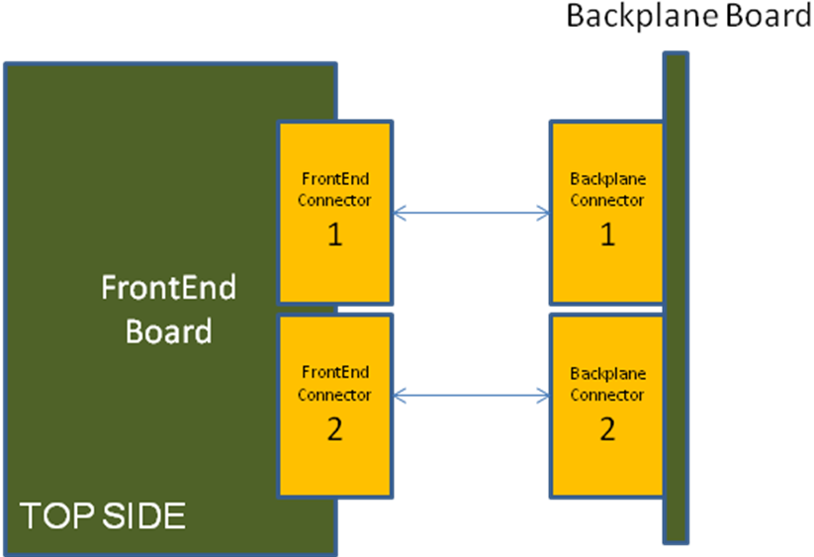
Fig 1. Connection diagram between front-end board and backplane board

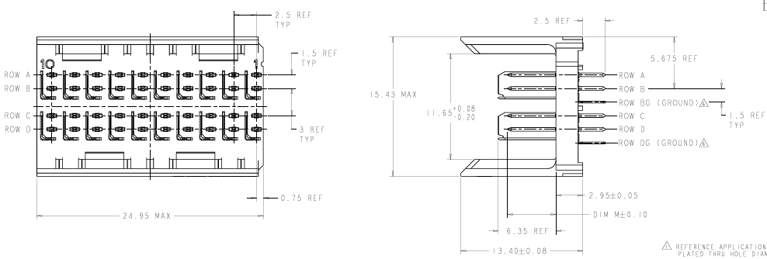
Fig 2. Tyco 6469025-1 drawings (Backplane connector)

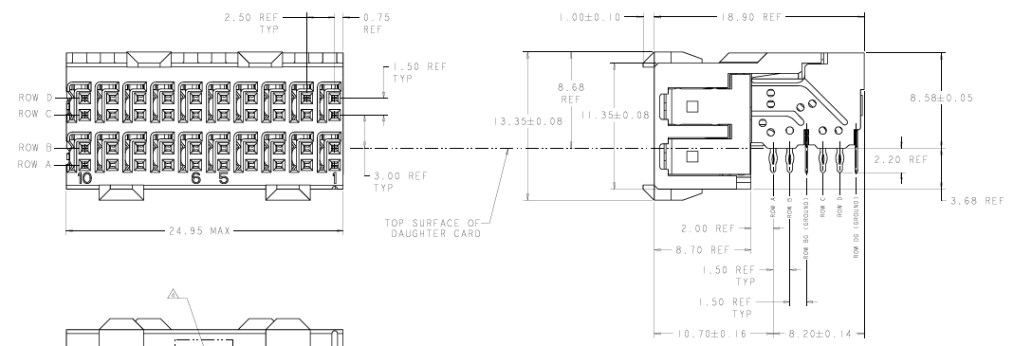
Fig.3 Tyco 6469028-1 drawings (FrontEnd connector)

Connectors pinout

CONNECTOR | ROW | PIN NUMBER | SIGNAL
BACKPLANE CON. 2 | A | 1 | AN_L1_IN2_P
BACKPLANE CON. 2 | B | 1 | AN_L1_IN2_N
BACKPLANE CON. 2 | C | 1 | AN_L1_IN5_P
BACKPLANE CON. 2 | D | 1 | AN_L1_IN5_N
BACKPLANE CON. 2 | A | 2 | AN_L1_IN1_P
BACKPLANE CON. 2 | B | 2 | AN_L1_IN1_N
BACKPLANE CON. 2 | C | 2 | AN_L1_IN4_P
BACKPLANE CON. 2 | D | 2 | AN_L1_IN4_N
BACKPLANE CON. 2 | A | 3 | AN_L1_IN0_P
BACKPLANE CON. 2 | B | 3 | AN_L1_IN0_N
BACKPLANE CON. 2 | C | 3 | AN_L1_IN3_P
BACKPLANE CON. 2 | D | 3 | AN_L1_IN3_N
BACKPLANE CON. 2 | A | 4 | AN_L0_OUT_P
BACKPLANE CON. 2 | B | 4 | AN_L0_OUT_N
BACKPLANE CON. 2 | C | 4 | AN_TRG_OUT0_P
BACKPLANE CON. 2 | D | 4 | AN_TRG_OUT0_N
BACKPLANE CON. 2 | A | 5 | AN_TRG_OUT1_P
BACKPLANE CON. 2 | B | 5 | AN_TRG_OUT1_N
BACKPLANE CON. 2 | C | 5 | FPGA_CONF0 (JTAG_TCK)
BACKPLANE CON. 2 | D | 5 | FPGA_CONF1 (JTAG_TDI)
BACKPLANE CON. 2 | A | 6 | FPGA_CONF2 (JTAG_TMS)
BACKPLANE CON. 2 | B | 6 | FPGA_CONF3 (JTAG_TDO)
BACKPLANE CON. 2 | C | 6 | FPGA_SLOW_CTRL0 (SPI_CLK)
BACKPLANE CON. 2 | D | 6 | FPGA_SLOW_CTRL1 (SPI_MOSI)
BACKPLANE CON. 2 | A | 7 | FPGA_SLOW_CTRL2 (SPI_CE)
BACKPLANE CON. 2 | B | 7 | FPGA_SLOW_CTRL3 (SPI_MISO)
BACKPLANE CON. 2 | C | 7 | DIG_TRG_OUT0_P
BACKPLANE CON. 2 | D | 7 | DIG_TRG_OUT0_N
BACKPLANE CON. 2 | A | 8 | DIG_TRG_OUT1_P
BACKPLANE CON. 2 | B | 8 | DIG_TRG_OUT1_N
BACKPLANE CON. 2 | C | 8 | DIG_TRG_OUT2_P
BACKPLANE CON. 2 | D | 8 | DIG_TRG_OUT2_N
BACKPLANE CON. 2 | A | 9 | DIG_TRG_OUT3_P
BACKPLANE CON. 2 | B | 9 | DIG_TRG_OUT3_N
BACKPLANE CON. 2 | C | 9 | DIG_TRG_OUT4_P
BACKPLANE CON. 2 | D | 9 | DIG_TRG_OUT4_N
BACKPLANE CON. 2 | A | 10 | DIG_TRG_OUT5_P
BACKPLANE CON. 2 | B | 10 | DIG_TRG_OUT5_N
BACKPLANE CON. 2 | C | 10 | DIG_TRG_OUT6_P
BACKPLANE CON. 2 | D | 10 | DIG_TRG_OUT6_N
Table 1 – Backplane connector 2 pinout

CONNECTOR | ROW | PIN NUMBER | SIGNAL
BACKPLANE CON. 1 | A | 1 | SPARES0_P
BACKPLANE CON. 1 | B | 1 | SPARES0_N
BACKPLANE CON. 1 | C | 1 | SPARES1_P
BACKPLANE CON. 1 | D | 1 | SPARES1_N
BACKPLANE CON. 1 | A | 2 | SPARES2_P
BACKPLANE CON. 1 | B | 2 | SPARES2_N
BACKPLANE CON. 1 | C | 2 | BUSY_P
BACKPLANE CON. 1 | D | 2 | BUSY_N
BACKPLANE CON. 1 | A | 3 | ETH_LED1
BACKPLANE CON. 1 | B | 3 | ETH_LED2
BACKPLANE CON. 1 | C | 3 | POWER_+24V
BACKPLANE CON. 1 | D | 3 | POWER_+24V
BACKPLANE CON. 1 | A | 4 | POWER_+24V
BACKPLANE CON. 1 | B | 4 | POWER_+24V
BACKPLANE CON. 1 | C | 4 | TRGL1_P
BACKPLANE CON. 1 | D | 4 | TRGL1_N
BACKPLANE CON. 1 | A | 5 | TRGCONF_P
BACKPLANE CON. 1 | B | 5 | TRGCONF_N
BACKPLANE CON. 1 | C | 5 | TRGTYPE0_P (TRGTYPE_CLK_P)
BACKPLANE CON. 1 | D | 5 | TRGTYPE0_N (TRGTYPE_CLK_N)
BACKPLANE CON. 1 | A | 6 | TRGTYPE1_P (TRGTYPE_DATA_P)
BACKPLANE CON. 1 | B | 6 | TRGTYPE1_N (TRGTYPE_DATA_N)
BACKPLANE CON. 1 | C | 6 | TRGTYPE2_P (TRGTYPE_SPARE_P)
BACKPLANE CON. 1 | D | 6 | TRGTYPE2_N (TRGTYPE_SPARE_N)
BACKPLANE CON. 1 | A | 7 | TIMEPPS_P
BACKPLANE CON. 1 | B | 7 | TIMEPPS_N
BACKPLANE CON. 1 | C | 7 | EXTCLK_P
BACKPLANE CON. 1 | D | 7 | EXTCLK_N
BACKPLANE CON. 1 | A | 8 | 1DW_IPADDR
BACKPLANE CON. 1 | B | 8 | FPGA_PROGRAM
BACKPLANE CON. 1 | C | 8 | ETH0_P
BACKPLANE CON. 1 | D | 8 | ETH0_N
BACKPLANE CON. 1 | A | 9 | ETH1_P
BACKPLANE CON. 1 | B | 9 | ETH1_N
BACKPLANE CON. 1 | C | 9 | ETH2_P
BACKPLANE CON. 1 | D | 9 | ETH2_N
BACKPLANE CON. 1 | A | 10 | ETH3_P
BACKPLANE CON. 1 | B | 10 | ETH3_N
BACKPLANE CON. 1 | C | 10 | RJ45_MAGNETICS_2_5V
BACKPLANE CON. 1 | D | 10 | N.C.
Table 2 – Backplane connector 1 pinout

CONNECTOR | ROW | PIN NUMBER | SIGNAL
FRONTEND CON. 2 | A | 1 | AN_L1_IN2_P
FRONTEND CON. 2 | B | 1 | AN_L1_IN2_N
FRONTEND CON. 2 | C | 1 | AN_L1_IN5_P
FRONTEND CON. 2 | D | 1 | AN_L1_IN5_N
FRONTEND CON. 2 | A | 2 | AN_L1_IN1_P
FRONTEND CON. 2 | B | 2 | AN_L1_IN1_N
FRONTEND CON. 2 | C | 2 | AN_L1_IN4_P
FRONTEND CON. 2 | D | 2 | AN_L1_IN4_N
FRONTEND CON. 2 | A | 3 | AN_L1_IN0_P
FRONTEND CON. 2 | B | 3 | AN_L1_IN0_N
FRONTEND CON. 2 | C | 3 | AN_L1_IN3_P
FRONTEND CON. 2 | D | 3 | AN_L1_IN3_N
FRONTEND CON. 2 | A | 4 | AN_L0_OUT_P
FRONTEND CON. 2 | B | 4 | AN_L0_OUT_N
FRONTEND CON. 2 | C | 4 | AN_TRG_OUT0_P
FRONTEND CON. 2 | D | 4 | AN_TRG_OUT0_N
FRONTEND CON. 2 | A | 5 | AN_TRG_OUT1_P
FRONTEND CON. 2 | B | 5 | AN_TRG_OUT1_N
FRONTEND CON. 2 | C | 5 | FPGA_CONF0 (JTAG_TCK)
FRONTEND CON. 2 | D | 5 | FPGA_CONF1 (JTAG_TDI)
FRONTEND CON. 2 | A | 6 | FPGA_CONF2 (JTAG_TMS)
FRONTEND CON. 2 | B | 6 | FPGA_CONF3 (JTAG_TDO)
FRONTEND CON. 2 | C | 6 | FPGA_SLOW_CTRL0 (SPI_CLK)
FRONTEND CON. 2 | D | 6 | FPGA_SLOW_CTRL1 (SPI_MOSI)
FRONTEND CON. 2 | A | 7 | FPGA_SLOW_CTRL2 (SPI_CE)
FRONTEND CON. 2 | B | 7 | FPGA_SLOW_CTRL3 (SPI_MISO)
FRONTEND CON. 2 | C | 7 | DIG_TRG_OUT0_P
FRONTEND CON. 2 | D | 7 | DIG_TRG_OUT0_N
FRONTEND CON. 2 | A | 8 | DIG_TRG_OUT1_P
FRONTEND CON. 2 | B | 8 | DIG_TRG_OUT1_N
FRONTEND CON. 2 | C | 8 | DIG_TRG_OUT2_P
FRONTEND CON. 2 | D | 8 | DIG_TRG_OUT2_N
FRONTEND CON. 2 | A | 9 | DIG_TRG_OUT3_P
FRONTEND CON. 2 | B | 9 | DIG_TRG_OUT3_N
FRONTEND CON. 2 | C | 9 | DIG_TRG_OUT4_P
FRONTEND CON. 2 | D | 9 | DIG_TRG_OUT4_N
FRONTEND CON. 2 | A | 10 | DIG_TRG_OUT5_P
FRONTEND CON. 2 | B | 10 | DIG_TRG_OUT5_N
FRONTEND CON. 2 | C | 10 | DIG_TRG_OUT6_P
FRONTEND CON. 2 | D | 10 | DIG_TRG_OUT6_N
Table 3 – Frontend connector 2 pinout

CONNECTOR | ROW | PIN NUMBER | SIGNAL
FRONTEND CON. 1 | A | 1 | SPARES0_P
FRONTEND CON. 1 | B | 1 | SPARES0_N
FRONTEND CON. 1 | C | 1 | SPARES1_P
FRONTEND CON. 1 | D | 1 | SPARES1_N
FRONTEND CON. 1 | A | 2 | SPARES2_P
FRONTEND CON. 1 | B | 2 | SPARES2_N
FRONTEND CON. 1 | C | 2 | BUSY_P
FRONTEND CON. 1 | D | 2 | BUSY_N
FRONTEND CON. 1 | A | 3 | ETH_LED1
FRONTEND CON. 1 | B | 3 | ETH_LED2
FRONTEND CON. 1 | C | 3 | POWER_+24V
FRONTEND CON. 1 | D | 3 | POWER_+24V
FRONTEND CON. 1 | A | 4 | POWER_+24V
FRONTEND CON. 1 | B | 4 | POWER_+24V
FRONTEND CON. 1 | C | 4 | TRGL1_P
FRONTEND CON. 1 | D | 4 | TRGL1_N
FRONTEND CON. 1 | A | 5 | TRGCONF_P
FRONTEND CON. 1 | B | 5 | TRGCONF_N
FRONTEND CON. 1 | C | 5 | TRGTYPE0_P (TRGTYPE_CLK_P)
FRONTEND CON. 1 | D | 5 | TRGTYPE0_N (TRGTYPE_CLK_N)
FRONTEND CON. 1 | A | 6 | TRGTYPE1_P (TRGTYPE_DATA_P)
FRONTEND CON. 1 | B | 6 | TRGTYPE1_N (TRGTYPE_DATA_N)
FRONTEND CON. 1 | C | 6 | TRGTYPE2_P (TRGTYPE_SPARE_P)
FRONTEND CON. 1 | D | 6 | TRGTYPE2_N (TRGTYPE_SPARE_N)
FRONTEND CON. 1 | A | 7 | TIMEPPS_P
FRONTEND CON. 1 | B | 7 | TIMEPPS_N
FRONTEND CON. 1 | C | 7 | EXTCLK_P
FRONTEND CON. 1 | D | 7 | EXTCLK_N
FRONTEND CON. 1 | A | 8 | 1DW_IPADDR
FRONTEND CON. 1 | B | 8 | FPGA_PROGRAM
FRONTEND CON. 1 | C | 8 | ETH0_P
FRONTEND CON. 1 | D | 8 | ETH0_N
FRONTEND CON. 1 | A | 9 | ETH1_P
FRONTEND CON. 1 | B | 9 | ETH1_N
FRONTEND CON. 1 | C | 9 | ETH2_P
FRONTEND CON. 1 | D | 9 | ETH2_N
FRONTEND CON. 1 | A | 10 | ETH3_P
FRONTEND CON. 1 | B | 10 | ETH3_N
FRONTEND CON. 1 | C | 10 | RJ45_MAGNETICS_2_5V
FRONTEND CON. 1 | D | 10 | N.C.
Table 4 – Frontend connector 1 pinout

Signal descriptions

This section contains a description of the signals in the interface. The signals are grouped by functionality.

Signal group: AN_L1_IN0..5
Number of pairs: 6
Electrical standard: Analog differential
Direction (FrontEnd board point of view): INPUT
Description: L0 signals from neigbour clusters. They are outputs from the Analog L0 decision circuit in the front-end boards of neighbor clusters. They are used by the L1 decision circuit in the front-end board. Used only by Analog Trigger system.
Additional comments:

Signal group: AN_L0_OUT
Number of pairs: 1
Electrical standard: Analog differential
Direction (FrontEnd board point of view): OUTPUT
Description: Output from the Analog L0 decision circuit in the front-end board. It is connected to the backplane where is fanned out and sent to the neigbour clusters and sent back to the local cluster. Used only by Analog Trigger system.
Additional comments:

Signal group: AN_TRG_OUT0..1
Number of pairs: 2
Electrical standard: LVDS
Direction (FrontEnd board point of view): OUTPUT
Description: Output of the L1 decision circuit in the front-end board. The circuit is able to provide 2 trigger outputs to implement double threshold scheme (Colibri). In principle it would be interesting that this signal is routed through the FE FPGA in order to operate the FE board with local trigger without the need of a backplane connected. Used only by Analog Trigger system.
Additional comments:

Signal group: FPGA_CONF0..3
Number of pairs: 2
Electrical standard: Single ended (LVCMOS or similar)
Direction (FrontEnd board point of view): BIDIRECTIONAL
Description: These signals are intended to implement the reconfiguration of the backplane FPGA in order be able to make remote reconfiguration. One possibility is to implement a JTAG chain where FE FPGA would be master and backplane FPGA and backplane non-volatile memory would be slaves. Used both by Analog and Digital Trigger systems.
Additional comments:

Signal group: FPGA_SLOW0..3
Number of pairs: 2
Electrical standard: Single ended (LVCMOS or similar)
Direction (FrontEnd board point of view): BIDIRECTIONAL
Description: Intended to implement the slow control of the backplane FPGA. One possibility is to implement a SPI link where FE FPGA would be the master and backplane FPGA would be the slave.
Used both by Analog and Digital Trigger systems.
Additional comments:

Signal group: DIG_TRG_OUT0..6
Number of pairs: 7
Electrical standard: LVDS
Direction (FrontEnd board point of view): OUTPUT
Description: Outputs from the Digital Trigger L0 discrimination circuit in FE board.
Additional comments:

Signal group: TRGL1
Number of pairs: 1
Electrical standard: LVDS
Direction (FrontEnd board point of view): INPUT
Description: This is the L1 accept signal. It is used both by Digital and Analog Trigger systems. In Colibri trigger implementation, this is the distributed signal related with high level threshold trigger.
Additional comments:

Signal group: TRGCONF
Number of pairs: 1
Electrical standard: LVDS
Direction (FrontEnd board point of view): INPUT
Description: This is additional signal to TRGL1, can be used for several functionalities, for example the tagging of a cluster region. It can be used both for Analog and Digital trigger systems. In Colibri trigger implementation, this is the distributed signal related with low level threshold trigger.

Additional comments:

Signal group: BUSY
Number of pairs: 1
Electrical standard: LVDS
Direction (FrontEnd board point of view): OUTPUT
Description: This signal is used by the Front-end board to flag that it is busy and it is not able of processing more incoming triggers.
Additional comments:

Signal group: TRGTYPE0..2
Number of pairs: 3
Electrical standard: 3 LVDS pairs or 6 single ended LVCMOS or similar
Direction (FrontEnd board point of view): INPUT
Description: Additional trigger information that the backplane FPGA provides to the FE FPGA. It is intended to be able to run from different trigger sources and conditions (physics, pedestals, calibration) without stopping data taking. This information is added to event data (maybe only in one of the clusters) in order to tag them. This can be used both for Analog or Digital trigger systems
Additional comments: in case of serial link for trigger type transmission the following signal mapping is defined:
TRGTYPE0 => trigger type serial link clock
TRGTYPE1 => trigger type serial link data
TRGTYPE2 => spare

Signal group: ETH0..3
Number of pairs: 4
Electrical standard: Ethernet physical layer
Direction (FrontEnd board point of view): BIDIRECTIONAL
Description: Ethernet data link bypassed from the FE board to the RJ45 connector in the backplane board.
Additional comments:

Signal group: EXTCLK
Number of pairs: 1
Electrical standard: LVDS
Direction (FrontEnd board point of view): INPUT
Description: Clock signal provided by the backplane board to the FE board. Baseline frequency is 10MHz but could be other frequency value as required by Frontend board. This signal can also be disabled if not needed. This signal can be provided by both Analog Trigger Distribution system (neigbour distribution based, daisy chain configuration) or by Clock distribution system for Digital Trigger (Central crate based, star configuration)
Additional comments:

Signal group: TIMEPPS
Number of pairs: 1
Electrical standard: LVDS
Direction (FrontEnd board point of view): INPUT
Description: 1 Pulse Per Second signal provided by the backplane board to the FE board. This signal can be provided by both Analog Trigger Distribution system (neigbour distribution based, daisy chain configuration) or by Clock distribution system for Digital Trigger (Central crate based, star configuration)
Additional comments:

Signal group: POWER
Number of pairs: 2
Electrical standard: Power supply for FE board, in principle +24V
Direction (FrontEnd board point of view): Positive power supply. The return of this power rail is done by connector GND.
Description:
Additional comments:

Signal group: 1DW_IPADDR
Number of pairs: 1
Electrical standard: Single Ended
Direction (FrontEnd board point of view): INPUT
Description: 1DW_IPADDR is used to provide IP address to the FE board. The IP address number is provided by one-wire bus chip like DS2502-48 allocated in the backplane.
Additional comments:

Signal group: FPGA_PROGRAM
Number of pairs: 1
Electrical standard: Single Ended
Direction (FrontEnd board point of view): OUTPUT
Description: FPGA_PROGRAM can be used to re-configure the backplane FPGA without the need of a power cycle. This signal should be connected to Front-End FPGA.
Additional comments:

Signal group: RJ45_MAGNETICS_2.5V
Number of pairs: 1
Electrical standard: DC level
Direction (FrontEnd board point of view): OUTPUT
Description: Polarization of ethernet RJ45 connector magnetics
Additional comments:

Mechanical drawings

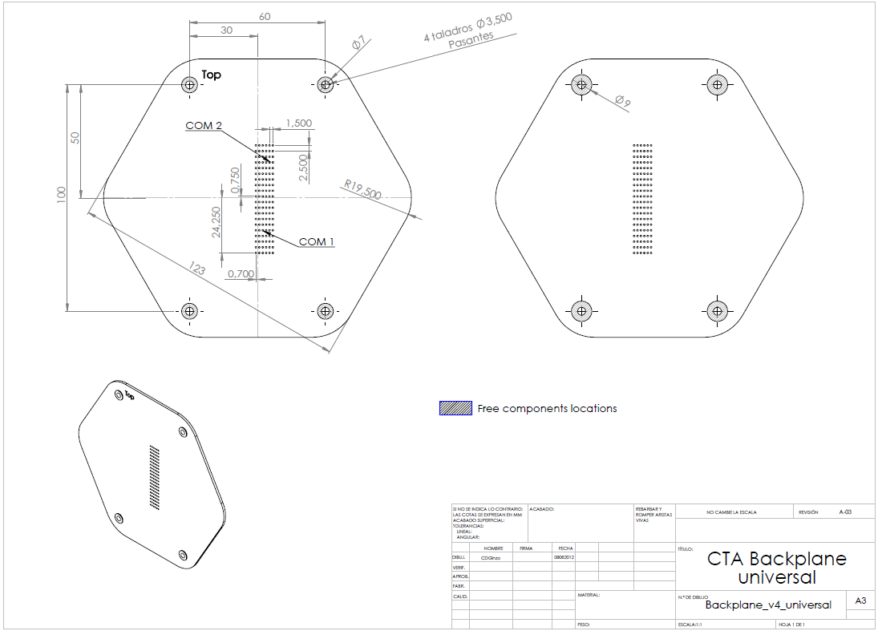
Fig 4. Backplane drawings.

Fig 5. Backplane drawings (detail): FrontEnd-Backplane interface connector position at backplane. This is the TOP layer view of the backplane. The connectors are installed in the BOTTOM layer. Notice the coordinates of the pin 1 of the FE-BP connectors are referred to the center of the cluster, that is, the center of the FE board itself, assuming a FE board thickness of 1.6mm.

Fig 6. 3D view of FrontEnd and backplane boards. In Front-end board the FE-BP interface connectors are installed in the TOP layer. In backplane board, FE-BP connectors are installed in BOTTOM layer, and telescope interface connectors, power connector, FPGA and neighbor connectors are installed in TOP layer.

Fig 7. FE-BP interface connector position at FrontEnd board.

