L2 Controller Board Rev.2, User Manual

Author | Laboratory |  | Approved by | Laboratory
Karl-Heinz Sulanke DESY

List of Abbreviations
SPI | Serial Peripheral Interface | RW | Read / Write
L2CB | L2 Controller Board | RO | Read Only
CTDB | Clock & Trigger Distribution Board | RWC | Read / Write Clear
L2BP | L2 Crate Backplane | 76h | 76 hexadecimal
LVDS | Low Voltage Digital Signalling

History
Version | Date | Observation
1 | 18/10/2016 | Draft
2 | 20/03/2017
3 | 29/05/2018

Distribution

Table of Contents
1 Introduction 3
2 L2CB Interfaces 3
2.1 Ethernet to FPGA 3
3 Slow Control via SPI Bus 4
4 L2CB Register Address Map, Base Address = 000h 6
5
Introduction

This document describes the slow control software interface between the L2CB board and the CTDBs.

L2CB Interfaces

Ethernet to FPGA
The microcontroller based unit Stamp9G45 is used as a 100MBit Ethernet to FPGA-bridge. It shares a 16 bit memory bus interface with the FPGA.
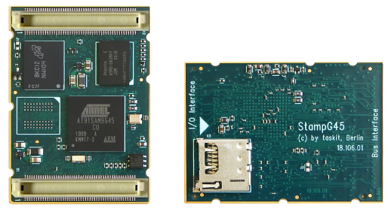
Figure 1: Stamp9G45
To communicate with each of the 18 CTDBs a shared SPI bus is implemented. The L2CB is the bus master.

L2CB to TIB
The L2CBs upper RJ45 connector, named “TIP_clock”, receives the 10 MHz clock and the 1PPS signal from the TIB. It is assumed, that the leading edge of the 1PPS signal follows the 10MHz leading edge after 7ns.

Slow Control via SPI Bus

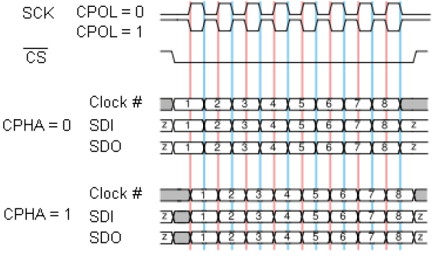
Figure 2: SPI Bus Modes. The used SPI Bus mode is of the type CPOL = 0, CPHA = 1

L2 Backplane, SPI Bus signals
SPI_SCLK | L2CB output that provides 32 clock cycles at each slow control access. The frequency of the clock it is 6.25 MHZ . The electrical standard for this signal is LVDS. Other frequencies are possible.
SPI_SYNCn | L2CB output , low during the slow control access and else high. Electrical standard for this signal is LVDS.
SPI_MOSI | Master output / slave input data line. A 32-bit word is transmitted at each slow  control access. Electrical standard for this signal is LVDS.  The most significant bit is transmitted first. The format of the 32-bit word is shown in table 1.
SPI_MISO | Master input / slave output data line. Electrical standard for this signal is LVDS.  A 16-bit word is transmitted at each slow control access. The most significant bit is transmitted first. Active at a read access, else tristated. This line provides the information of the addressed CTDB register.

Bit range | Usage
31 | RD = ‘0’, WR = ‘1’
30-16 | Address_14..0, register address
15-0 | Data_15..0, data word

Table 1: Slow control 16 bit data field, Bit-15 (MSB) is sent first

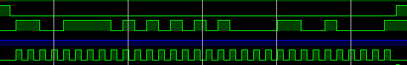 | SPI_SYNCn
 | SPI_MOSI
 | SPI_MISO
 | SPI_SCLK
Figure 3: Example, writing data 4321h to address 4f55h
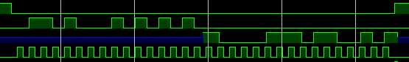 | SPI_SYNCn
 | SPI_MOSI
 | SPI_MISO
 | SPI_SCLK
Figure 4: Example, reading data 8765h to address 68aah

L2CB Register Address Map, Base Address = 000h

hex addr. | Name | Usage
00 | CTRL | Control register
02 | STAT | Status register
04 | SPAD | SPI Address register
06 | SPTX | SPI Tx Data register
08 | SPRX | SPI Rx Data register
0a | TSTMP0 | Time stamp, bits 15..0
0c | TSTMP1 | Time stamp, bits 31..16
0e | TSTMP2 | Time stamp, bits 47..32
10 | TEST | Test register, 16 bit R/W
12 | L1SEL | L1 Trigger channel select, for masking and up delay adjust
14 | L1MSK | L1 Trigger mask for channels of selected L2-crate slot
16 | L1DEL | L1 trigger delay in 37ps steps, 0..5ns
...
...
fe | FREV | Firmware Revision, bits 15..0

The registers can be accessed by the Stamp9G45 module via ethernet or RS232
Register Description
attribute | explanation
RW | Read / Write
RO | Read Only
RWC | Read / Write Clear (writing a ‘1’ clears the bit)

CTRL @ address 00h, 16 bit RW, power_on_value = 0 (0000h)
Bit | Attr. | Usage
15 | RW | 0 to 1 change latches a 48 bit time stamp counter, clocked by TIB_10MHz
14..0 | RW | reserved

STAT @ address 02h, 16 bit RO, RWC, power_on_value = 0 (0000h)
Bit | Attr. | Usage
0 | RO | ‘1’= SPI bus cycle busy
1 | RO | ‘1’= L1 delay set busy
15..2 | ‘0’ | Reserved, read value is ‘0’

Status bits to poll on the readiness of the operation.

Any write operation to the SPAD register initiates a SPI cycle. For SPI write operations, data have to be written to the SPTX register first ! Before initiating the next SPI cycle check STAT-bit_0 (polling on readiness).
SPAD @ address 04h, 13 bit RW, power_on_value = 0 (0000h)
Bit | Attr. | Usage
7..0 | RW | CTDB register address
12..8 | RW | L2-Crate, CTDB slot number: 1..9, 13..21
14..13 | ‘0’ | Reserved, write ‘0’
15 | RW | ‘1’ = Write cycle, ‘0’ = Read cycle

SPTX @ address 06h, 16 bit RW, power_on_value = 0 (0000h)
Bit | Attr. | Usage
15..0 | RW | SPI (CTDB register ) data, to be sent

SPRX @ address 08h, 16 bit RO, power_on_value = 0 (0000h)
Bit | Attr. | Usage
15..0 | RO | SPI (CTDB register ) data received

The 0 to 1 transition of the CTRL-reg. bit_15 latches the 48 bit counter, driven by a 125MHz clock (8ns). The clock is synchronous to the TIB-10MHz clock.
TSTMP0 @ address 0ah, 16 bit RO, power_on_value = 0 (0000h)
Bit | Attr. | Usage
15..0 | RO | time stamp, bits 15..0 , multiples of 8ns

TSTMP1 @ address 0ch, 16 bit RO, power_on_value = 0 (0000h)
Bit | Attr. | Usage
15..0 | RO | time stamp, bits 31..16

TSTMP2 @ address 0eh, 16 bit RO, power_on_value = 0 (0000h)
Bit | Attr. | Usage
15..0 | RO | time stamp, bits 47..32

TEST @ address 10h, 16 bit RW, power_on_value = 0 (0000h)
Bit | Attr. | Usage
15..0 | RW | read / write test register, no additional functionality

L1SEL @ address 12h, 16 bit RW, power_on_value = 0 (0000h)
Bit | Attr. | Usage
3..0 | RW | CTDB channel number of selected slot, valid are: 1..15
8..4 | RW | L2-crate slot number, valid are: 1..9, 13..21
15..9 | RO | unused, read value is ‘0’

After power on, all L1s are blocked. Write a ‘1’ to the selected L1MSK bit for enabling the dedicated L1 signal.
L1MSK @ address 14h, 16 bit RW, power_on_value = 0 (0000h)
Bit | Attr. | Usage
0 | RO | unused, read value is ‘0’
15..1 | RW | trigger mask for the selected (L1SEL reg.) slot, each channel has its own select bit, valid are 0000h...fffeh, ‘0’ means L1-trigger of the selected channel is not used

Before changing the L1 delay of a particular channel, check the STAT-bit_1 (polling on readiness). The delay for other channels can be set immediately. Note, the readiness for a particular channel requires the occurrence of several L1 signals.
L1DEL @ address 16h, 8 bit RW, power_on_value = 0 (0000h)
Bit | Attr. | Usage
7..0 | RW | L1 delay of selected ( by L1SEL reg.) trigger channel, usable range 0..128 (x 37ps)
15..8 | RO | 00h

FREV @ address fe, 16 bit RO
Bit | Attr. | Usage
15..0 | RO | read back of the L2CB firmware revision

