|  |
| --- |
| **L2CB (OPC UA based) Slow Control ICD** |

|  |  |  |  |  |
| --- | --- | --- | --- | --- |
| **Author** | *Laboratory* |  | **Approved by** | *Laboratory* |
| Karl-Heinz Sulanke DESY | |  |  | |
|  | |  |  | |
|  | |  |  | |

|  |  |
| --- | --- |
| **Acronym** | **Description** |
| OPC UA | Open Platform Communications Unified Architecture |
| SDK | Software Development Kit |
| DIM | Device Interface Model |
| DOM | Document Object Model |
| SPI | Serial Peripheral Interface |
| L2CB | L2 Controller Board |
| CTDB | Clock & Trigger Distribution Board |
|  |  |
|  |  |
|  |  |
|  |  |
|  |  |
|  |  |
|  |  |
|  |  |
|  |  |

|  |  |  |
| --- | --- | --- |
| **History** | | |
| Version | Date | Observation |
| 1 | 24/10/2020 | Draft |
|  |  |  |
|  |  |  |
|  |  |  |
|  |  |  |
|  |  |  |
|  |  |  |

|  |  |
| --- | --- |
| **Distribution** |  |

**Table of Contents**

1 Introduction 4

1.1 Hardware 4

2 C++ OPC UA Server for the L2CB 5

2.1 Object Tree in the OPC UA Server Address Space 6

2.2 C++ OPC UA Server, Performance Tests 7

2.3 Read Data Flow 8

2.4 Write Data Flow 8

2.5 L2CB Server Variables 9

2.6 Source code at the DESY GIT repository and DESY local SVN repository 10

2.7 OPC UA L2CB Server Prototype 10

# Introduction

This document describes the slow control interface between the L2CB board and the CTDBs, an OPCUA implementation by [David Melkumyan](mailto:david.melkumyan@desy.de). The document is based on his status update report from March 2018 with the title “ Prototyping the C++ OPC UA Server for the L2 CTDB”.

He implemented the first (@DESY) C++ Server, that represents the L2CB hardware via standard software layer, based on the OPCUA protocol.

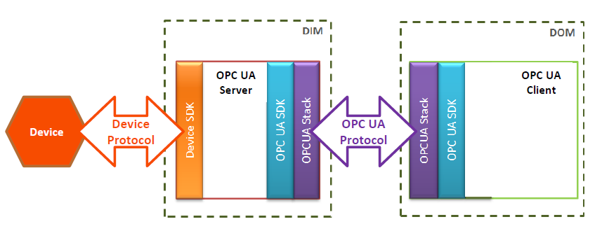

## Hardware

The Linux ARM based microcontroller unit Stamp9G45 is used as a 100MBit Ethernet to FPGA-bridge. It shares a 16 bit memory bus interface with the FPGA.

|  |
| --- |
|  |
| **Figure 1**: Stamp9G45 |

To communicate with each of the 18 CTDBs a shared SPI bus is implemented. The L2CB is the bus master.

|  |
| --- |
| C++ OPC UA Server for the L2CB |

# 

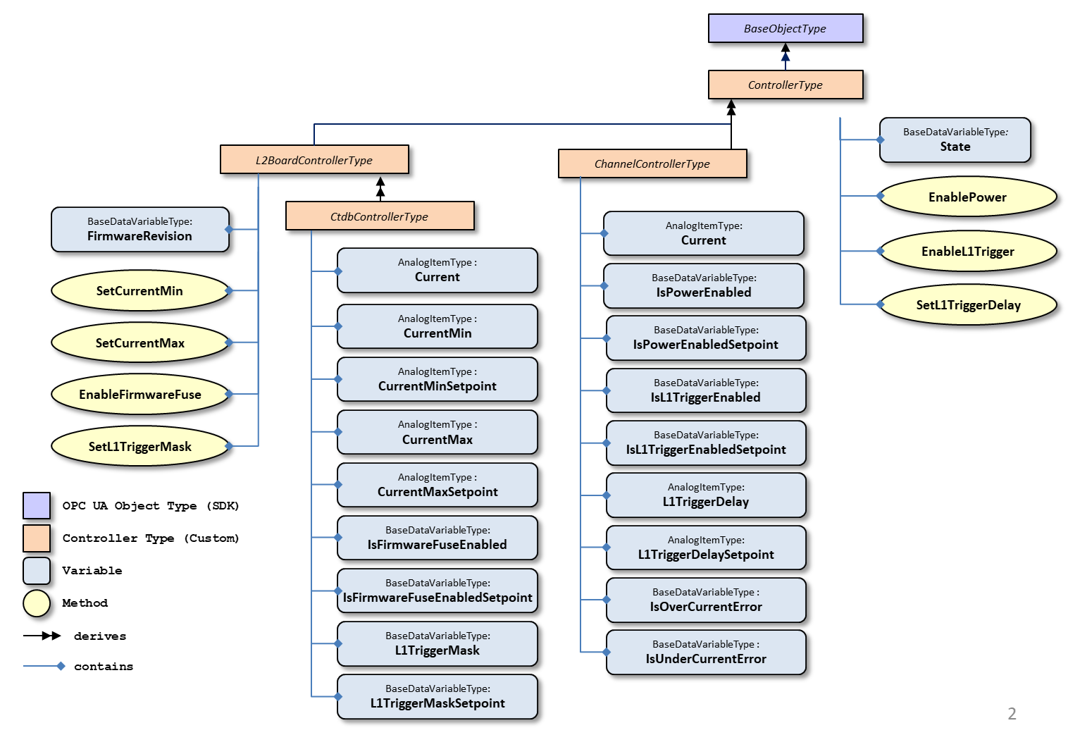

## Object Tree in the OPC UA Server Address Space

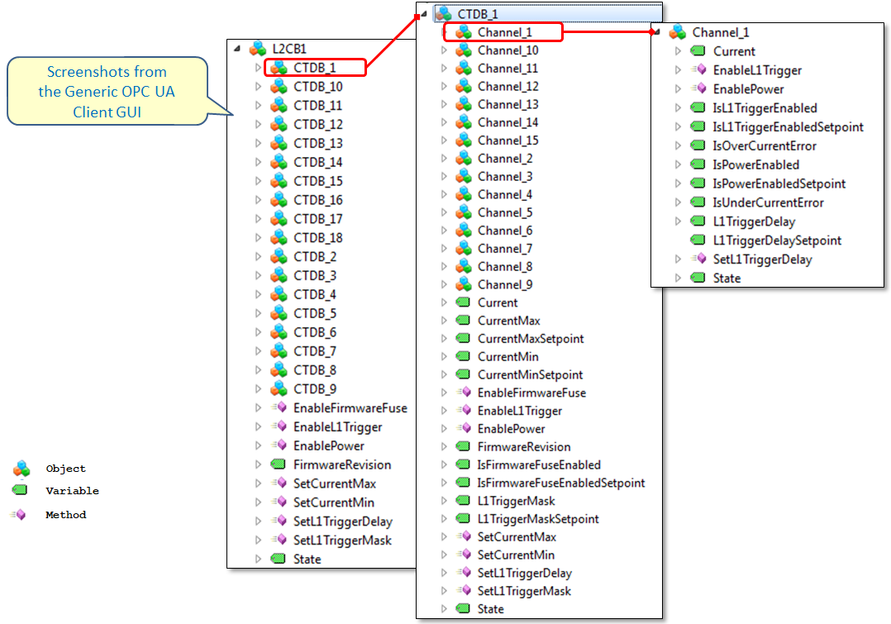

## C++ OPC UA Server, Performance Tests

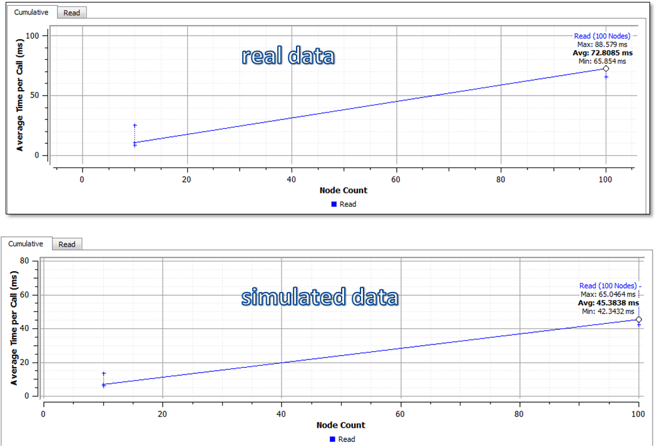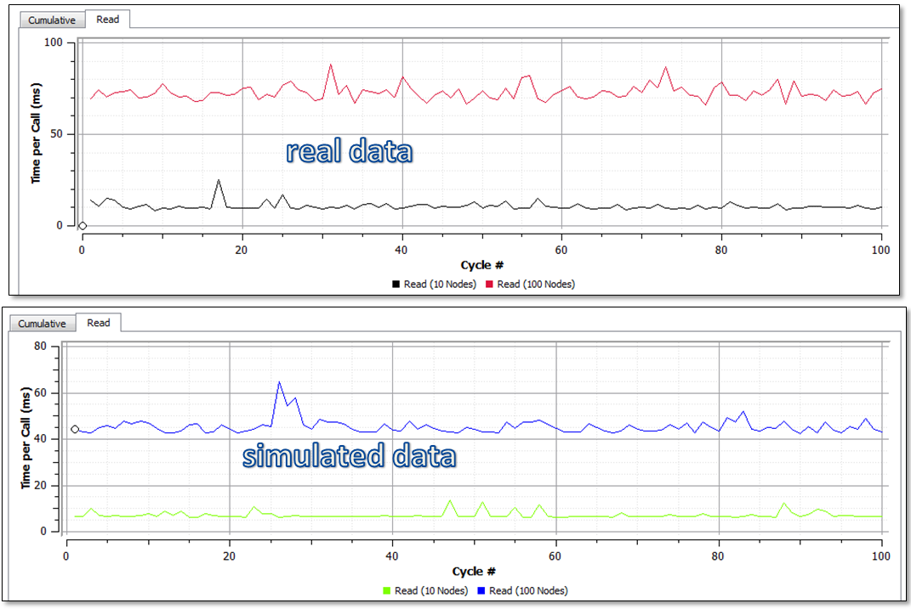

## Read Data Flow

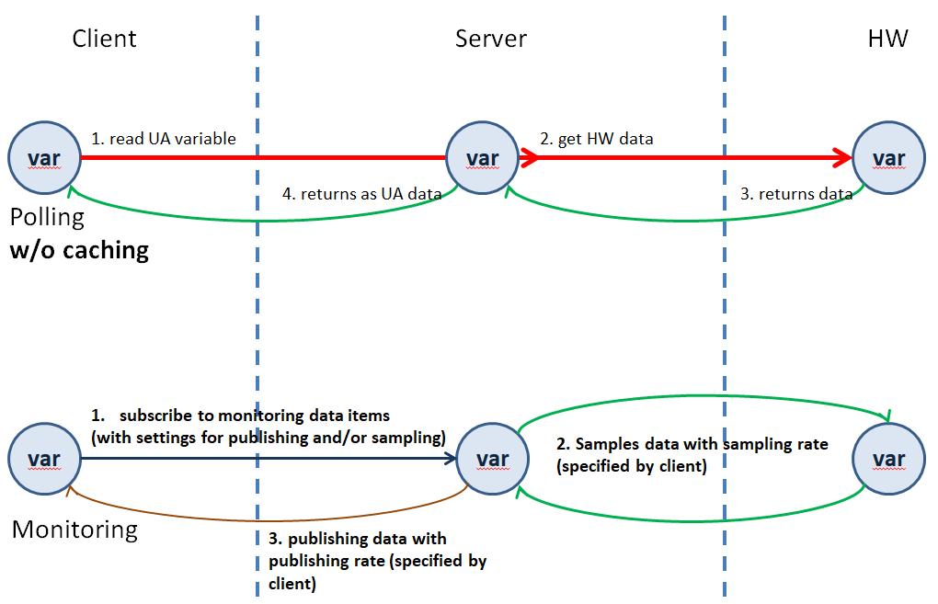

## Write Data Flow

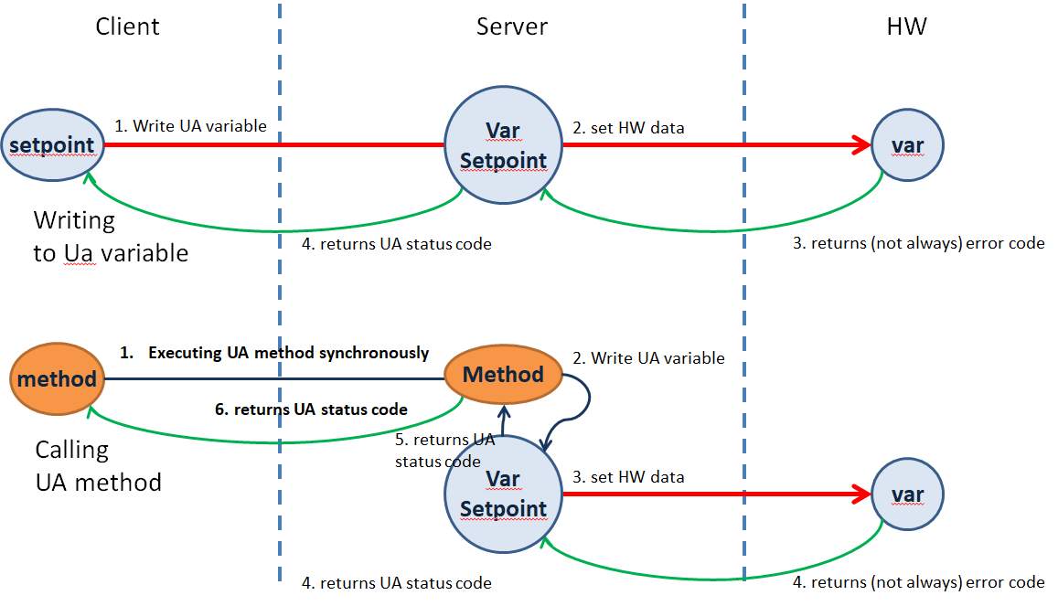

## L2CB Server Variables

**Update / Sampling rates & initial / simulated values**

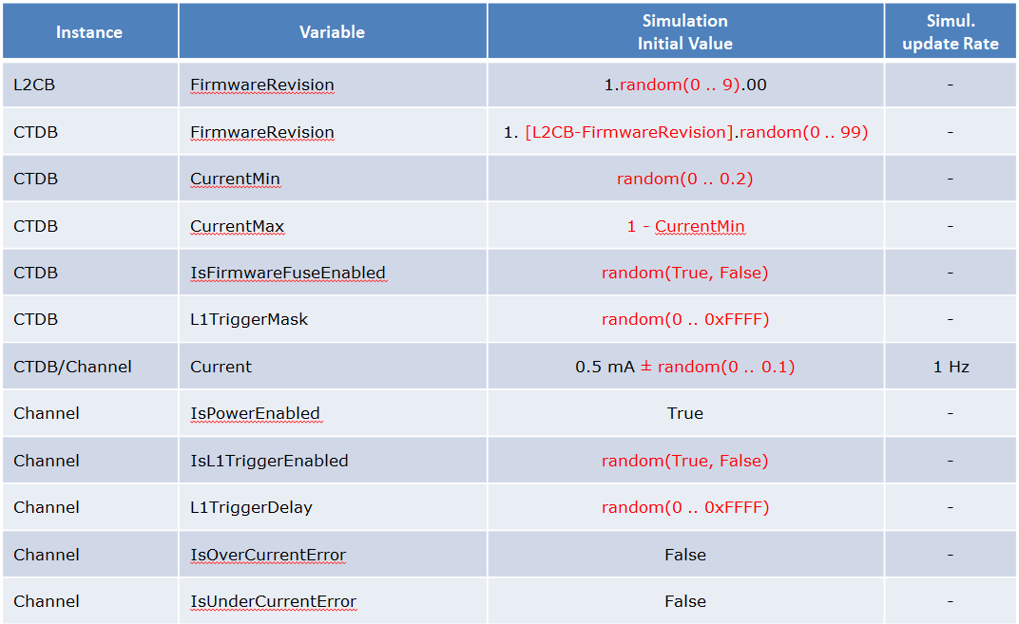

**Data monitoring**

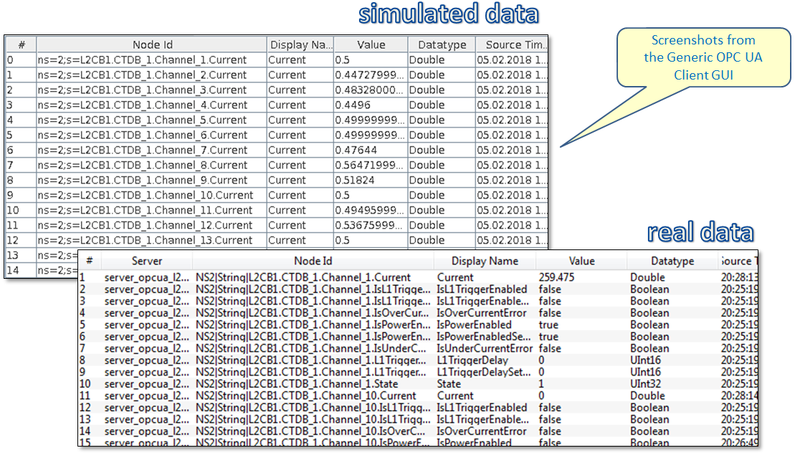

## Source code at the DESY GIT repository and DESY local SVN repository

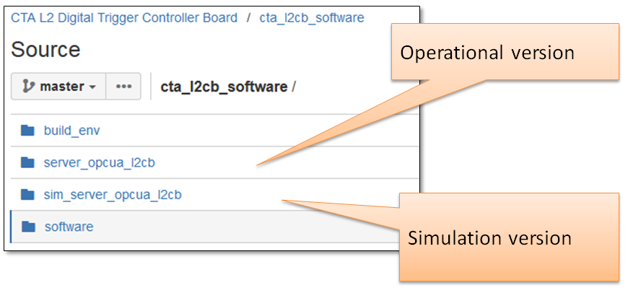

## OPC UA L2CB Server Prototype

An initial version is implemented (with integrated HAL library), cross-compiled and tested on the embedded system.

A preinstalled version is available on host CTA_L2CB1 (IP 141.34.130.21) under

/opt/opcua/server_opcua_l2cb/server_opcua_l2cb

The source code is committed to the GIT (DESY Stash) repository at:

<https://stash.desy.de/projects/CTAL2CB/repos/cta_l2cb_software/browse/server_opcua_l2cb>

available (as tar file) at:

<https://desycloud.desy.de/index.php/s/EKEbVHDYaXLn5GR>