Basic Parts
- 1x subrack 6HE 84TE 235T LD 24563-452
- 1x 19" bracket type F with handel holes 24564-498
- 1x front handle, 12.2mm, clear anodised, 6U 10501-008
- 2x back cover plate (half width), 6U 20848-139

Tools
- Torx- wrench T20H
- Slotted screwdriver

Mounting

Crate
- mount module rails (front, middle, back) using screws M4x14/10 (according to „Subrack User Manual 64560-114“ p. 2) to one side wall
- slide in threaded stripes and hole striped
- use right orientation of the side walls, pressed-in holding point inside
- mount handles
- follow the received construction manual !
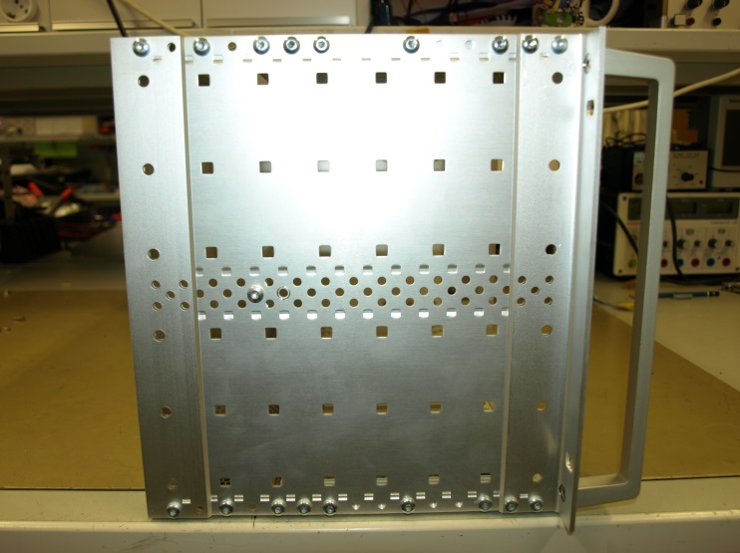

Guide Rails and Front Plates

Gray Guide Rail at Pos.
1 | 00 – 03
2 | 04 – 07
3 | 08 – 11
4 | 12 – 15
5 | 16 – 19  Red Guide Rail at Pos.  1 40 – 43
6 | 20 – 23
7 | 24 – 27
8 | 28 – 31
9 | 32 – 35
10 | 48 – 51
11 | 52 – 55
12 | 56 – 59
13 | 60 – 63
14 | 64 – 67
15 | 68 – 71
16 | 72 – 75
17 | 76 – 79
18 | 80 – 83

- Mount front plates at not used positions:
  - 36 – 39
  - 44 – 47

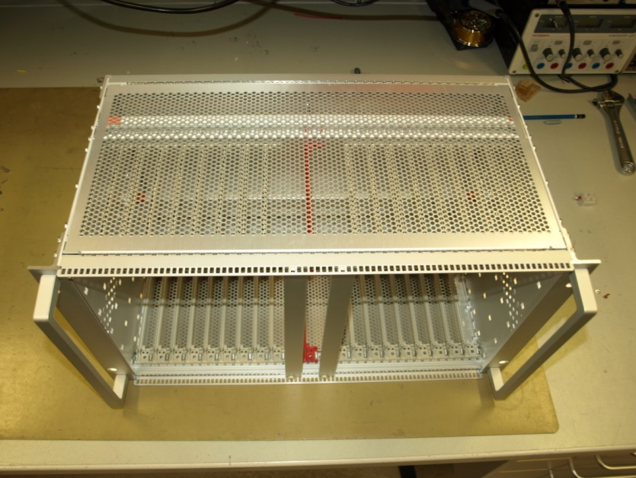
Cover Plates
- Mount cover plates according to „Subrack User Manual 64560-114“

Back Plane Mounting

Material needed
- 84x M2,5x10mm screws
- 84x M2,5 washers
- 38x M4x10mm screws, brass
- 38x M4 washers, brass
- 38x M4 toothed locked washer, brass
- 8x distant bolts, nylon, M3x15
- Backplane L2BP1
- Copper rails (check dedicated folder)
- 8x 0.2m braided cable (black, 35mm²) with tubular lugs M8 at both ends
- 0.4m braided cable (red, 2,5mm²) with tubular lug M4 / wire end ferrule
- 0.4m braided cable (blue, 2,5mm²) with tubular lug M4 / wire end ferrule
- 0.1m braided cable (blue, 2,5mm²) with tubular lug M4 / tubular lug M4
- 1x prepared half back plate with 24V power connectors
- 1x prepared half back plate with 240VAC power connector

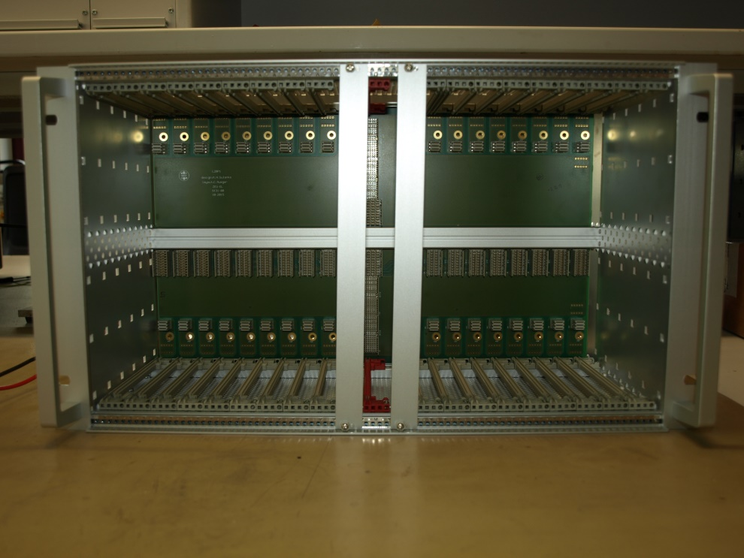
Mounting
- mount backplane L2BPx to the module rails
- mount 8 nylon distant bolts to the copper rails
- mount the copper rails to the backplane using M4 screws / washers (brass)
- attach the black power cables loosely to the copper rails

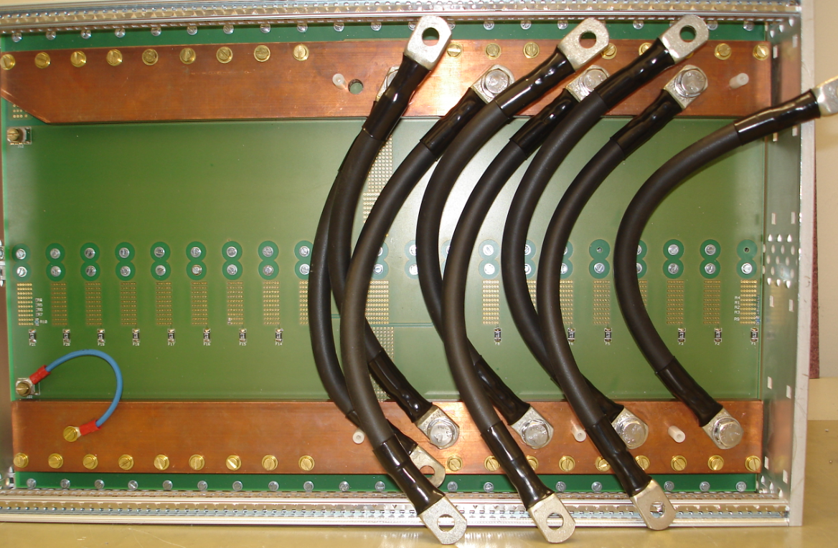

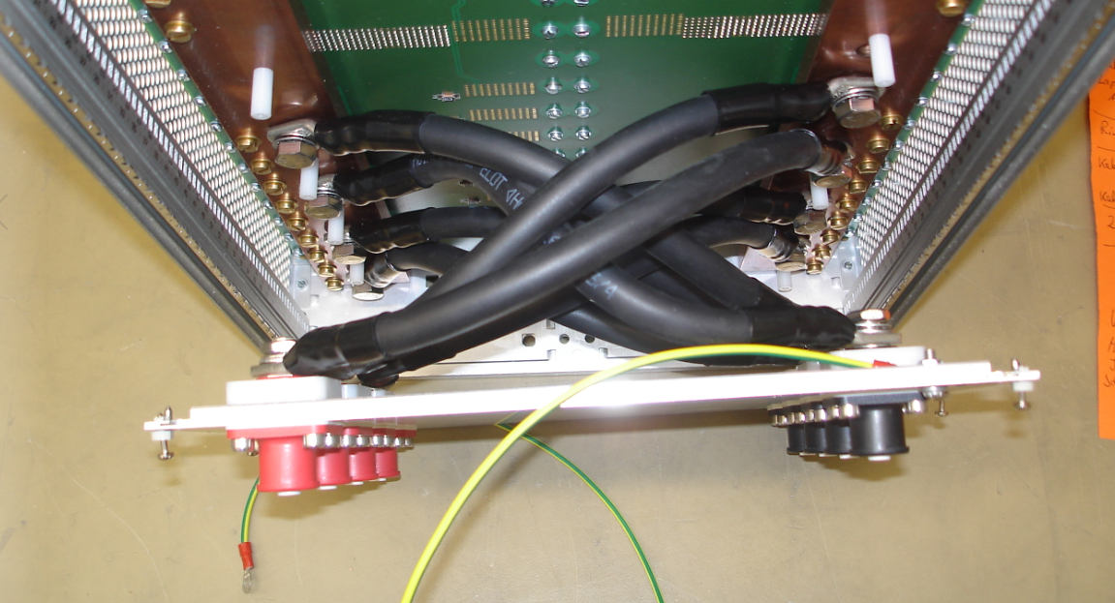
- attach the power cable and the chassis ground to the back plates power connectors

- Fix the inner power cable connection first
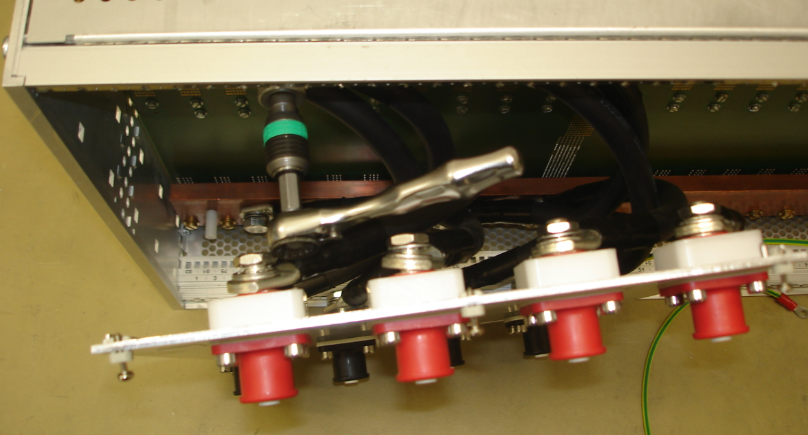

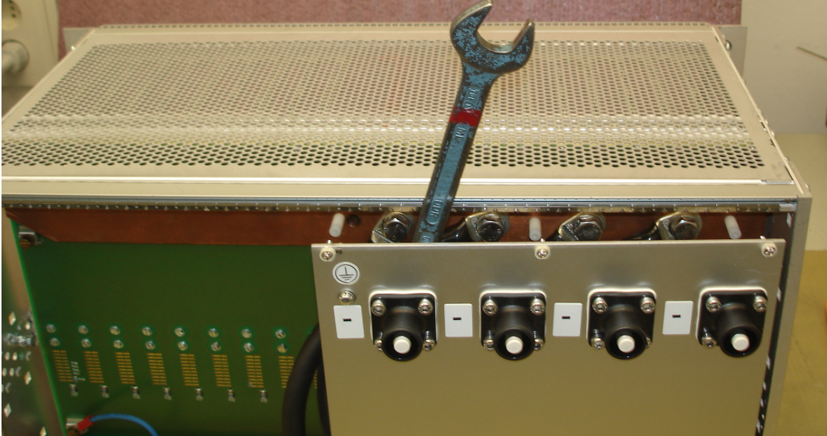
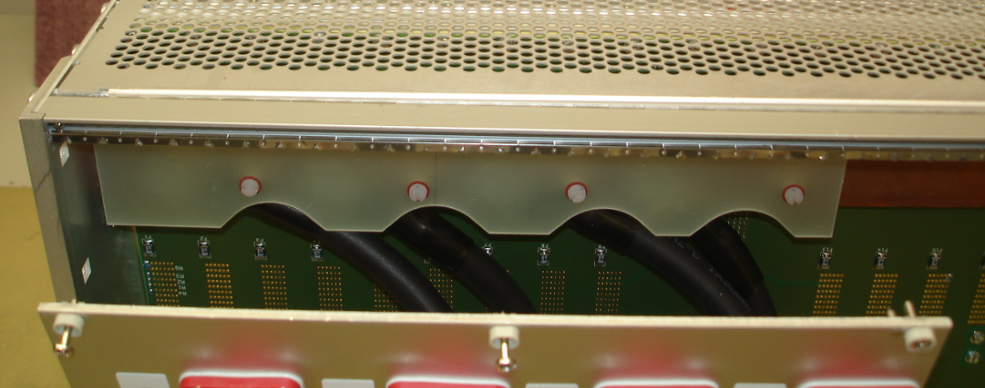
- Fix the outer power cable connection afterwards

- Mount the isolating FR4 plates

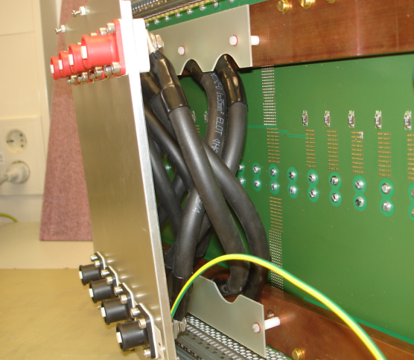
- Mount the back plate

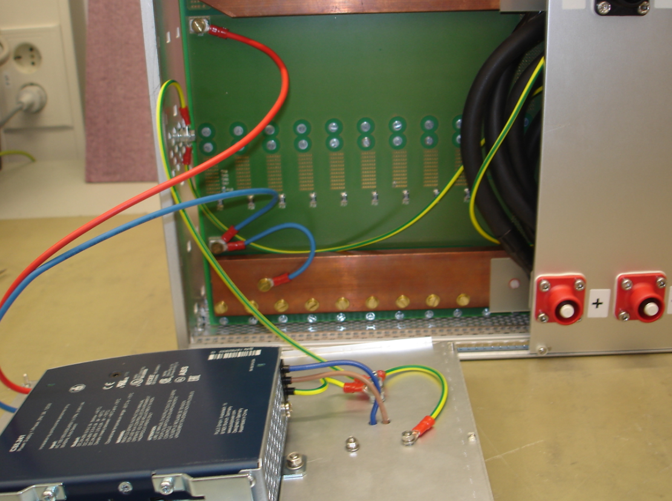
- Connect the blue (-), the red (+) of the auxiliary power supply and the chassis ground to the backplane

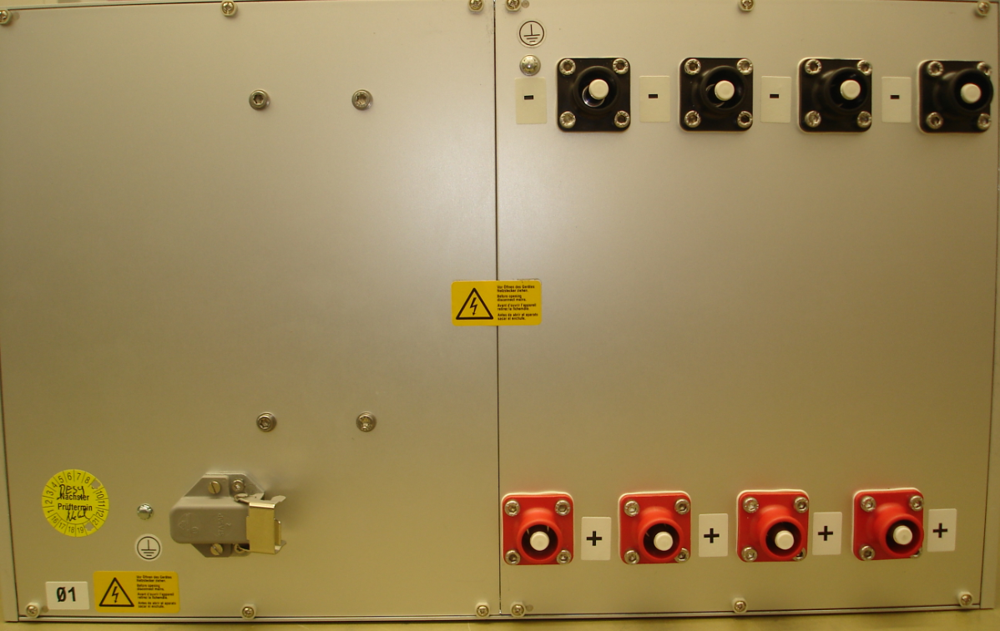
- Close the back side of the crate. Done !

