|  |
| --- |
| **L2Crate Mechanical Interface Definition** |

|  |  |  |  |  |
| --- | --- | --- | --- | --- |
| **Author** | *Laboratory* |  | **Approved by** | *Laboratory* |
| **Karl-Heinz Sulanke DESY** | |  |  | |
|  | |  |  | |
|  | |  |  | |

|  |  |  |  |
| --- | --- | --- | --- |
| **List of Abbreviations** | | | |
|  |  |  |  |
|  |  |  |  |
|  |  |  |  |
|  |  |  |  |
|  |  |  |  |
|  |  |  |  |
|  |  |  |  |
|  |  |  |  |
|  |  |  |  |

|  |  |  |
| --- | --- | --- |
| **History** | | |
| Version | Date | Observation |
| 01 | 21/10/2020 | Draft |
|  |  |  |
|  |  |  |
|  |  |  |
|  |  |  |
|  |  |  |
|  |  |  |
|  |  |  |
|  |  |  |
|  |  |  |
|  |  |  |
|  |  |  |
|  |  |  |
|  |  |  |

|  |  |
| --- | --- |
| **Distribution** |  |

**Table of Contents**

1 Introduction 3

2 Mechanics 3

2.1 Dimensions 3

# Introduction

This document describes L2Crate mechanical interface.

# Mechanics

The L2Crate is a 6U standard 19” rack.

At the back side an extra space depth of 35mm is required, to accommodate the power connectors (242mm -> 277mm)

## Dimensions

For details check the file **L2Crate_mechanics.stp** or the Schroff website, product ID **24563-452.**

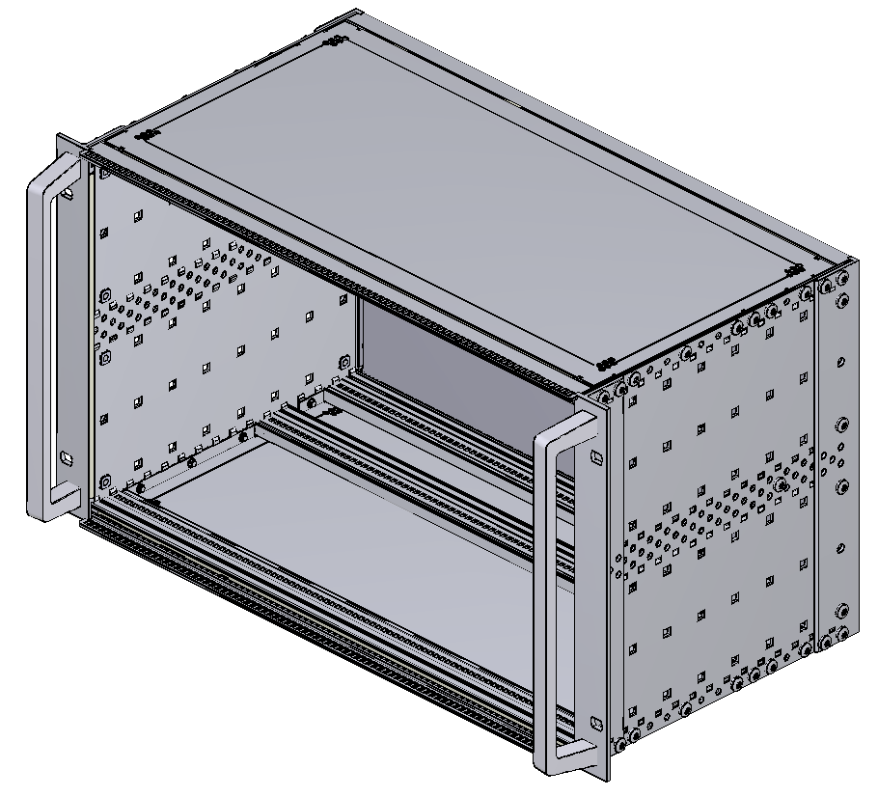

448

266

242

190.5

D = 7.5

D = 7.5

282

483