|  |
| --- |
| **L2Crate Power Supply Box Interface Definition** |

|  |  |  |  |  |
| --- | --- | --- | --- | --- |
| **Author** | *Laboratory* |  | **Approved by** | *Laboratory* |
| **Karl-Heinz Sulanke DESY** | |  |  | |
|  | |  |  | |
|  | |  |  | |

|  |  |  |  |
| --- | --- | --- | --- |
| **List of Abbreviations** | | | |
| PSB | Power Supply Box |  |  |
|  |  |  |  |
|  |  |  |  |
|  |  |  |  |
|  |  |  |  |
|  |  |  |  |
|  |  |  |  |
|  |  |  |  |
|  |  |  |  |

|  |  |  |
| --- | --- | --- |
| **History** | | |
| Version | Date | Observation |
| 01 | 21/10/2020 | Draft |
|  |  |  |
|  |  |  |
|  |  |  |
|  |  |  |
|  |  |  |
|  |  |  |
|  |  |  |
|  |  |  |
|  |  |  |
|  |  |  |
|  |  |  |
|  |  |  |
|  |  |  |

|  |  |
| --- | --- |
| **Distribution** |  |

**Table of Contents**

1 Introduction 4

2 Mechanics 4

2.1 Auxiliary Power Supply, PULS CS5.C241-C1, Back Plate Mounting 5

5

2.2 24V Power Connectors, Back Plate, Sketch 6

3 Connectors, Types and Usage 7

3.1 L2Crate Internal Power Cabling 7

4 Auxiliary Power Supply PULS CS5.C241-C1, Data 8

# Introduction

This document describes mechanical and electrical interface between the L2Crate and the PSB.

# Mechanics

The L2Crate is a 6U standard 19” rack.

The connections to the PSB are accommodated at the back side.

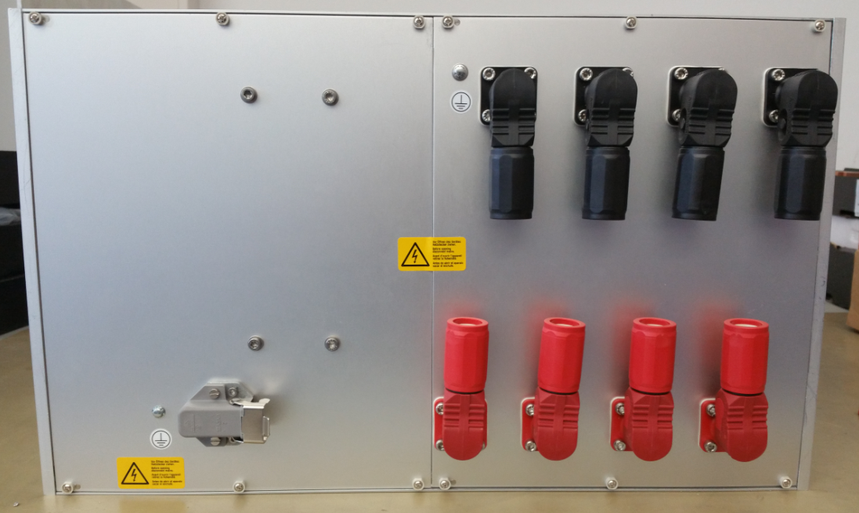

GND Connectors

+24V Connectors

240VAC

## Auxiliary Power Supply, PULS CS5.C241-C1, Back Plate Mounting

## 

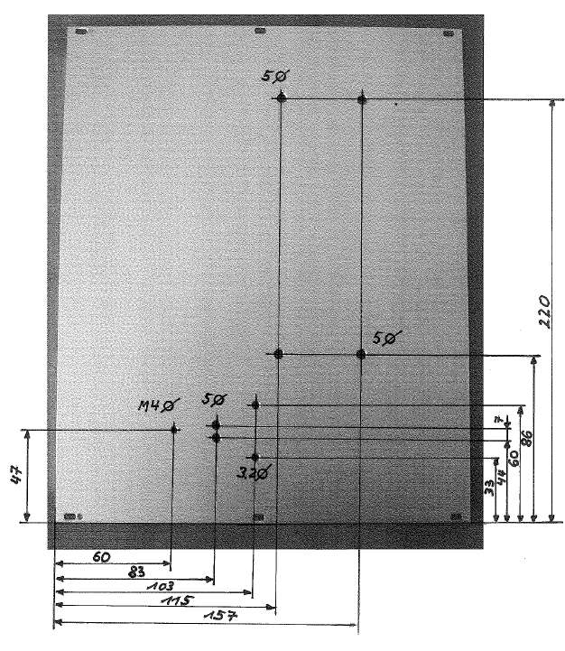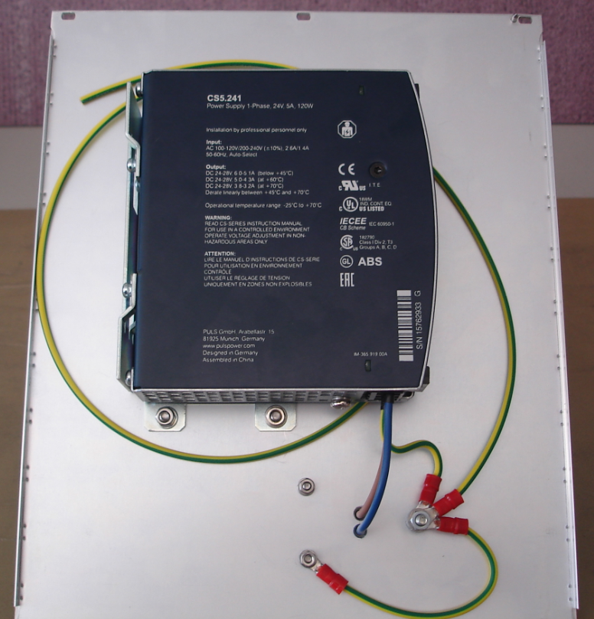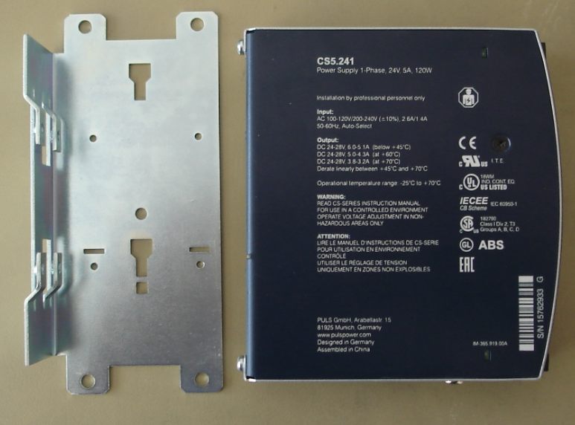

## 24V Power Connectors, Back Plate, Sketch

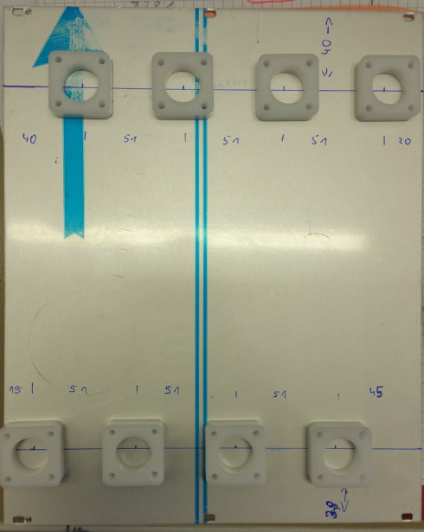

# Connectors, Types and Usage

|  |  |  |  |
| --- | --- | --- | --- |
| **description** | **manufacturer** | **ID** | **remark** |
| power entry, receptable, 200A, black | AMPHENOL INDUSTRIAL | SLPRBTPSB | 4x, 200A, crate socket, GND |
| power entry, receptable, 200A, red | AMPHENOL INDUSTRIAL | SLPRBTPSR | 4x, 200A, crate socket, +24V |
| power entry, plug, 200A, black | AMPHENOL INDUSTRIAL | SLPPB50BSB | 4x, 200A, cable plug, GND |
| power entry, plug, 200A, red | AMPHENOL INDUSTRIAL | SLPPB50BSR | 24x, 00A, cable plug, GND |
| 240VAC power connector | Hirschmann | 930822106 | auxiliary power supply CS5.241-C1 |
| 240VAC power connector lock | Hirschmann | 732 044000 |

## L2Crate Internal Power Cabling

Cable used: 35mm2 copper, H01N2-D1x35, Lapp Group

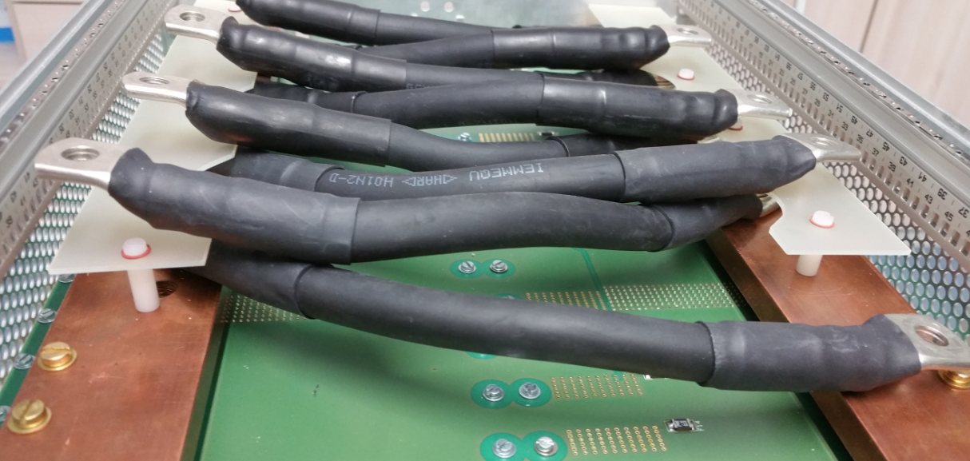

# Auxiliary Power Supply PULS CS5.C241-C1, Data

