|  |
| --- |
| DTS Quality Check Procedure for Production |

|  |  |  |  |  |
| --- | --- | --- | --- | --- |
| **Author** | *Laboratory* |  | **Approved by** | *Laboratory* |
| **Karl-Heinz Sulanke DESY** | |  |  | |
|  | |  |  | |
|  | |  |  | |

|  |  |  |  |
| --- | --- | --- | --- |
| **List of Abbreviations** | | | |
| DTS | Digital Trigger System |  |  |
| CTDB | Clock & Trigger Distribution Board |  |  |
| DTB | Digital Trigger Backplane |  |  |
| FEB | Frontend Board |  |  |
| L2BP | L2 Crate Backplane |  |  |
| L2CB | L2 Crate Controller Board |  |  |
|  |  |  |  |
|  |  |  |  |
|  |  |  |  |

|  |  |  |
| --- | --- | --- |
| **History** | | |
| Version | Date | Observation |
| 01 | 21/10/2020 | Draft |
|  |  |  |
|  |  |  |
|  |  |  |
|  |  |  |
|  |  |  |
|  |  |  |
|  |  |  |
|  |  |  |
|  |  |  |
|  |  |  |
|  |  |  |
|  |  |  |
|  |  |  |

|  |  |
| --- | --- |
| **Distribution** |  |

**Table of Contents**

1 Introduction 3

1.1 Items to be tested 3

1.2 DTB Test 3

1.3 DTB Cable Tester 5

1.4 CTDB and L2CB Test 6

1.5 L2Crate Testing 7

# Introduction

This document describes the presently used quality check for the elements of the DTS system.

## Items to be tested

|  |  |
| --- | --- |
| **Item** | **remark** |
| DTB |  |
| DTB cabling | 40 pos. flat cabling DTB interconnect |
| CTDB |  |
| L2CB |  |
| L2Crate |  |

## DTB Test

|  |  |  |
| --- | --- | --- |
| **Item** | **Test Procedure** | **responsible** |
| PCB | electrical test and impedance test (with protocol) | Vendor |
| Assembled Board | automated optical, test based on a reference board  automated electrical test (impedances), using flying probes, based on a reference board | Vendor |
| Assembled Board | power shortcut test, all voltage rails, using a multimeter  power test, all voltage rails, using a multimeter  functional tests, using dedicated firmware, test cabling, a test board, a lab power supply, a PC and a scope  most of the functionality can be tested with the board itself, using back looped signals  the FEB interface is tested, using a specially designed test board (L0_TB)  the L2Crate interface gets tested, using a single CTDB including special firmware  the tester has to follow a defined test protocol | DESY |

**DTB Test Equipment**

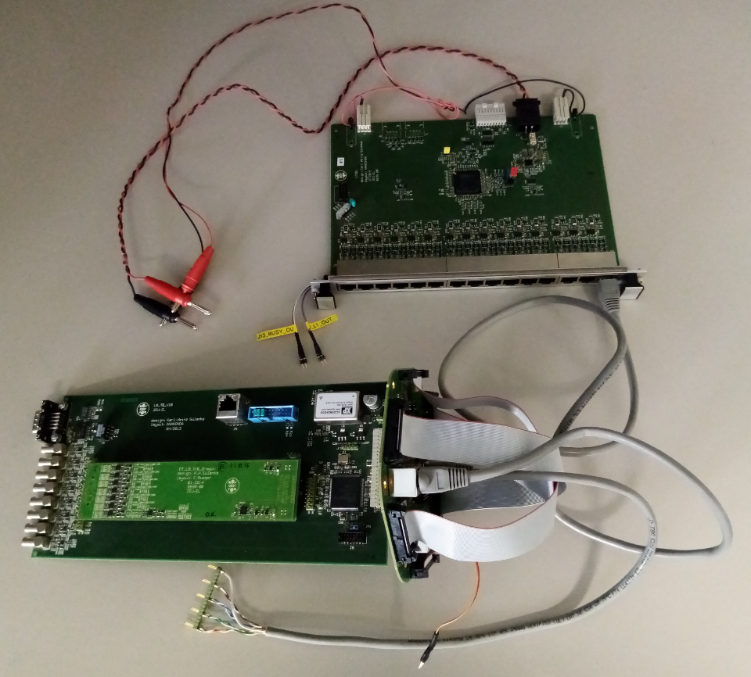

CTDB

in standalone mode

L0_TB

DTB,

to be tested

## DTB Cable Tester

See below the cable tester. Connectivity to the crimped connector is tested by push button + LED monitoring. Shortcuts between neighbour pins / lines are also being detected.

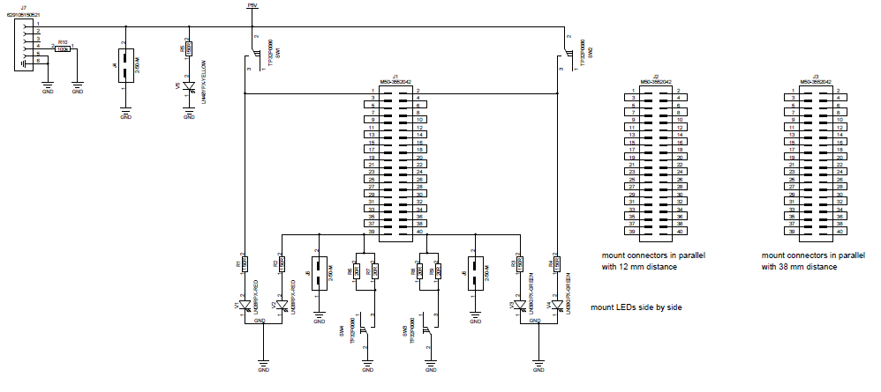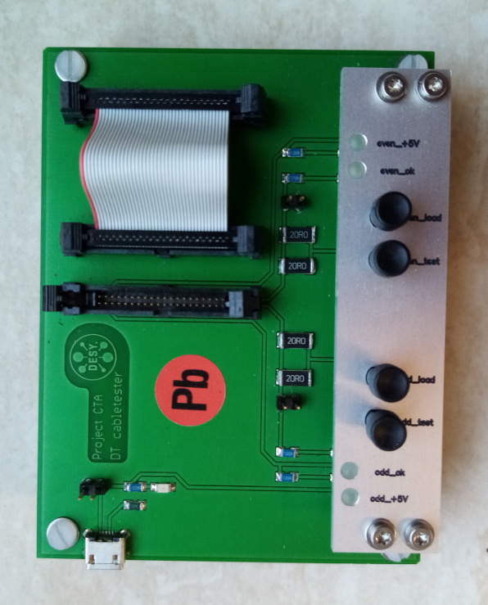

## CTDB and L2CB Test

|  |  |  |
| --- | --- | --- |
| **Item** | **Test Procedure** | **responsible** |
| PCB | electrical test and impedance test (with protocol) | Vendor |
| Assembled Boards | optical test  power shortcut test, all voltage rails, using a multimeter  power test, all voltage rails, using a multimeter  functional tests, using the 7 cluster test setup, a PC and a scope. The L2CBs TIB interface is tested with faked TIB signals, generated by the L2CBs FPGA.  the tester has to follow a defined test protocol | DESY |

Until now, the existing CTDBs and L2CBs have been produced at the DESY-Zeuthen workshop only, with limited (no automation) test procedures. For the mass production the same equipment could be used, like the one for the DTB production. To test the functionality of both boards, the DESY test setup is being used, see below.

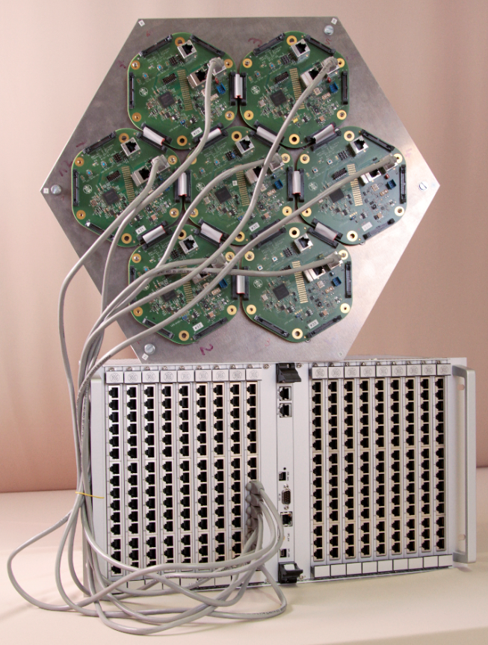

## L2Crate Testing

The L2Crate is also tested, using the above shown 7 cluster test setup. One CTDB and one L2CB are being used, to test in a consecutive way all CTDB slots and channels.

.