|  |
| --- |
| **DTB-CTDB Interface Definition** |

|  |  |  |  |  |
| --- | --- | --- | --- | --- |
| **Author** | *Laboratory* |  | **Approved by** | *Laboratory* |
| **Karl-Heinz Sulanke DESY** | |  |  | |
|  | |  |  | |
|  | |  |  | |

|  |  |  |  |
| --- | --- | --- | --- |
| **List of Abbreviations** | | | |
| DTB | Digital Trigger Backplane |  |  |
| FEB | Frontend Board |  |  |
| CTDB | Clock & Trigger Distribution Board |  |  |
| PPS | Pulse Per Second |  |  |
|  |  |  |  |
|  |  |  |  |
|  |  |  |  |
|  |  |  |  |
|  |  |  |  |

|  |  |  |
| --- | --- | --- |
| **History** | | |
| Version | Date | Observation |
| 01 | 21/10/2020 | Draft |
|  |  |  |
|  |  |  |
|  |  |  |
|  |  |  |
|  |  |  |
|  |  |  |
|  |  |  |
|  |  |  |
|  |  |  |
|  |  |  |
|  |  |  |
|  |  |  |
|  |  |  |

|  |  |
| --- | --- |
| **Distribution** |  |

**Table of Contents**

1 Introduction 3

2 Mechanics 3

3 Cabling 4

4 Connector Signals 4

5 Signal Timing 5

# Introduction

This document describes the connection between the DTB and the CTDB**.**

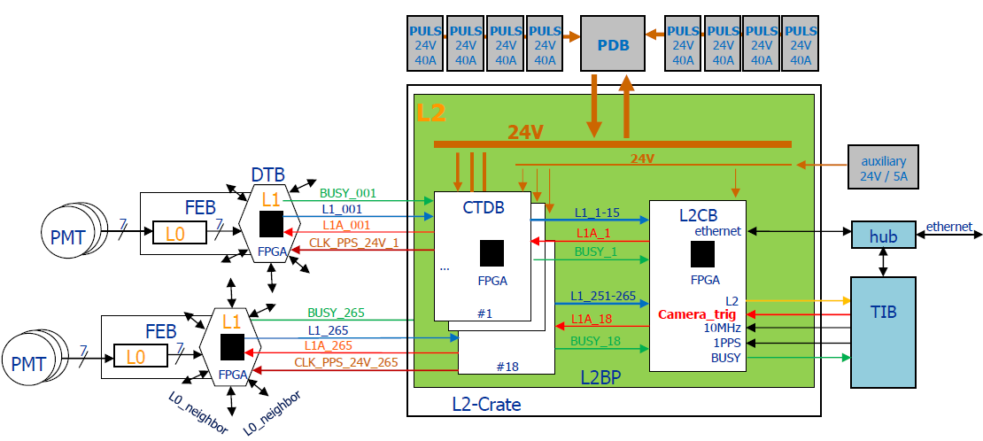

# Mechanics

|  |  |  |  |  |
| --- | --- | --- | --- | --- |
| **side** | **connector type** | **manufacturer** | **man.-ID** |  |
| DTB | RJ45, vertical | MOLEX | 85508-5001 |  |
| CTDB | RJ45, horizontal, 6 ports  and 3 ports | HARTING | 765-9129  765-9117 |  |

# Cabling

Standard shielded CAT.6 patch cable, 1:1, 3m length , R&M R803161 (orange, RAL2011)

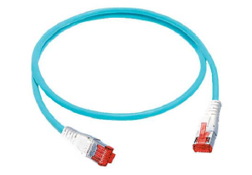

# Connector Signals

|  |  |  |  |  |
| --- | --- | --- | --- | --- |
| **RJ45-pin** | **DTBs schematic- signal** | **direction**  **(DTB view)** | **level** | **remark** |
| 1 | J13_CLK_EXT_P | in | 24V DC, modulated with 0.4V pk-pk clock_pps, | FEB power, clock modulated with PPS, |
| 2 | J13_CLK_EXT_N |
| 3 | J13_BUSY_N | out | LVDS | FEBs BUSY signal |
| 6 | J13_BUSY_B |
| 4 | J13_L2_IN_P | in | LVDS | L1A, camera trigger, propagated to FEB |
| 5 | J13_L2_IN_N |
| 7 | J13_L1_OUT_N | out | LVDS | L1 trigger, generated by DTB |
| 8 | J13_L1_OUT_P |
| shield | GND |  |  |  |

# Signal Timing

|  |  |  |
| --- | --- | --- |
| **signal** | **description** | **waveform** |
| CLK_EXT | 50MHz diff. signal, duty cycle 50:50, every second, one pulse with duty cycle 25:75 for PPS encoding | CLK_EXT and PPS after decoding |
| BUSY | driven by FEB after reception of a camera trigger, duration FEB (software) dependent |  |
| L2_IN | camera trigger (= L1A), pulse length defined by TIB firmware |  |
| L1_OUT | by DTB, up going trigger, pulse length programmable between unshaped or shaped in multiples of 8ns from 8ns to 120ns, | see 3nn- L1_OUT in green, below |