|  |
| --- |
| **Statement of Work**  **for the CTDB assembly** |

|  |  |  |  |  |
| --- | --- | --- | --- | --- |
| **Prepared by** | *Signature* |  | **Accepted by** | *Signature* |
| K.-H. Sulanke, DESY |  |  |  |  |
|  |  |  |  |  |
|  |  |  |  |  |

|  |  |
| --- | --- |
| **Summary** |  |

|  |  |  |
| --- | --- | --- |
| **Document Change Record** | | |
| *Version* | *Date* | *Observations* |
| 1 | 2020/10/18 | First draft |
|  |  |  |
|  |  |  |

|  |  |
| --- | --- |
| **Distribution** | ***See Distribution list at the end of this document*** |

* **Table of Contents –**

1. Introduction 3

1.1 Purpose of this document 3

1.2 Contractor’s tasks and responsibilities 3

2. References 3

2.1 Applicable Documents 3

2.2 Reference Documents 3

2.3 Normative Documents 3

2.4 Abbreviations and Nomenclature 3

3. SPECIFICATIONS FOR MANUFACTURING 4

4. DELIVERABLE ITEMS 7

4.1 Customer contacts and responsibilities 7

4.2 Manufacturer contacts and responsibilities 7

4.3 Design tools 7

4.4 Deliverable Hardware and Firmware 7

4.5 Spare Philosophy, Spare Provision and Re-Use 7

4.6 Ground Support Equipment and Test Equipment 7

5. SPECIFIC WORK TO BE PERFORMED 8

5.1 Manufacturing Activities 8

Process description 8

5.2 Delivery, Final Acceptance, Preservation and Storage Activities 8

**5.2.1** Delivery 8

**5.2.1** Final acceptance 8

5.3 Export Control 9

6. CUSTOMER FURNISHED ITEMS 9

6.1 Manufacturing files and documents 9

6.2 Components and materials 9

6.3 Tools 9

# Introduction

## Purpose of this document

This document describes the manufacturing requirements and procedure for the CTDB board.

## Contractor’s tasks and responsibilities

**Tasks expected from the contractor:** CTDB board manufacture and assembly

**Limits in terms of responsibilities:** Board delivery

# References

## Applicable Documents

|  |  |  |  |
| --- | --- | --- | --- |
| **Applicable Documents (AD)** | | | |
| **AD** | **Title** | **Reference** | **Version** |
| 1 | Product assurance plan | MST-CAM-PL-0166 | 2.2 |
|  |  |  |  |

## Reference Documents

List here all documents that have been used to write this SoW, and where information can be found to increase understanding of activities. Reference documents are not intended to be fulfilled as requirement documents.

|  |  |  |  |
| --- | --- | --- | --- |
| **Reference Documents (RD)** | | | |
| **RD** | **Title** | **Reference** | **Version** | |
| **1** |  |  |  | |
| **2** |  |  |  | |
| **3** |  |  |  | |
| **4** |  |  |  | |

## Normative Documents

Follows the general normative in its last version: IPC-A-600 and IPC-4101D

Contractors quality system under normative ISO-EN-UNE 9001:2008

## Abbreviations and Nomenclature

|  |  |  |  |
| --- | --- | --- | --- |
| **List of Abbreviations** | | | |
| DTB | Digital Trigger Backplane |  |  |
| CTDB | Clock & Trigger Distribution Board |  |  |
| PCB | Printed Circuit Board |  |  |
|  |  |  |  |
|  |  |  |  |
|  |  |  |  |
|  |  |  |  |
|  |  |  |  |
|  |  |  |  |

.

# SPECIFICATIONS FOR MANUFACTURING

|  |  |
| --- | --- |
| **Regulations** | IPC-A-600  IPC-4101D |
| **Soldering** | RoHS directive 2011/65/EU |
| **Electric test** | IPC-9252 level B |

**PCB Layerstack**

* final thickness : 1.82mm
* 100 ohm impedance in layers : L1, L4, L7, L8
* 50 ohm impedance in layers : L1, L4, L7, L8

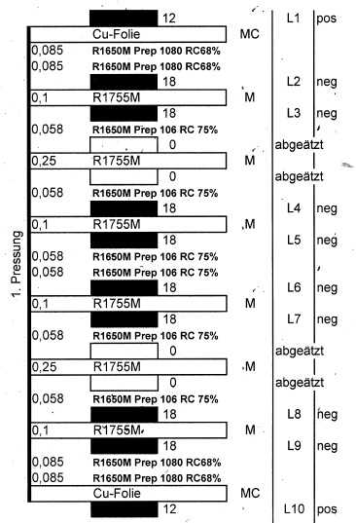

**100ohm Impedance Layer 1**

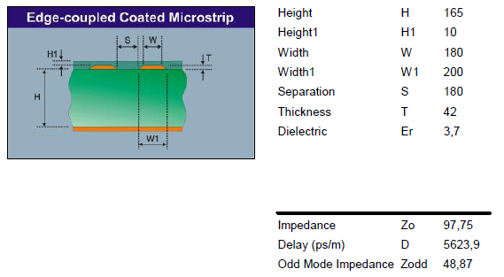

**100ohm Impedance Layers 4, 7, 8**

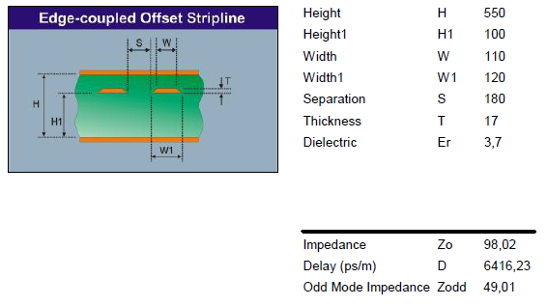

**50ohm Impedance Layer 1**

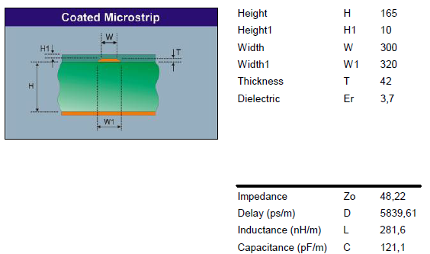

**50ohm Impedance Layers 4, 7, 8**

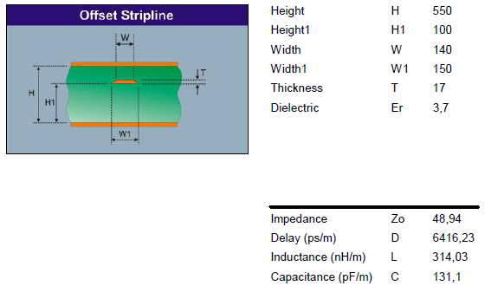

# DELIVERABLE ITEMS

## Customer contacts and responsibilities

|  |  |  |
| --- | --- | --- |
| Name | Responsibility | Contact |
| Juan Abel Barrio | Project Manager | barrio@gae.ucm.es |
| K.-H. Sulanke | Schematic and Firmware design | karl-heinz.sulanke@desy.de |
| Brigitte Kielgas | PCB design | info@anakonda.de |

## Manufacturer contacts and responsibilities

Manufacturer:DESY-Z_EL1, +49 33762 77538, wolfgang.philipp@desy.de

## Design tools

Schematic and PCB layout :Mentor Graphics Version VX.2.5

## Deliverable Hardware and Firmware

CTDB board

## Spare Philosophy, Spare Provision and Re-Use

The total quantity of manufactured boards includes spares if failure during production or testing occurs. Two samples will remain at DESY for a 7 cluster test bench.

## Ground Support Equipment and Test Equipment

The CTDB board will be tested by the DESY team. The manufacturer is responsible for an optical inspection. Further comprehensive functional tests take place at DESY Zeuthen. The test setup consists out of a lab power supply, a L2-crate, a DTB + L0 test board and a PC.

# SPECIFIC WORK TO BE PERFORMED

## Manufacturing Activities

### Process description

|  |  |  |  |  |
| --- | --- | --- | --- | --- |
| **Step** | **Activity** | **Responsible** | **Description** | **Document/record** |
| 1 | Manufacturing files delivery | Customer | Deliver of every file for the manufacture of the PCB. | Gerber files |
| 2 | File acceptance | Sub-contractor | Files for manufacture are revised and accepted |  |
| 3 | Components delivery | Customer | Procurement of the components to be mounted on the board. | Bill of materials for assembly |
| 4 | Control of component | Sub-contractor | Control the delivered components. |  |
| 5 | Component storage | Sub-contractor | Component will be stored in a controlled humidity and temperature room when unpacked/unsealed |  |
| 6 | PCB manufacturing | Sub-contractor | The PCB is delivered by the subcontractor | Impedance test protocol |
| 7 | Manufacturing revision | Sub-contractor | Manufacturing procedure validation by the customer (written by the manufacturer and validated by the customer) | Manufacturing procedure |
| 8 | Manufacturing | Sub-contractor | In compliance with the manufacturing procedure |  |
| 9 | CTDB delivery | Sub-contractor | Arrival of the product. | Incoming Inspection sheet. |
| 10 | Functional tests | Customer | Performed at DESY | Validation report |

## Delivery, Final Acceptance, Preservation and Storage Activities

### Delivery

The DESY-Zeuthen workshop delivers the boards after the visual inspection. In case of non-conformities, the non-conformity should be documented and reported to the customer.

The list of materials will be stored. The spare components of the manufacture will be stored in the case of another production needed or for future versions.

### Final acceptance

Boards must fulfill at least IPC class 2. Non-conformities should be documented and reported.

Functional tests are performed at DESY. A board to be accepted should pass the test. Rejected board will be returned to the manufacturer for repairing action.

## Export Control

Not applicable, the sub-contractor is hosted inside the European Union

# CUSTOMER FURNISHED ITEMS

## Manufacturing files and documents

|  |  |  |  |
| --- | --- | --- | --- |
| **Manufacturing files and documents** | | | |
| **Title** | **Description** | **Reference** | **Version** |
| Statement of work | This document |  | 1 |
| Images for reference | CAD screenshots and layer stack | Board_Images | 2 |
| CTDB Bill Of Material | Components list for CTDB board assembly |  | 2 |
| Gerbers files | Mentor output, Manufacturing files for PCB, and components placement |  | 2 |
| Pick and place file | Mentor output |  | 2 |
| NC drills | Mentor output |  | 2 |

## Components and materials

All components are delivered by DESY.

## Tools

Press fit tools (connectors) are provided by DESY.

**DISTRIBUTION LIST**

|  |  |  |  |
| --- | --- | --- | --- |
| **INTERNAL DISTRIBUTION** |  | **EXTERNAL DISTRIBUTION** | |
|  | **Name** | **Company** |
|  |  |  |  |
|  |  |  |  |
|  |  |  |  |
|  |  |  |  |
|  |  |  |  |
|  |  |  |  |
|  |  |  |  |
|  |  |  |  |
|  |  |  |  |
|  |  |  |  |
|  |  |  |  |
|  |  |  |  |
|  |  |  |  |