Clock & Trigger Distribution Board Rev.2, User Manual

Author | Laboratory |  | Approved by | Laboratory
Karl-Heinz Sulanke DESY

List of Abbreviations

76h | 76 hexadecimal
CTDB | Clock & Trigger Distribution Board
DTB | Digital Trigger Backplane
FEB | Frontend Board
L2BP | L2 Crate Backplane
L2CB | L2 Controller Board
LVDS | Low Voltage Digital Signalling
MISO | master in slave out
MOSI | master out slave in
PDB | Power Distribution Box
PMT | Photo Multiplier Tube
RO | Read Only
RW | Read / Write
RWC | Read / Write Clear
SCLK | serial clock
SPI | Serial Peripheral Interface
SYNCn | low active synchronization (frame signal)
TIB | Trigger Interface Box
LED | Light emitting diode

History
Version | Date | Observation
1 | 05/01/2018 | 1st Revision
2 | 21/05/2020 | monitoring LEDs meaning added

Distribution

Table of Contents
1. Introduction 4
2. Slow Control via SPI Bus 5
3. FEB Powering and Current Measurement 7
3.1 FEB Powering by Jumper 9
4. Register Description 10
4.1. PON_TIME Register 10
4.2. POFF_TIME Register 10
4.3. ADC_SRATE Register 10
4.4. DEBUG Register 11
5. Register Address Map 12
6. Register, Bits and Bytes 13
7. Monitoring LEDs 16

Introduction
This document describes the CTDB, in detail its register functionality. Each CTDB is connected to 15 FEBs via Cat.7 cables. The L2-crate is populated with 18 CTDBs. The slot address (L2-crate position, the CTDB is plugged to) of each CTDB is hard encoded in the L2BP, means there is no need to assign an address e.g. by using jumpers. The CTDB, like the L2CB is powered by an auxiliary power supply, NOT by the main camera power supply being used to power the 265 FEBs. The auxiliary power supply comes up first, ensuring that all FPGAs are loaded, before the software is able to power on the FEBs.
Main tasks of the CTDB are:
- clock and 1PPS distribution to the FEBs, sourced by the L2CB
- reception and propagation of 15 L1 signals
- fanning out and propagating the camera trigger signal to the FEBs
- reception and propagation of the FEB BUSY signals to the L2CB
The 256 x 16 bit register block is accessible via the SPI bus, physically located on the L2BP. This SPI bus is shared among all 18 CTDBs, populating the L2-crate. Bus master is the L2CB.
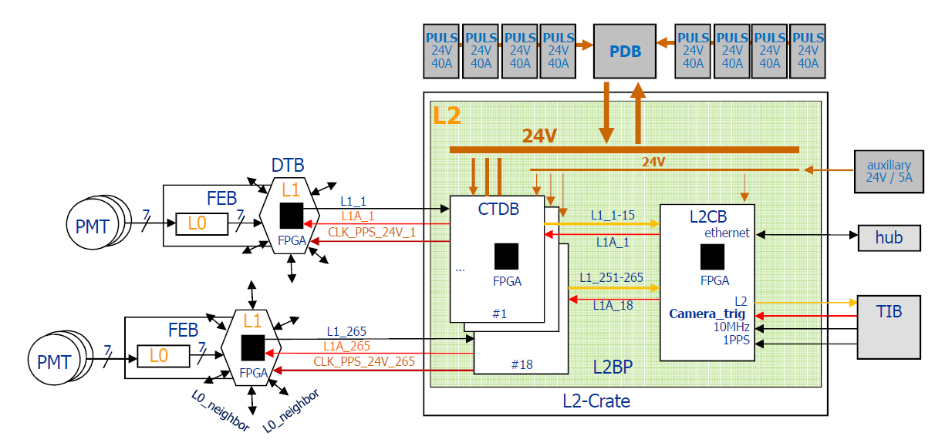
Figure 1: Trigger and Power Topology

Slow Control via SPI Bus

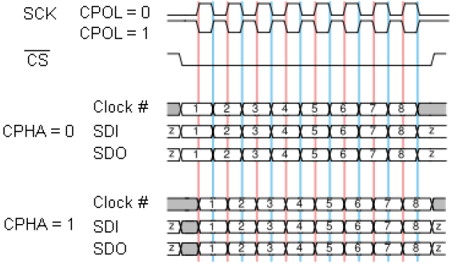
Figure 2: SPI Bus Modes. The used SPI Bus mode is of the type CPOL = 0, CPHA = 1

L2 Backplane, SPI Bus signals
SPI_SCLK | L2CB output that provides 32 clock cycles at each slow control access. The frequency of the clock it is 6.25 MHZ . The electrical standard for this signal is LVDS. Other frequencies are possible.
SPI_SYNCn | L2CB output , low during the slow control access and else high. Electrical standard for this signal is LVDS.
SPI_MOSI | Master output / slave input data line. A 32-bit word is transmitted at each slow  control access. Electrical standard for this signal is LVDS.  The most significant bit is transmitted first. The format of the 32-bit word is shown in table 1.
SPI_MISO | Master input / slave output data line. Electrical standard for this signal is LVDS.  A 16-bit word is transmitted at each slow control access. The most significant bit is transmitted first. Active at a read access, else tristated. This line provides the information of the addressed CTDB register.

Bit range | Usage
31 | RD = ‘0’, WR = ‘1’
30..29 | ‘0’, not used
28..24 | slot address 4..0 (1..9, 13..21)
23..16 | CTDB register address 7..0
15..0 | CTDB register data 15..0

Table 1: SPI bit usage, Bit-31 (MSB) is sent first

SPI_SYNC | 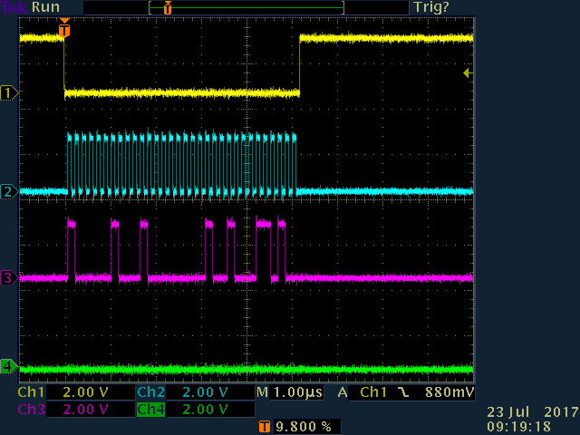
SPI_SCLK
SPI_MOSI
SPI_MISO
Figure 5: Measured, SPI write cycle of 1234h to address 20h of CTDB at slot 2

SPI_SYNC | 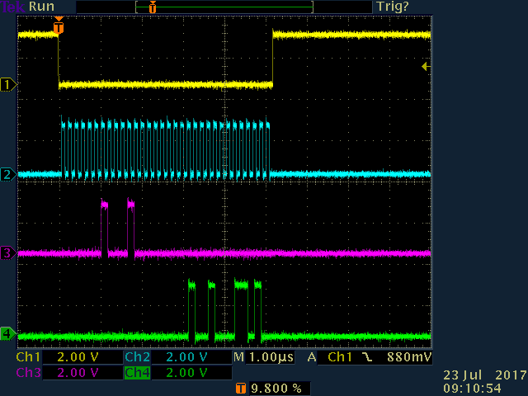
SPI_SCLK
SPI_MOSI
SPI_MISO
Figure 6: Measured, SPI read of 1234h from address 20h of CTDB at slot 2

Measured SPI bus cycles are illustrated above. The Bus cycle time is about 5.4 us. Higher rates can be achieved by adapting the L2CB firmware accordingly.

FEB Powering and Current Measurement
To power on the FEBs, one has to set the appropriate bit of the PONF register. The bit position corresponds to the CTDB channel number, with number one for the top and number 15 for the bottom channel. The numbers are engraved at the left side of the RJ45 connectors. Because the CTDB channel numbering starts with ‘1’, Bit_0 of the registers PONF, OVER_CUR and UNDER_CUR is unused.
The firmware continuously measures the current for the 15 FEBs. The default cycle time is 44.8us. The registers CUR_01 to CUR_15 provide a 12 bit current value. To get mA it has to be multiplied with 0.485 resulting in almost 2A for the full range.
The current limits are defined by the CUR_MIN and CUR_MAX registers. Once the current of a particular channel is not within the limits, the power gets shut down immediately and the STAT register bit_0 pops up. By reading both, the OVER_CUR and the UNDER_CUR register, the male functioning channel can be identified easily by the appropriate bit been set. In case of a real shortcut, it is possible that the bit of the UNDER_CUR register is set, instead of the expected bit of the OVER_CUR register. Reason is the power switch circuit FPF2702MX , acting faster than the firmware fuse (max. 44.8us).
To recover from such a state, the appropriate bit of the PONF has to be cleared and set again. This operation clears the corresponding error status bits as well.

SADC1_nCS | 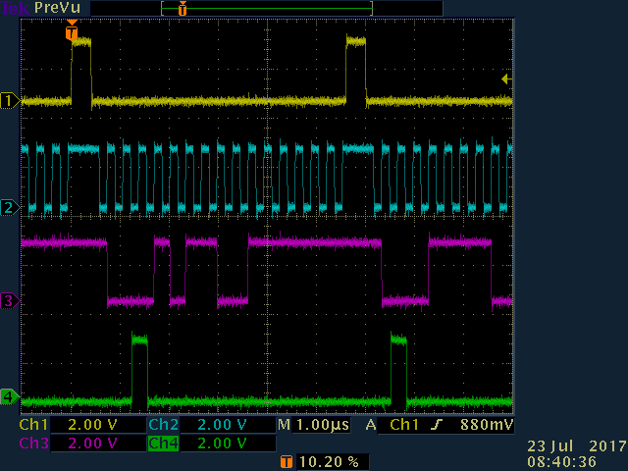
SADC1_SCLK
SADC1_DIN
SADC1_DOUT
Figure 7: SPI signals of the ADC AD7928 (U45, U46), used for the current measurement

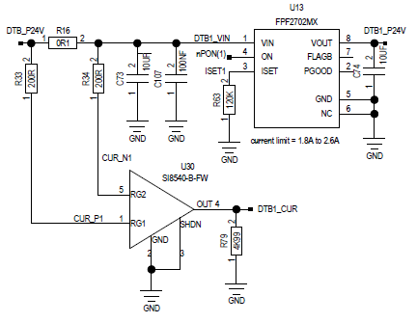
Figure 8: power switch circuit FPF2702MX
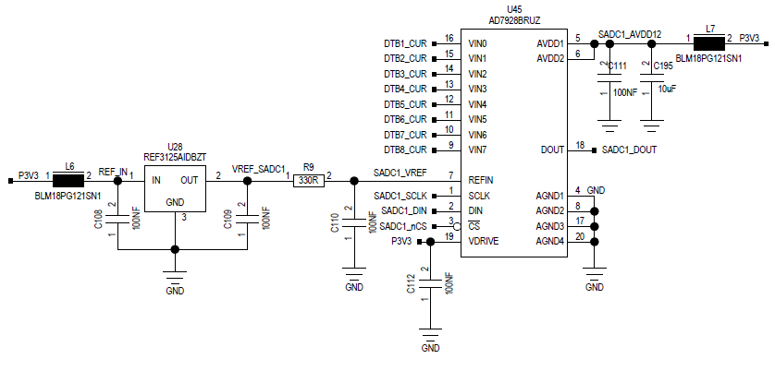
Figure 9: one of two ADCs AD7928, being used for the current measurement

FEB Powering by Jumper
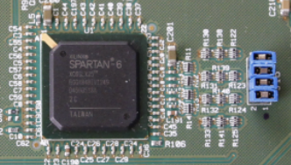
SEL(3)
SEL(2)
SEL(1)
SEL(0)
Figure 10: Test pins SEL(0) to SEL(3)
The FEBs can also be powered in groups by setting jumpers on the test pin field J16, signals SEL(0)...SEL(3), according to the following schema:
SEL-jumper set |  |  |  | CTDB channel powered
3 | 2 | 1 | 0 | 15 | 14 | 13 | 12 | 11 | 10 | 9 | 8 | 7 | 6 | 5 | 4 | 3 | 2 | 1
 |  |  | x |  |  |  |  |  |  |  |  |  |  |  |  |  |  | x
 |  | x |  |  |  |  |  |  |  |  |  |  |  |  |  |  | x | x
 |  | x | x |  |  |  |  |  |  |  |  |  |  |  |  | x | x | x
 | x |  |  |  |  |  |  |  |  |  |  |  |  |  | x | x | x | x
 | x |  | x |  |  |  |  |  |  |  |  |  |  | x | x | x | x | x
 | x | x |  |  |  |  |  |  |  |  |  |  | x | x | x | x | x | x
 | x | x | x |  |  |  |  |  |  |  |  | x | x | x | x | x | x | x
x |  |  |  |  |  |  |  |  |  |  | x | x | x | x | x | x | x | x
x |  |  | x |  |  |  |  |  |  | x | x | x | x | x | x | x | x | x
x |  | x |  |  |  |  |  |  | x | x | x | x | x | x | x | x | x | x
x |  | x | x |  |  |  |  | x | x | x | x | x | x | x | x | x | x | x
x | x |  |  |  |  |  | x | x | x | x | x | x | x | x | x | x | x | x
x | x |  | x |  |  | x | x | x | x | x | x | x | x | x | x | x | x | x
x | x | x |  |  | x | x | x | x | x | x | x | x | x | x | x | x | x | x
x | x | x | x | x | x | x | x | x | x | x | x | x | x | x | x | x | x | x
The jumper setting overwrites the software control. The current limitation is fixed at 2A. The DEBUG register value must be 0000h (power up value).

Register Description
Some registers, located at the top address region, allow additional tuning. Their default settings after power on usually do not need any modification. But if required, there is some room for optimizing or debugging.

4.1. PON_TIME Register
This register defines the period of time in ms, after software controlled power on, while the firmware fuse is disabled. Otherwise the firmware fuse would react, once the inrush current is above the programmed max. value of 1.6A (typical).The measurement below shows the typical FEB inrush current (green curve,~2A pk). The current limitation of about 2A here is due to the configuration of the FPF2702MX, see R63 at Figure 8.

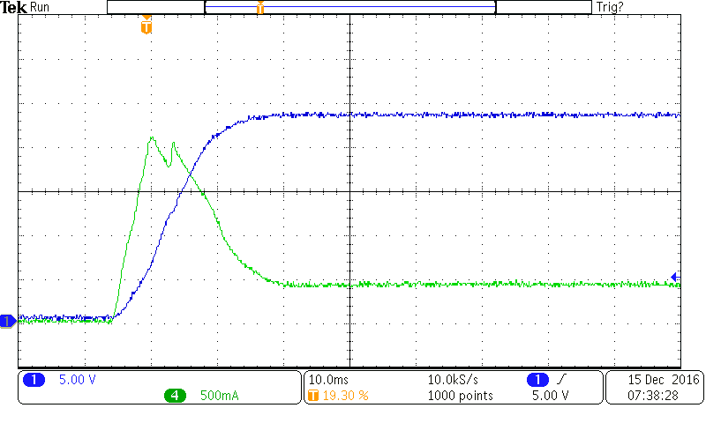  PON_TIME  CUR_MAX  CUR_MIN |  | 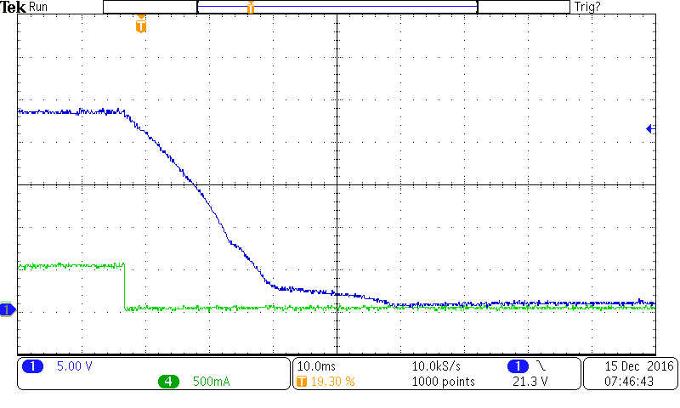  POFF_TIME
Voltage
Current
Figure 11: 24V Power on (left) and off (right), measured FEB current and voltage

4.2. POFF_TIME Register
This register defines the period of time in ms, after software controlled power off, before the next power on is possible. Goal is, to wait until all capacitors are fully discharged and the FEB voltage is almost zero. Keep in mind, the FPGA configuration needs a voltage ramp to get started.

4.3. ADC_SRATE Register
The refresh rate for the FEB current ADC can be set by writing a number between 8 and 255 to the ADC_SRATE register. The standard refresh rate is 44.8us (~22kHz) .
refresh_rate = 5.6us * ADC_RATE (= 44.8 us after power on)

4.4. DEBUG Register
The DEBUG register allows to program the usage of the test pin field J16 (SEL(0)..SEL(3)), see figure 10. After power up, the test pins can be used as inputs to power a group of FEBs according to the table shown at chapter 3.1. . By writing a value according to the table shown below, the test pins can be used to verify the timing of several signals, e.g. for the backplane SPI bus or the SPI bus used to control the two serial ADCs (FEB current measurement). Note, the pins 1,3,5,7 of J16 are connected to GND.
DEBUG-reg. value | J16-Pin | Signal (CTDB-schematic) | Remark
00h | 2 | SEL(0)-input | Set jumpers to power on groups of FEB w/o any software control. Current limit is fixed at about 2A .
00h | 4 | SEL(1)-input
00h | 6 | SEL(2)-input
00h | 8 | SEL(3)-input
01h | 2 | SADC1_nCS | Check the timing for the current measurement by probing the SPI bus signals of the serial ADC AD7928 (U45).
01h | 4 | SADC1_SCLK
01h | 6 | SADC1_DIN
01h | 8 | SADC1_DOUT
02h | 2 | SADC2_nCS | Check the timing for the current measurement by probing the SPI bus signals of the serial ADC AD7928 (U46).
02h | 4 | SADC2_SCLK
02h | 6 | SADC2_DIN
02h | 8 | SADC2_DOUT
03h | 2 | SPI_SYNC | Check the timing and monitor the SPI bus communication on the L2-crates backplane, with the L2CB acting as the bus master.
03h | 4 | SPI_SCLK
03h | 6 | SPI_MOSI
03h | 8 | SPI_MISO

5. Register Address Map

hex addr. | Name | Usage
00 | PONF | Power On / Off register
01 | CUR_01 | value * 0.485 = FEB_24V_current in mA, RJ45 ports 1..15,
... |  | value * 0.485 = FEB_24V_current in mA, RJ45 ports 1..15,
0F | CUR_15 | value * 0.485 = FEB_24V_current in mA, RJ45 ports 1..15,
10 | CUR_00 | value * 0.485 = CTDB_(own)_24V_current in mA
11 | CUR_MIN | FEB current, lower limit
12 | CUR_MAX | FEB current, upper limit
13 | OVER_CUR | over current detected
14 | UNDER_CUR | under current detected
20 | CTRL | control register for common usage
21 | STAT | status register for common usage
FB | PON_TIME | time in ms, to disable the firmware fuse after power on
FC | POFF_TIME | time in ms, after power down, before the next power on is possible
FD | ADC_SRATE | ADC (cur. measurement) sampling rate
FE | DEBUG | to program the usage of the test pins SEL0..3
FF | FREV | Firmware Revision, bits 15..0

6. Register, Bits and Bytes

PONF @ address 00h, 16 bit RW, power_on_value = 0 (0000h)
Bit | Attr. | Usage
0 | RO | ‘0’, reserved
15..1 | RW | port_15..1, port_1 is the top connector, write a ‘1’ to power on individual ports, write a ‘0’ to power off the port or to clear the errors status

CUR_01..15 @ address 01..0Fh, 12 bit RO, power_on_value = 0 (0000h)
Bit | Attr. | Usage
11..0 | RO | FEB current, 0.485 mA / bit, full scale ~2 A
15..12 | RO | ‘0’

CUR_00 @ address 10h, 12 bit RO, power_on_value = 0 (0000h)
Bit | Attr. | Usage
11..0 | RO | CTDB-own current load at 24V_aux, 0.485 mA / bit, full scale ~2 A
15..12 | RO | ‘0’

CUR_MIN @ address 11h, 12 bit RW, power_on_value = 100 mA (00CEh)
Bit | Attr. | Usage
11..0 | RW | lower current limit, 0.485 mA / bit, full scale ~ 2 A
15..12 | RO | ‘0’

CUR_MAX @ address 12h, 12 bit RW, power_on_value = 1600 mA (0CE3h)
Bit | Attr. | Usage
11..0 | RW | uppper current limit, 0.485 mA / bit, full scale ~2 A
15..12 | RO | ‘0’

OVER_CUR @ address 13h, 15 bit RO, power_on_value = 0 (0000h)
Bit | Attr. | Usage
0 | RO | ‘0’, reserved
15..1 | RO | ports 15..1, ‘1’ = individual current above the max. current limit

UNDER_CUR @ address 14h, 15 bit RO, power_on_value = 0 (0000h)
Bit | Attr. | Usage
0 | RO | ‘0’, reserved
15..1 | RO | ports 15..1, ‘1’ = individual current below the min. current limit

CTRL @ address 20h, 16 bit RW, power_on_value = 0 (0001h)
Bit | Attr. | Usage
0 | RW | firmware fuse enable (check, if FEB current is within the limits)
14..1 | RW | reserved
15 | RW | LED_ENA, ‘1’ enables monitoring LEDs

STAT @ address 21h, 16 bit RO, power_on_value = 0 (0000h)
Bit | Attr. | Usage
0 | RO | over or under current for at least 1 of the 15 ports detected
1 | RO | if set, current values are available, “dummy”, is on 20us after FPGA load
15..2 | RO | ‘0’, reserved

PON_TIME @ address FBh, 8 bit RW, power_on_value = 0032h (50ms)
Bit | Attr. | Usage
7..0 | RW | period of time, after power on, while the firmware fuse is disabled, multiples of 1ms
15..8 | RO | ‘0’

POFF_TIME @ address FCh, 8 bit RW, power_on_value = 003Ch (60ms)
Bit | Attr. | Usage
7..0 | RW | period of time, after powering off, preventing power up while capacitors at the FEB are not yet fully discharged
15..8 | RO | ‘0’

ADC_RATE @ address FDh, 8 bit RW, power_on_value = 0 (0008h)
Bit | Attr. | Usage
7..0 | RW | FEB current ADC, refresh rate, only number >=8 will be accepted, standard min refresh rate is 44.8us  refresh_rate = 5.6us * ADC_RATE (= 44.8 us after power on)
15..8 | RO | ‘0’

DEBUG @ address FEh, 8 bit RW, power_on_value = 0 (0000h)
Bit | Attr. | Usage
7..0 | RW | 00h : power on groups of FEBs by setting jumpers  01h : serial ADC1 (U45), monitoring SPI bus signals at test pin field J16  02h : serial ADC2 (U46), monitoring SPI bus signals at test pin field J16  03h : L2-crate backplane, monitoring SPI bus signals
15..8 | RO | ‘0’

FREV @ address FFh, 16 bit RO, power_on_value : binary firmware rev. number
Bit | Attr. | Usage
11..0 | RO | CTDB firmware revision
15..12 | RO | CTDB PCB revision

7. Monitoring LEDs
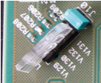
Enable the monitoring LEDs for test purposes only, to avoid light emission in the camera! The table shows the meaning of the LEDs. The LEDs can be hard enabled, by setting the jumper J10 or by software, setting bit_15 of the CTRL register.

LED | color | meaning
V129 (lower) | red | FPGA configuration failed
V130 | green | FPGA configuration successful
V132 | yellow | L1 trigger (up going)
V131(upper) | blue | L1A camera trigger (down going)

