Protocol for the Profibus Communication between the Laser Inhibit SPS (LIS) and the PITZ Control System (CS)

The FDL-Profibus Protocol is handled at the SPS via the Functions AG_SEND and AG_RECEIVE from the SIMATIC-NET library. PB-address of Laser- SPS is 11, LSAP is 12. The communication with the control system is realized via unspecified FDL connection ( free layer 2 access ), that’s why address of the remote station is written in the first 4 bytes of the data blocks. These 4 bytes are cut during receiving of DB20 or added during sending of DB30 from the CS.
There are two directions of communication: LIS_2_CS and CS_2_LIS.

LIS_2_CS
When in running mode, the SPS will try to send a data block to the CS every 2 seconds. It contains information about the inputs, maskbits, internal states and outputs of the Laser.
The status data block has a length of 32 byte and the following structure:

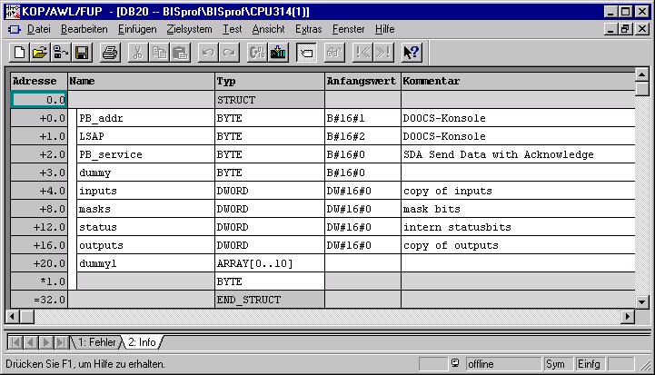

The description of the meaning of the status register bits can be found in symbol table of the SPS-program.

CS_2_LIS
The CS can send data blocks of max. 32 bytes to the SPS containing commands for the LAS to set masks and enable / disable the Laser. If the SPS is in running mode it will try to receive such blocks via Profibus. The most of these commands are only 4 bytes long.
The first word (2 bytes) has to contain the command itself, the second one a parameter that can be TRUE or FALSE. For fail save operation the ASCII-value of the command and parameter letter has to be accompanied by its ones-complement in the high-byte of the word.
The following commands are implemented:

Command Letter | Parameter | 1. word | 2. word | description
S (enable Laser) | T (rue) | 0xAC53 | 0xAB54 | Reset Laser Stop FF
S (disable Laser) | F (alse) | 0xAC53 | 0xB946 | Set Laser Stop FF
M (ask set) | T | 0xB24D | 0xAB54 | Set mask
M (ask reset) | F | 0xB24D | 0xB946 | Reset mask
*) The data block of the Mask command consists of the two words shown above and additional data, that has to be written into the SPS. In this case the 4 byte mask block has to follow.

Received data blocks with anything else than defined commands in the two first words (corresponding to the table) will be ignored.

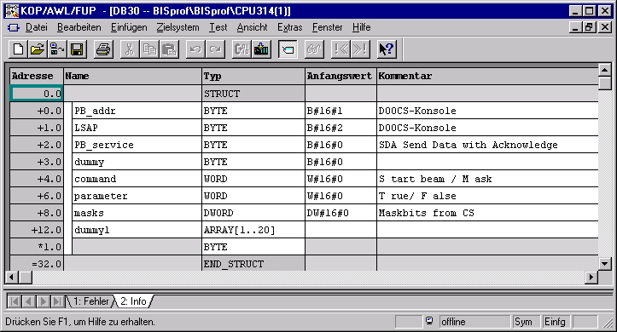
Received data blocks with anything else than defined commands in the two first words (corresponding to the table) will be ignored.
In detail the input, status, mask and output bits have the following meaning:

inputs Byte SPS Datablock Byte.Bit
S_BIT_1.I waterflow 0 o.k. E 4.0 In1/8 BOOL, DB20 +4.0, MD30
S_BIT_2.I waterflow 1 o.k. E 4.1 In1/9 BOOL
S_BIT_3.I waterflow 2 o.k. E 4.2 In1/10 BOOL
S_BIT_4.I waterflow 3 o.k. E 4.3 In1/11 BOOL
S_BIT_5.I ampflow o.k. E 4.4 In1/12 BOOL
S_BIT_6.I amptemp o.k. E 4.5 In1/13 BOOL
S_BIT_7.I VME- clock E 4.6 In1/14 BOOL
S_BIT_8.I door1 closed E 4.7 In1/15 BOOL
S_BIT_9.I door2 closed E 5.0 In1/0 BOOL
S_BIT_10.I door3 closed E 5.1 In1/1 BOOL
S_BIT_11.I door4 closed E 5.2 In1/2 BOOL
S_BIT_12.I switch tunnel shut open E 5.3 In1/3 BOOL
S_BIT_13.I switch streak shut open E 5.4 In1/4 BOOL
S_BIT_14.I switch_both shut open E 5.5 In1/5 BOOL
S_BIT_15.I IL-Tunnel o.k. E 5.6 In1/6 BOOL
S_BIT_16.I enable shut tunnel BIS E 5.7 In1/7 BOOL
D_BIT_1.I1 (shutter tunnel closed)n.c. E 6.0 In2/8 BOOL
D_BIT_1.I2 shutter tunnel open E 6.1 In2/9 BOOL
D_BIT_2.I1 shutter streak closed E 6.2 In2/10 BOOL
D_BIT_2.I2 shutter streak open E 6.3 In2/11 BOOL
S_BIT_17.I oscill cooling o.k. E 6.4 In2/12 BOOL
S_BIT_18.I laser stop button E 6.5 In2/13 BOOL
S_BIT_19.I switch remote enable on E 6.6 In2/14 BOOL
S_BIT_20.I button dist. remote press E 6.7 In2/15 BOOL
S_BIT_21.I close tunnel shut. by CS E 7.0 In2/0 BOOL
S_BIT_22.I IL-Linac o.k. E 7.1 In2/1 BOOL

maskbits

S_BIT_5.M mask ampflow M 38.4 Ma1/13 BOO masks, DB20 +8.0, MD38
S_BIT_6.M mask amptemp M 38.5 Ma1/14 BOOL
S_BIT_17.M mask oscillcool M 40.4 Ma1/12 BOOL
internal statusbits

SBIT_1.I remote distance enabled M 34.0 St1/8 BOOL DB20 +12.0, MD34

SBIT_2.I remote near enabled M 34.1 St1/9 BOOL

SBIT_3.I PBs2bok M 34.3 St1/10 BOOL

SBIT_4.I PBsent M 34.5 St1/11 BOOL

SBIT_5.I err_PBsend M 34.6 St1/12 BOOL

SBIT_6.I err_PBrec M 34.7 St1/13 BOOL

SBIT_7.I PBrecd M 35.0 St1/14 BOOL

SBIT_8.I PBrun M 35.1 St1/15 BOOL

SBIT_9.I Laser disable pulse M 35.2 St1/0 BOOL

SBIT_10.I Laser enable pulse M 35.3 St1/1 BOOL

outputs
O_BIT_1.I door laser green A 8.0 Out1/8 BOOL DB20 +16.0, MD42
O_BIT_2.I door laser red A 8.1 Out1/9 BOOL
O_BIT_3.I door streak green A 8.2 Out1/10 BOOL
O_BIT_4.I door streak red A 8.3 Out1/11 BOOL
O_BIT_5.I shutter tunnel open A 8.5 Out1/13 BOOL
O_BIT_6.I shutter streak open A 8.6 Out1/14 BOOL
O_BIT_7.I enable dist remote lamp A 8.7 Out1/15 BOOL
O_BIT_8.I shutter o.k. A 9.0 Out1/0 BOOL
O_BIT_9.I display door on A 9.1 Out1/1 BOOL
O_BIT_10.I disp laser on A 9.2 Out1/2 BOOL
O_BIT_11.I disp streak on A 9.3 Out1/3 BOOL
O_BIT_12.I disp tunnel on A 9.4 Out1/4 BOOL
O_BIT_13.I shutter tunnel closed2BIS A 9.5 Out1/5 BOOL
O_BIT_14.I PB o.k. LED A 9.6 Out1/6 BOOL
O_BIT_15.I laser beam disabled A 9.7 Out1/7 BOOL
O_BIT_16.I power-out A 12.0 Out2/8 BOOL
O_BIT_18.I water2-out A 12.4 Out2/10 BOOL
O_BIT_19.I water3-out A 12.5 Out2/11 BOOL
O_BIT_20.I pockel disable A 12.6 Out2/12 BOOL
O_BIT_21.I water0-out A 16.0 Out2/13 BOOL

All signals to the control system via profibus are active low ( 0 )!!!!

