Protocol for the Profibus Communication between the Beam Inhibit System (BIS) and the PITZ Control System (CS)

The FDL-Profibus Protocol is handled at the SPS via the Functions AG_SEND and AG_RECEIVE from the SIMATIC-NET library. PB-address of BIS- SPS is 10, LSAP is 11. The communication with the control system is realized via unspecified FDL connection ( free layer 2 access ), that’s why address of the remote station is written in the first 4 bytes of the data blocks. These 4 bytes are cut during receiving of DB20 or added during sending of DB30 from the CS.
There are two directions of communication: BIS_2_CS and CS_2_BIS.

BIS_2_CS
When in running mode, the SPS will try to send a data block to the CS every 2 seconds. The one and only data block is the status data block. It contains information about the screens, the valves, end switches and the beam modes.

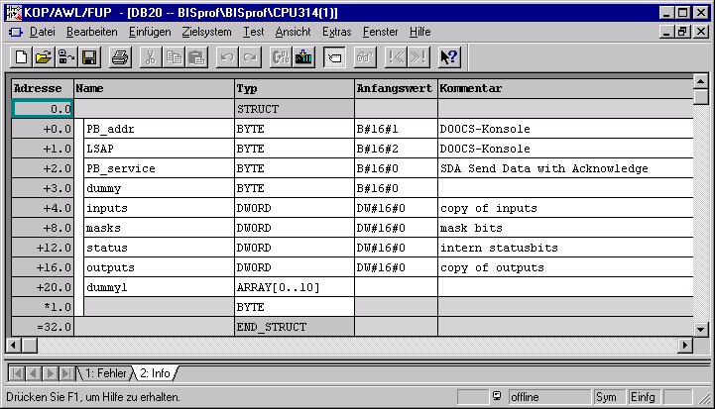
The status data block has a length of 32 byte and the following structure:

The description of the meaning of the status register bits can be found in symbol table of the SPS-program.

CS_2_BIS
The CS can send data blocks of max. 32 bytes to the SPS containing commands for the BIS to set masks and start / stop beam. If the SPS is in running mode it will try to receive such blocks via Profibus. The most of these commands are only 4 bytes long.
The first word (2 bytes) has to contain the command itself, the second one a parameter that can be TRUE or FALSE. For fail save operation the ASCII-value of the command and parameter letter has to be accompanied by its ones-complement in the high-byte of the word.
The following commands are implemented:

Command Letter | Parameter | 1. word | 2. word | description
S (tart beam) | T (rue) | 0xAC53 | 0xAB54 | Reset Beam Stop FF
S (top beam) | F (alse) | 0xAC53 | 0xB946 | Set Beam Stop FF
M (ask set) | T | 0xB24D | 0xAB54 | Set mask
M (ask reset) | F | 0xB24D | 0xB946 | Reset mask
*) The data block of the Mask command consists of the two words shown above and additional data, that has to be written into the SPS. In this case the 4 byte mask block has to follow.

Received data blocks with anything else than defined commands in the two first words (corresponding to the table) will be ignored.

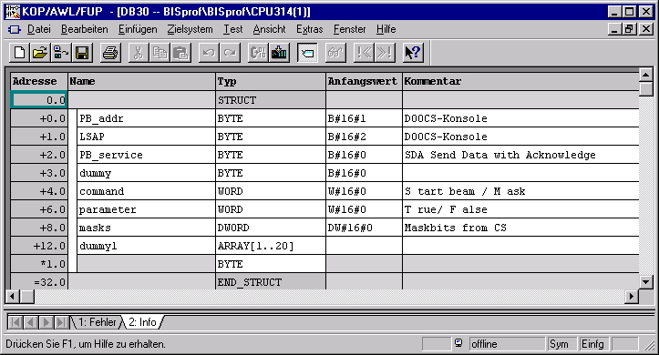
Received data blocks with anything else than defined commands in the two first words (corresponding to the table) will be ignored.
In detail the input, status, mask and output bits have the following meaning:

inputs Byte
S_BIT_1.I raddiation & interl ok E 4.0 0.0 BOOL inputs, DB20 +4.0, MD30
D_BIT_1.I1 vacuum valve 1 closed E 4.1 0.1 BOOL
D_BIT_1.I2 vacuum valve 1 open E 4.2 0.2 BOOL
D_BIT_2.I1 vacuum valve 2 closed E 4.3 0.3 BOOL
D_BIT_2.I2 vacuum valve 2 open E 4.4 0.4 BOOL
D_BIT_3.I1 vacuum valve 3 closed E 4.5 0.5 BOOL
D_BIT_3.I2 vacuum valve 3 open E 4.6 0.6 BOOL
D_BIT_4.I1 vacuum valve 4 closed E 4.7 0.7 BOOL
D_BIT_4.I2 vacuum valve 4 open E 5.0 1.0 BOOL
S_BIT_2.I laser shutter 1 closed E 5.1 1.1 BOOL
S_BIT_3.I pressurised air ok E 5.2 1.2 BOOL
D_BIT_5.I1 vacuum valve 6 closed E 5.3 1.3 BOOL
D_BIT_5.I2 vacuum valve 6 open E 5.4 1.4 BOOL
S_BIT_4.I dipole on E 5.5 1.5 BOOL
D_BIT_6.I1 mirror to pepperpot in E 5.6 1.6 BOOL
D_BIT_6.I2 mirror to pepperpot out E 5.7 1.7 BOOL
D_BIT_7.I1 mirror to cathode in E 6.0 2.0 BOOL
D_BIT_7.I2 mirror to cathode out E 6.1 2.1 BOOL
D_BIT_8.I1 far cup screen in E 6.2 2.2 BOOL
D_BIT_8.I2 far cup screen out E 6.3 2.3 BOOL
D_BIT_9.I1 viewscreen inj in E 6.4 2.4 BOOL
D_BIT_9.I2 viewscreen inj out E 6.5 2.5 BOOL
D_BIT_10.I1 viewscreen ana in E 6.6 2.6 BOOL
D_BIT_10.I2 viewscreen ana out E 6.7 2.7 BOOL
D_BIT_11.I1 viewscreen image PP in E 7.0 3.0 BOOL
D_BIT_11.I2 viewscreen image PP out E 7.1 3.1 BOOL
D_BIT_12.I1 mirror image PP in E 7.2 3.2 BOOL
D_BIT_12.I2 mirror image PP out E 7.3 3.3 BOOL
S_BIT_5.I cathode lin out E 7.4 3.4 BOOL
S_BIT_6.I cathode lat out E 7.5 3.5 BOOL
S_BIT_7.I beam stop button E 7.6 3.6 BOOL
S_BIT_8.I solenoid supply ok E 7.7 3.7 BOOL

maskbits
D_BIT_1.M mask vac valve 1 M 38.0 4.0 BOOL masks, DB20 +8.0, MD38
D_BIT_2.M mask vac valve 2 M 38.1 4.1 BOOL
D_BIT_3.M mask vac valve 3 M 38.2 4.2 BOOL
D_BIT_4.M mask vac valve 4 M 38.3 4.3 BOOL

D_BIT_5.M mask vac valve 6 M 38.5 4.5 BOOL
S_BIT_4.M mask dipole on M 38.6 4.6 BOOL
D_BIT_6.M mask mirror to pp M 38.7 4.7 BOOL
D_BIT_7.M mask mirror to cath M 39.0 5.0 BOOL
D_BIT_8.M mask far cup screen M 39.1 5.1 BOOL
D_BIT_9.M mask viewscreen inj M 39.2 5.2 BOOL
D_BIT_10.M mask viewscreen ana M 39.3 5.3 BOOL
D_BIT_11.M mask screen image PP M 39.4 5.4 BOOL
D_BIT_12.M mask mirror image PP M 39.5 5.5 BOOL
S_BIT_8.M mask gun solen supply ok M 39.6 5.6 BOOL
S_BIT_2.M mask laser shutt 1 M 39.7 5.7 BOOL

S_BIT_3.M mask pressurised air ok M 40.1 6.1 BOOL

S_BIT_5.M mask cath lin M 40.3 6.3 BOOL
S_BIT_6.M mask cath lat M 40.4 6.4 BOOL

internal statusbits
valves ok M 34.0 8.0 BOOL intern statusbits, DB20 +12.0, MD34
sensor not o.k. M 34.1 8.1 BOOL "
PBs2bok M 34.3 8.2 BOOL Profibus seems to be ok.
BISfaultFlag M 34.4 8.3 BOOL set by OB81
PBsent M 34.5 8.4 BOOL set 1 if sent done
err_PBsend M 34.6 8.5 BOOL Error during Profibus Transmission
err_PBrec M 34.7 8.6 BOOL Error during Profibus Receive
PBrecd M 35.0 8.7 BOOL
PBrun M 35.1 9.0 BOOL
stop beam pulse M 35.2 9.1 BOOL 1 sec pulse
start beam pulse M 35.3 9.2 BOOL 1 sec pulse

outputs
O_BIT.1 repetition rate 1 Hz A 8.0 12.0 BOOL to Laser, outputs, DB20 +16.0, MD42
O_BIT.2 repetition rate 10 Hz A 8.1 12.1 BOOL to CS
O_BIT.3 pulse length 50 µs A 8.2 12.2 BOOL to CS
O_BIT.4 pulse length 800 µs A 8.3 12.3 BOOL to CS
O_BIT.5 op-mode cond set A 8.4 12.4 BOOL to CS
O_BIT.6 op-mode gun set A 8.5 12.5 BOOL to CS
O_BIT.7 op-mode analyse set A 8.6 12.6 BOOL to CS
O_BIT.8 op-mode injector set A 8.7 12.7 BOOL to CS
O_BIT.9 op-mode UV laser set A 9.0 13.0 BOOL to CS
O_BIT.10 op-mode PP align set A 9.1 13.1 BOOL to CS
O_BIT.11 RF enable A 9.2 13.2 BOOL to CS
O_BIT.12 L-shutter enable A 9.3 13.3 BOOL to Laser
O_BIT.13 Beam Stop A 9.4 13.4 BOOL to CS

